Surgery sheet 19 9-3-2016
Mandibular and condylar fractures
Edentulous mandibular fractures
The mandible has certain features that make it more susceptible for fractures compared to other facial bones. One of these features is the loss of teeth, and we all know that clearance of teeth is followed by alveolar resorption, so we will have atrophic jaw that is more susceptible for fracture.
Furthermore, the ID blood supply (ID artery, vein, neural bundle) would be lost with the recession, and the only blood supply of the mandible will depend on the periosteum.
So the risk of surgery in edentulous mandible is higher compared to dentate, due to compromised blood supply. And with surgery and muco-perioseal flaps we will compromise the blood supply further.
Most of these patients are elderly, and most commonly medically compromised, and that would compromise our treatment, also the patient may not fit for surgery and anesthesia.
We can say that elderly patients are fit for closed reduction rather than open reduction unless there are indications.
Another feature is that loss of teeth will lead to loss of occlusion, and occlusion is important feature in closed reduction. So if the patient doesn’t have a denture we make him one, or we can use his exciting one, and we ask the prosthe department to do gunning splint to enhance intermaxillary fixation.
Gunning splint is something like the denture, that we make when the denture is broken after trauma, its temporary like bite blocks.
We do intermaxillary fixation several weeks prior to closed reduction.
Without occlusion we can’t do reduction nor fixation.
A general rule in fractures treatment is that the simpler the treatment the better the results. Specially in elderly and very young patients, go for the most conservative choice that works.
We have 3 options, the closed reduction (non-surgical), open reduction, rigid fixation.
If the bone is very atrophic and weak, we need rigid fixation.
When assessing the case we have to look at the medical assessment and local assessment of the fracture, and if the whole assessment gives you indication optimal bone healing, that means we might need load sharing, so we use mini plates.
But the mandible is very atrophic, very thin, and medically compromised, so no optimal fracture healing condition, because all of that we need load bearing not load sharing, so the most type of fixation used when surgery is intended is the reconstructive plate for load bearing.
Again, specific concern has to be paid for mandibular fractures in children, the mandibular bone in children has specific concern that there is a growing stage in the bone, we have mixed dentition, all these features complicate the surgical option. Arch wires are very heavy on deciduous teeth, the may loosen them.
So we start with the most conservative option that is the closed reduction, unless its contraindicated such in epileptic patients.
The best way other than intermaxillary fixation is using occlusal splint, its like RPD with wires that go under and around the mandible to provide adequate fitness between the two surfaces of fracture.
In children prolonged intermaxillary fixation is not preferred, because it can cause TMJ ankyloses, actually it’s the most common cause for TMJ ankyloses, so its only indicated for 2 weeks in children, not any longer than that. In adults its okay up to two months
The third important part of mandibular fractures is the condylar fracture.
The condyle is a primary growth center and what applies for these fractures doesn’t apply for other fractures.
We might leave a medially displaced condylar fracture or treat it conservatively, expecting that it will be modified with growth.
We always say that the condyle is the most common site for mandibular fractures, other say that the body is the most common, and that varies according to geography, the trauma is most commonly in the symphesial area, and the force is transmitted to the condyle.
In accidents high forces are directly transmitted and cause body and angle fractures, so the etiology determines the type of fracture.
Intra-capsular fractures account for 14% in adults, but in children it’s the most common and accounts for about 40% of all condylar fractures.
This also depends on the thickness of condyle and the condylar necks height, in young patient we have short neck and thick condyle, so the force is directly transmitted to the condylar head causing fracture.
But in the adults the most common is sub-condylar or condylar neck, because its long, so it’s the weakest point.
So the incidence of fracture in the condyle is dependent on the age.
Most condylar fractures are unilateral rather than bilateral and in the left side.
Surgical anatomy of the condyle:
Condyle is articulated to the glenoid fossa and the articular disk between them, and the lateral pterygoid muscle is attached to the anterior part of the condyle and the articular disk, so in case of fracture there will be anterio-medial displacement, and it’s the most common direction in condylar fracture, but generally displacement could occur in any direction but the most common is anterio-medial under the action of lateral pterygoid muscle.
Mechanism of injury, if its directed to the left we expect a contra lateral fracture of the condyle, but if it was a heavy force we expect bilateral fracture.
Guard mans fracture (for the body guards), the force is directly on the symphesial area leading to laceration of the chin, midline fracture and bilateral fracture when the mouth is closed, when the mouth is open during trauma we have bilateral body fracture not midline fracture, and also associated with bilateral condylar fracture, this mainly depends on the direction and velocity of force determining the type and severity of fracture
Classifications of condylar fractures
threre are many classification but the most two beneficial classification are:
I-Kelley's classification (1991) depending on the location of the fracture (surgical site):
1-capsular or intracapsular
2-condylar neck fracture
3-subcondylar fracture
This classification is related to the age of the patient that can affects the fracture location
The most complicated one and the one that most probably need difficult surgical treatment is intracapsular fracture and as you go away from the the condyle the percentage of autoredection increases like in subcondylar fractures
II- depending on the degree of the displacement occurs to the condyle:
1-non displaced fracture: the condyle is fractured but remains in it's place without any displacment
2-displaced fracture: in any direction but the most common direction the condyle to be displaced to is anteriomedial direction but also it's still inside the glenoid fossa
3-dislocated outside the glenoid fossa
4-comminuted fracture: when the condyle is fractured into small pieces
-these are the most important in terms of clinical significant and implications
_____________________________________________________________
Clinical signs and symptoms of condylar fractures
-always these cases of fractures are emergency cases and if a pt with signs of fracture come to your private clinic you have to refer it directly to the emergency department
- in the EM the pt have to be assessed for primary (ABCs) survey and the pt is stable then they refer it to the surgeon, the first step the surgeon has to do is REASSESSMENT of the (ABCs), then he can start the secondary survey which can't be done on the pt if he is not a stable .
secondary survey is taking history from the pt about his medical history , his chief complaint, the injury and how does it happened, the time of the injury, The direction and magnitude of the force
-they always say adequate history leads to definitive diagnosis
-medical history like diabetes, bisphospnate, radiotherapy and others can modify the treatment and change your intended treatment
EXAMINATION:
always start with systemic palpation from supraorbital to infraorbital area to the condyle to the posterior border of the ramus to the mid line bilaterally until your both hands touch each others
-if you find any step during palpation it means there is a fracture there
-but usually condylar fractures appears clinically as pain or tenderness in the condyle area or sometimes it's not a fractures but just heamoarthrosis or diffusion of the blood to the affected area without fracture or what is called (non fracture injury)
-if diffusion happens it will cause anterior or lateral open bite the ipsilateral side and the diffusion prevents the condyle to return to it's position and actually there is to type:
1- when the occlusion can be obtained
2- and some times we can't obtain occlusion
in both the treatment is conservative using intermaxillary fixation or some times arthrocentecis, but in cases of fracture the open bite will happen in the contra lateral side
-Deviation of the mandible to the same side of the fracture . As the patient unconsciously shifts his mandible to the side of injury to avoid pain stimulation at that side
- spasms leading to limitation of mouth opening
- bleeding from the ear ( otorrhagia ): an alarming sign that requires further investigation .
- inability to palpate the TMJ during movement .
- abnormal function of the TMJ . Limitation of mouth opening ,deviation of the mandible ,an open bite . Note that an open bite occurs on the contralateral side of the fracture . An anterior open bite is associated with bilateral fractures .
During your examination look for any signs that can be alarming such as bleeding from the ear .This sign could indicate:
1. Base of skull fracture , usually associated with the battle sign(ecchymosis around the mastoid process) .
2. Laceration of the external auditory meatus .
3. Displacement of the condyle into the middle cranial fossa .
After being sure that the patient isn’t suffering from any spinal injury , tilt the head and look for any dripping fluids . If a clear fluid is dripping , CSF leakage is suspected. This can be confirmed by performing a simple test using a filter paper . Double ring sign is what we look for in this case . Which is a halo of clear fluid around the central blood clot . If this test was positive , further tests are required . In this case beta 2 transferrin test . Which is an immunoflorescence test to confirm the presence of CSF .
Positive beta 2 transferrin test does not exclusively indicate CSF leakage , it could also indicate lymphatic leakage . Whereas nasal leakage indicates CSF leakage only .
Treatment can be controversial with CSF leakage . Some clinicians prescribe antibiotics ( clindamycin ) as the dura is torn, while others report no benefit of antibiotics in such cases as they don’t cross the blood brain barrier .
The best management would be to reduce the fracture while placing the patient in an upright position and wait for 10 days . If the leakage hadn’t ceased by then , refer to a neurosurgeon .
RADIOGRAPHS
If you suspect a fracture , confirm your suspicion by ordering the proper radiograph . Look for areas of direct and indirect forces .
always start with minimal invasive investigation and if they are insufficient to help you, go one step further more.
Plain radiographs are sufficient for simple displaced fractures resulting from simple mechanism of injury . Such as PA skull and OPG.
More specific images such as reverse Town is the preferable projection in condylar fractures and it reveals medial displacement or subcondylar fracture . Lateral oblique could be used but it is not very specific .
In more severe injuries , a CT is warranted . Another indication for a CT is when surgery is intended .
MRI is indicated in cases of rupture or injury to the disc .
TREATMENT:
Taking into consideration all the proceeding factors a treatment plan is developed.Treating condylar fractures has pretty much the same aims as treating fractures at other sites .
Goals of condylar fracture repair :
Pain free mouth opening
Good jaw motion in all excursive movements
Restoration of pre-injury occlusion
Stable TMJs
Good facial and jaw symmetry .
The condyle is a very sensitive area . 5-20% of cases of facial asymmetry are attributed to condylar trauma , as it could lead to condylar hypoplasia.
Auto-correction is suspected in the condyle , but not necessarily ideally to restore the proper function of the joint , as it could be in the form of ankylosis
Types of treatment
Conservative management : always start with it especially in simple nondisplaced fractures soft diet and analgesia .
Closed reduction with IMF : to fix the two jaws together in the pre-injury occlusion . The period of IMF is dependent on the age and degree of displacement .
Open reduction and internal fixation .
-surgeons advise that you have to try to avoid open surgeries because it has many risks like nerve palsy and TMJ ankylosis and it not easily accessed to put plates there to fix the condyle in place
Tthe Royal college of surgeons initiated a clinical guideline in 1997 regarding the treatment of condylar fractures.
THEY always say: If you can achieve normal occlusion before the injury the you can do close reduction
The main factors considered are derangement of occlusion, the age and degree of displacement .

Some general rules or facts were considered :
A patient less than 12 years of age has a high potential for remodeling and occlusal development . Therefore , a more conservative approach is considered regardless of the degree of displacement .
A patient aged from 12-20 years is within a gray area .They have some capacity for remodeling but it is not highly predictable . Making the degree of displacement a factor to be considered during treatment planning .
In a patient more than 20 years of age , the remodeling is not predictable at all , so we might consider surgical treatment . Certain factors should be considered though .
So the main factors to determine a treatment plan are the age , degree of displacement and derangement of occlusion .
Age < 12 years
A high potential for remodeling .
The degree of displacement is not very important in terms of treatment .
Next , assess the occlusion . If there was no occlusal alteration , conservative approach is followed ( soft diet and analgesia ) . Should there be occlusal alteration , then reduce the fracture progressively by elastic traction using guiding or functional elastics ( functional IMF ) . They guide the mandible into pre-injury occlusion and the TMJs remain in function to enhance healthy remodeling (the patient is able to open and close his mouth) .
Functional IMF is the most commonly used means of fixation in such cases . However , rigid IMF (using wires ) may be indicated in certain cases , such as bilateral condylar fracture , or when elastics are not sufficient to guide the mandible correctly to the pre-injury occlusion .
If no improvement is observed after one month , surgery might be considered but Surgery at this young age is very unpredictable , it could induce ankylosis and lead to unpleasant consequences such as interference in the facial skeleton growth on that side of the face . 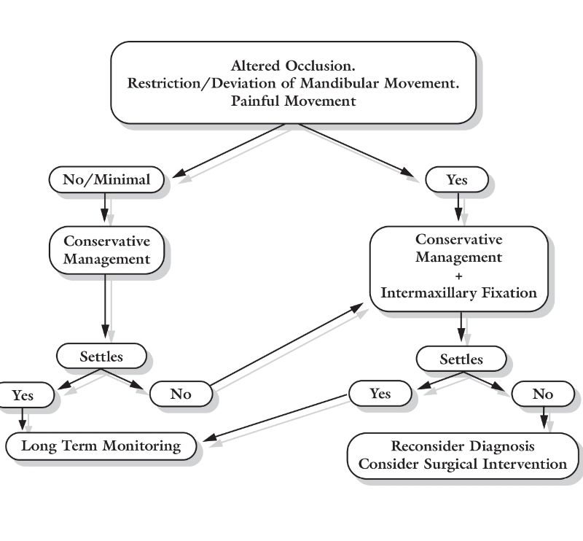
12-20 years of age
Here the degree of displacement has to be considered , however it is not as important as occlusal derangement , as there is still some potential capacity for remodeling ( but not highly predictable ) therefore the degree of displacement has to be considered when planning a treatment at this age .
- Open reduction and surgery is indicated in severe occlusal derangement and severe displacement of the condyle .
- if the occlusion was minimally altered but with severe displacement , conservative treatment is considered with or without IMF . IMF could lead to ankylosis . Therefore , if it was absolutely necessary , it has to be applied for 1-2 weeks only ( 10 days in average ) .
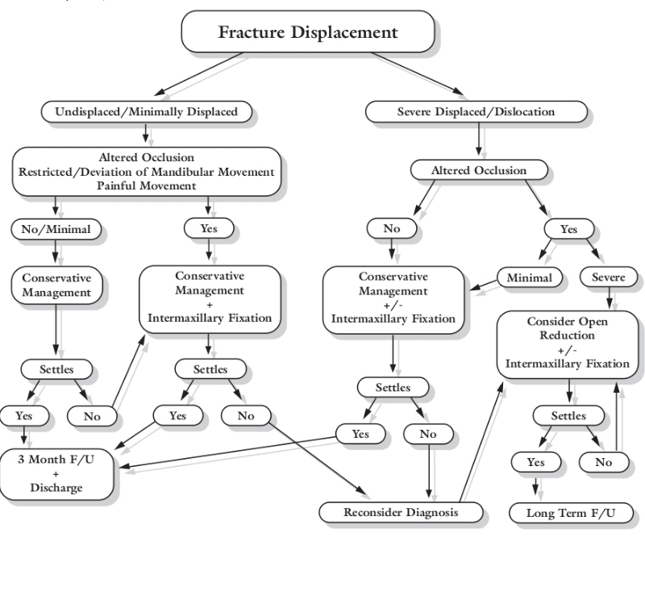

Age > 20 years .
The degree of displacement is as important as the occlusal status .If the occlusion was altered with minimal displacement of the condyle , conservative approach is followed WITH IMF
. 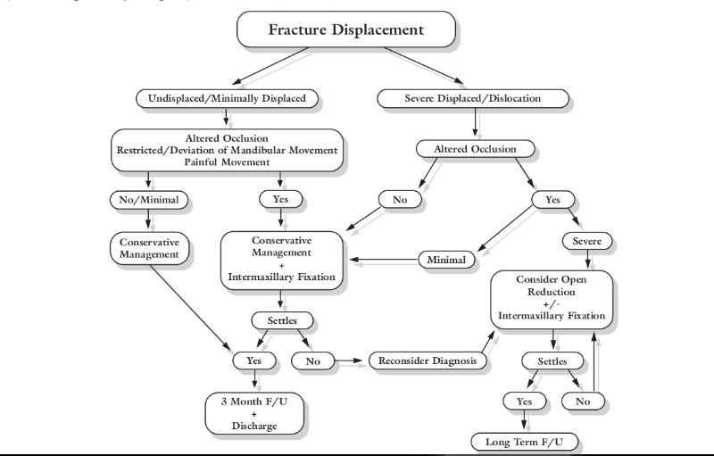

Follow up of condylar fracture patients is usually for 3 months , but it is life long when surgery is performed , or if the patient is less than 12 years of age .
Conservative treatment has better reported results in the literature .

The last 2 pages are from last year sheet because the doctor did not complete taking about the last subject and I think it's important to know about it

Thank you

