cleft lip repair on 3 months –
-primary palate repair on 1 year(( why not before or after one year ??
–growth of maxilla
- speech "articulation of sound "
*why cleft palate occur ?
–lack of fusion for palatal shelves
incomplete fusion of palatal shelves -
*Theories about cleft palate :
-abnormalities in programmed cell death lead to lack of palatal fusion .
-Isolated disruption of palate shelves can occur after closure of the lip
-Palatal closure is not completed until 9 weeks post-conception. "9-11 weeks need to close ".
- Prenatal Diagnosis by U/S at 12 weeks
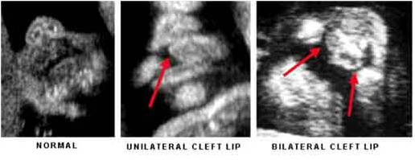
-after the first year the family think that his baby start talk but if palate is opened no good articulation of sound so sound not exit properly .
As we said before repair at 1 year not before because due to surgery cause scar which inhibit growth of maxilla , so those patient have class 3 or pseudo class 3 "mandible prognathism relatively due to underdeveloped maxilla.
-orthodontist consider the major part of team can see patient at 6 , 12 ,16 years .
*the bottle of baby with clefting use special feeding apparatus.
-must have coordinator "nurse " which coordinate between part of team –plastic surgeon who have the priority to do primary cleft repair "general surgeon can do cleft repair "
- those pt have problem in palate and continous ear problem and infection because Eustachian Tube is short in those pt and abnormal palatal muscle so must have ENT surgeon .
Also the team must have audiologist , speech pathologist .
About the role of dentist as Gp >> in oral hygiene , if need appliance and coordination with orthodontist to know when to start and when to complete ortho treatment .
About role of maxillofacial surgeon >>on 7,8,9,10,11 according to eruption of canine , in order to do bone graft which is important in arch continuity so by presence of bone canine can erupt .
Sequence of Interventions :
-Prenatal-1st few weeks
3 months – hearing test-
3-6 months – lip repair -
10-18 months – palate repair -
2-3 years -dental and speech evaluations-
-5 years – initial team conference-
- 7-9 years – team reassessment regarding lip and nose revision
9-14 years – orthodontia +/- bone graft-
- Adolescence - ?lip and nose revision " psychological aspect which affect on male and female so those pt need to do revision .
* after complete orthodontic start with orthognathic surgery " osteotmes" >> by set back of mandible and advancement of max or depend on case .
Hypernasality : sound exit from nose .
-you as dentist you must know the management of cleft lip and palate and sequence of treatment , also you must know that cleft not only involve lip or palate also orofacial clefting .

Tessier classification for cleft according to development of pharyngeal arhes:
-simple case >> cleft lip and palate .
-extensive case >> orofacial clefting " depend on line of development "
*repair not only need good scientific background but also need esthetic touch .
Repair occur by flaps ex: miller flap and eBay flap .
When you hav cleft we have shortage in tissue so we can increase tissue by local flap which move in away and realign the muscle below it to repair the cleft .
*you must know that patient with cleft lip have abnormality in nose (tip and cartilage )>> so when do lip repair do also nose rhinoplasty .

Sometime the abnormality in nose so sever so need early treatment .
-as we know before many syndrome cause cleft lip and palate also these syndrome include the pharynx "soft palate "
- sometime we have Submucous cleft :mucosa is closed but below it the muscle not aligned , this case diagnosed early , how the mother know if her child have submucous cleft ?? – choke - speech

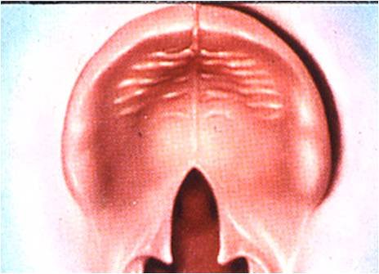
- Eustachian Tube Dysfunction : these patient take antibiotic due to ear infection .
** palatal repair >> mouth must be well opened so they have special type of retractor then palate open then do relief from side the suture
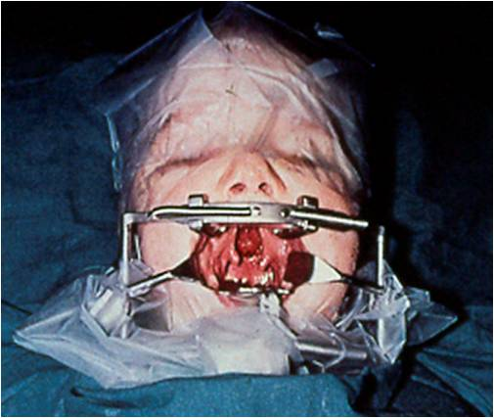
Problem in palatal repair >> after suture it from first time patient come back with fistula so usually those pt need 2 or 3 operations.
-sometime those patient need pharyngoplasty .
Type of flap not important we must now how repair occur .
Good luck
Enas Hawari

