15  Dent-2011.weebly.com | Lecture No.
17/2/2016 | Date:
Ashraf Abukaraky | Doctor:
علاء مطـر | Done by:
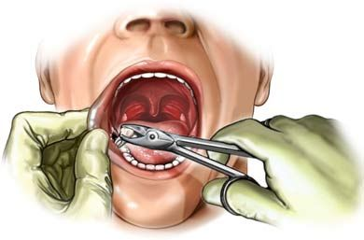
Oral Surgery II
University of Jordan
Faculty of Dentistry
5th year (2015-2016)
Price & Date of printing:

.........................................................................................................................................................................................................................................................
Hand Out
Slide
Sheet

Designed by: Hind Alabbadi
Initial Evaluation and Management of Maxillofacial Injuries

W
hen talking about trauma to the face initial assessment is of substantial importance; this is because maxillofacial injuries are associated with a number of risks to vital structures in the skull and maxillofacial complex e.g. airway, brain, orbits, nerves and sinuses. Furthermore, this area of maxillofacial and peri-oral structures serves an important role regarding appearance and esthetics and injuries that compromise this role will definitely result in negative psychological and social outcomes to the individual. More than 50% of patients with these injuries have multisystem trauma that require coordinated management involving different surgical specialties where each health care provider act as a member of the team.

Etiology:
The causes behind maxillofacial injuries differ from one country or population to the other i.e. the causes of maxillofacial trauma in developed countries are different than the causes in developing countries, for example the more developed the country is the less motor vehicle accident (MVA) is the cause of maxillofacial injuries and the possibility of other causes increase such as sport injury and personal violence injuries.
General causes of maxillofacial injuries:
- Motor vehicle accidents (MVA).
- Falls.
- Violence
- Sports.
- Work accidents.

Pathophysiology:
Facial and maxillofacial fractures can be classified according to the magnitude of force causing the injury into: High impact force injuries and low impact force injuries. This depends on the velocity and the distance/height of the object; the higher the velocity/distance the greater the impact of the trauma on facial structures.

Certain bones in the face can be fractured with a low impact force because of their anatomic features and/or lack of support e.g. nose and zygomatic arch. Other bones require higher impact force in order to be fractured e.g. supraorbital rim, mandible and zygoma.

After the initial assessment of facial fractures each bone is then considered separately i.e. the mandible, zygomatic complex or orbital fractures are considered and managed separately. In the coming lectures fractures affecting these bones are discussed in more details.
Beside fractures that affect single or few facial bones there are certain cases where multiple bones are affected "panfacial trauma"; this description is used when three, four or more of facial bones are fractures as a result of high energy impact force mechanism. It is common for panfacial fractures to be a part of other fractures affecting other parts of the body other than the face. The management of panfacial fractures is more difficult than fractures affecting single bones; this is because when multiple bones are fractured it is harder to find a reference to reduce and fix the bones according to it.
The management facial trauma differs according to the third of the face affected i.e. the face is divided to thirds; upper, middle and lower thirds. In the upper third trauma mostly results in fractures to the frontal bone and/or supaorbital rim, the management for this kind of injury is carried out by maxillofacial surgeons, neurosurgeons and ophthalmologists. Fractures in the mid-face "middle third" affect nasal bones, maxilla, dentoalveolar complex and nasoethmoidal complex. Trauma in the lower

third results in fractures to the mandible and/or dentoalveolar comlex.
When the word " trauma " is mentioned the one should always think about "reduction & fixation" as the type of management followed, reduction can be open or close reduction depending on whether an incision was created to access the bones, fixation can be rigid or non-rigid; rigid fixation is done using mini plates, non rigid fixation is performed with wires or other techniques.

Workup:
Workup is an essential part in the management of facial trauma, particularly when there are injuries. This part of assessment determines whether the patient can undergo a surgery and reveals any medical history issues that require special considerations before starting the procedure. The first test performed is blood test, then imaging studies are performed and the type of x-ray chosen depends on the complexity of the injury; simple injuries can be diagnosed with plane radiography while more complex injuries may require CT scan or CBCT images, CT images are used when soft tissue injuries are suspected while if the injury is limited to the hard tissues CBCT is used.
Prehospital Care:

ATLS:
As part of the initial assessment of patients with facial trauma ATLS-advanced trauma life support- is a worldwide adopted program in the initial assessment and management of patients with acute trauma is used. This is a training program for medical providers on how to evaluate and manage patients with acute trauma. In this program life-threatening conditions are assessed as part of the primary survey where a simple mnemonic ABCDE is used as following:

- Airway maintenance with cervical spine protection.
- Breathing and ventilation.
- Circulation with hemorrhage control.
- Disability/neurologic assessment.
- Exposure and environmental control.

Usually maxillofacial surgeon is not the responsible for this assessment of ATLS protocol unless the surgeon is the first one to encounter the patient; because in any emergency department there is a trauma team responsible for patient assessment before the surgery.

Glasgow Coma Scale:
One of the standards of general patient assessment is Glasgow coma scale; a neurological scale which aims to record the
conscious state of the patient, the patient is evaluated according to the criteria of the scale, then a score between 3 "deep unconsciousness" and 15 "fully awake" is obtained which gives a surgeon an idea about the management, prognosis and complications of the surgery e.g. a Glasgow coma scale of 6 for a patient with facial trauma indicates that the priority is not the surgical procedure but rather the maintenance of patient stability to keep him/her alive. . 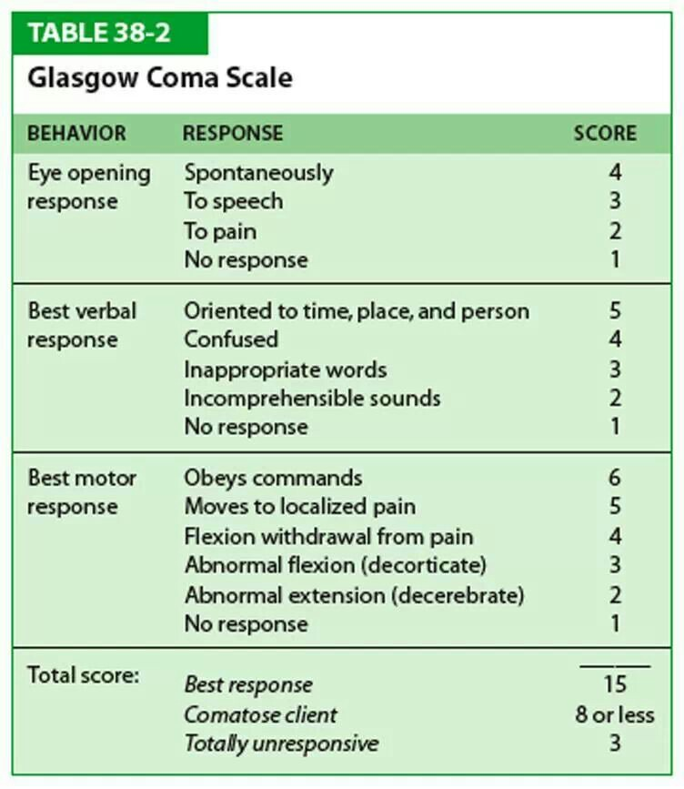

Medical and Surgical Therapy:
During the time of patient assessment and evaluation a general medical therapy is given to maintain normal fluid levels, reduce pain and prevent infection; these protocols may include:

- Administer oxygen and isotonic crystalloid fluids.
- Administer antibiotics for open fractures until their repair.
- Use of pain killers to reduce pain and discomfort.

Complications:
Any type of surgery used to manage maxillofacial trauma may result in complications, such as:
- Aspiration; foreign objects, teeth and even blood can be aspired and may result in many complications e.g. aspiration pneumonia.
- Airway compromise.
- Scars.
- Permanent facial deformities.
- Nerve damage.
- Sinusitis.
- Infection.

- Malnutrition.
- Weight loss.
- Malocclusion; setting a new occlusion different than the patient original occlusion.
- Hemorrhage.
- Malunion of fracture; failure of bone healing.
Note: There are two types of fractures that increase the risk of airway compromise; Postero-inferior displacement of a fractured maxilla and Bilateral parasymphyseal fracture of the mandible where genioglossus muscle pulls a fractured genial tubercle backwards and subsequently the tongue become elevated and may obstruct the airway.

Medical/Legal Pitfalls:
In any trauma case the medico-legal aspect of the treatment should always be considered, common pitfalls in this aspect:

- Failure to diagnose a fracture.
- Failure to diagnose associated injuries.
- Failure to diagnose an ocular injury.
- Failure to account for a missing tooth.
- Failure to obtain appropriate consent.
- Failure to manage injuries.
- Failure to document history.
- Failure to arrange for follow-up.

Outcomes and Prognosis:

In general the outcomes for surgical reduction and fixation of fractured maxillofacial bones aimed to manage facial trauma are good because of the rich vascular supply and the high healing potential in the area of maxillofacial structures.

Certain exceptions include cases with severe trauma and tissue loss that necessitate tissue construction/grafting with more difficult procedure and compromised prognosis. Extensive soft tissue injuries or avulsions and comminuted fractures are much more difficult to treat and may have poor outcomes. Severe hemorrhage from massive midface injuries may result in death.

Note: The subject of this lecture is not included in the recommended book; the reference is on Medscape.com with open access to four subsequent articles about the topics of the lecture including pictures and illustrations.

Initial Evaluation and Management

of Maxillofacial Injuries
Author :Al Haitham Al Shetawi, DMD, MD Oral and Maxillofacial Surgeon

Good Luck

