5  Dent-2011.weebly.com | Lecture No.
26/10/2015 | Date:
Dr.Shayab | Doctor:
Lina Qabaha | Done by:
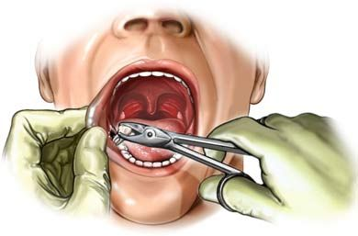
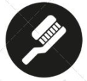
Oral Surgery II
University of Jordan
Faculty of Dentistry
5th year (2015-2016)
Price & Date of printing:

.........................................................................................................................................................................................................................................................
Hand Out
Slide
Sheet

Designed by: Hind Alabbadi

Preprosthetic surgery

It is the surgery that is needed before the placement of the final prosthesis or to prepare the mouth (hard and soft tissues) to receive the final prosthesis. As you know the ridge (either the lower or the upper) is subjected to the physiological process of resorption, and this resorption is dependent on many local and systemic factors (patients with complicated medical history with medical problems that could affect the bone is subjected to bone resorption more than medically fit patients, also patients with existing denture is subjected to resorption more than fit and healthy patients. So the aim of such surgery is to provide adequate hard and soft tissues to receive the final prosthesis either an implant or removable denture.
Before any preprosthetic surgery you have to work and plan effectively with the prosthodontist to reach the best treatment plan and decide which type of surgeries is needed.
The ideal requirements for the oral hard and soft tissues are:
1) no evidence of intra- or extra-oral pathologies.
2) Proper inter-arch relation (in ant-post, vertical and transverse relation)
3) the ideal shape of the arch ( uniform U shape with the vertical components parallel to each others)
4) adequate palatal vault form
5) proper post-tuberosity notching
6) no bony or soft tissues undercuts
7) adequate attached keratinized mucosa in the primary denture bearing areas
8) adequate vestibular depth
9) added strength when mand. Fracture may occur
10) protection of the neurovascular bundle
11) adequate bone support and attached soft tissue covering
So all these are requirements for final prosthesis and these could be different between the types of prosthesis.
The most important step in the preprosthetic surgery isn’t how to perform the technique of the surgery but how to assess the patient or to decide if this procedure is indicated or not _treatment planning and choosing the most suitable surgery and technique as each one has its own indications and contraindications.
The first important thing in planning of preprosthetic surgery is the history or the chief complain, and then we have to see the pt’s expectations, motivation and attitude. So the aim of this assessment is to determine the type of the procedure that has to be done. After that, it’s important to evaluate the pt’s medical condition (as if you have a diabetic pt. you have to explain him the fact that he has a higher resorption rate than competent pts. or a higher ratio of implant failure). This is followed by intra- and extra-oral examination and inspecting any problem that might affect your final prosthetic design.

Excess growth of the tuberosity:
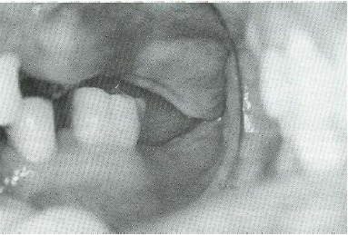
Here there is inadequate interarch space It might be due to excess soft tissue or bony growth and diagnosed by x-rays or clinical mapping( by giving local anesthesia and then probing to measure the thickness of the soft tissue) This overgrowth might reduce the interarch space resulting in interferences in the final prosthesis.
CTs and CBCTs have recently helped in assessing the quality and the quantity of bone before any preprosthetic surgery. And all these methods of examination (history, clinical examinations, radiographs,..) are important to determine your definite diagnosis and decide the final treatment plan and the surgery needed.

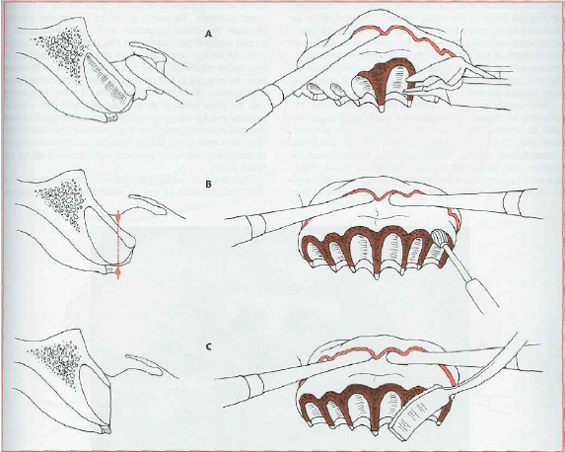
Simple Alveoplasty:
This is the most common preprosthetic procedure. In this surgery we aim to recontour the bone and remove any irregularities that affect the ridge, because they might cause frequent lacerations and excessive bone resorption when the final prosthesis is placed and compressed against the soft tissues. This also might cause instability and poor adaptation of the final prosthesis.
It is about removing bone from the surface or the labiocortical surface of the ridge, this can be done at the time of extraction or after the healing of the socket. This can be done by elevating full mucoperiosteal flap to expose the bone then remove it either by a rongeur or a bur, then smoothen it with a bone file. After that we close the flap with a continuous suture with locking that will insure good adaptation of the tissue over the bone.
By this type of surgeries you may achieve a “U” shaped ridge which is the ideal shape to get the maximum stability of the final prosthesis.
The flap incision should extend beyond the working area. If you expect tearing while making an envelope flap and applying pressure, you may do releasing incisions. No need to reach the basal bone with your releasing incisions, you only need good exposure and access to the working area.
In this procedure we just remove the bone from the labiocortical surface, so one of the disadvantages is that it decrease the height of the bone so such procedure is not indicated for implant.
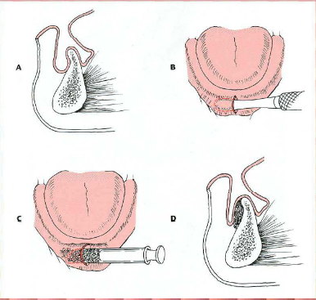
knife edge ridge
if there is adequate bone height we can do simple alveoplasty , but if there is no adequate bone height the best solution here is to graft bone.

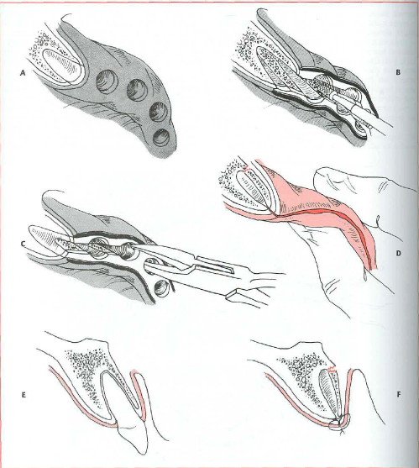
Interseptal Alveoplasty:
Applied at the time of alveoplasty, but in those cases which if you go for simple alveoplasty you are going to reduce the height of the ridge. So we remove the interseptal bone and squeeze the buccal ridge toward the palatal side. You may ease the fracture of the buccal bone by making a monocortical cut on each sides of the bone.
In this type of surgery, you are not removing much from the bone structure, furthermore, you are preserving the attachment of the labial structure and this will decrease the resorption because we don’t do flap. The height of the ridge is preserved but the width is reduced, so implant is contraindicated.
Use rongeur ـــ> to remove bulky bone
Use bur of bone file ــــ> to remove small irregularities.

Boney Exostosis in the Tuberosity area:
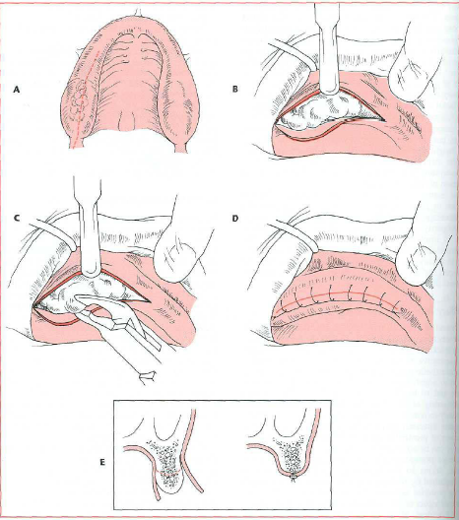
If the interarch space is decreased, you have to remove those exostosis, while if it is increased you have to move toward bone graft.
In the case of excision, start with a cristal incision, and then remove the exostosis with a bur or a rongeur.
Before proceeding, you have to take x-rays to detect the level of the sinus and to prevent any communication.
After any extraction, try to remove any bone irregularities to get a regular final healing ridge. Even if you are placing an implant you have to smoothen the ridge before the procedure, because if you leave any irregularity the threats will be exposed in some areas and covered in others.

Prominent Mylohyoid ridge:
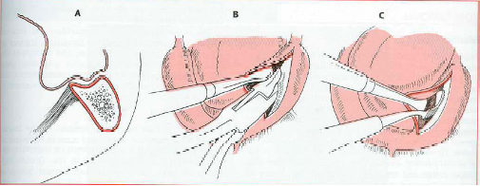
Excessive resorption in the mandible will cause prominent Mylohyoid ridge and external oblique ridge and depression in the middle of the ridge. So if the interarch space is increased you may go for bone grafting, but if reduced you have to lower the floor of the mouth and the myelohyoid ridge.
Do your crestal incision more buccally to avoid lingual n. injury but be careful from any hematoma in the floor of the mouth. Inform your pt. to attend the ER as soon as he feel any difficulties in breathing or swallowing or bleeding.
Lowering the floor of the mouth is more predictable.

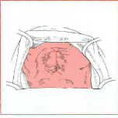
Torus Palatinus:
It varies in size and can be present in dentate or edentulous pts. in dentate pts. it is rarely indicated for removal unless interferes with speech, while in edentulous pts. if it’s presented in the post dam area it will interfere with the peripheral seal of the final prosthesis so it is usually indicated for removal.
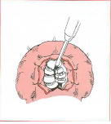
Start with a midline incision with releasing incisions ant. and post. But keep in mind that the soft tissue in the palate is very thin and easily lacerated. Retract the soft tissues with retraction sutures and divide the torus into small pieces to ease its removal without fracturing the bone and making communication with nasal cavity (oroantral communication).
Remove the pieces with a fine osteotome or a bur, then close it by simple interrupted suture.
To avoid hematoma and induce good adaptation you may add a solid liner or conditioner to the fitting surface of the denture over that area.
How to stop the bleeding of the greater palatine artery:
1. Apply continuous pressure for at least 5 min.
2. Do suture distal to the perforation.

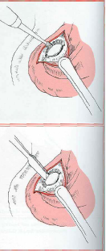
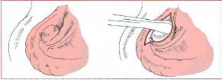
Torus Mandibularis:
It is indicated for removal whenever it is large or interferes with speech or final prosthesis. Start with cristal incision more buccal then direct exposure. If it’s large, don’t use a ronguer to remove it because you may fracture the mandible. So make a trough by a fissure bur between the tori and the lingual plate to separate it, then use chisel to separate it, Finally smoothen the area with a bur or a file and close the incision.
If you do bilateral don’t do continuous incision bilaterally, you have to leave a midline attachment to prevent hematoma which is very dangerous.

Irregular soft tissue

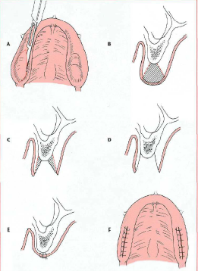
Excess unsupported soft tissues:
If present in the max. tuberosity area, elliptical incision is made(base narrower than the surface), remove the soft tissue then it will heal with primary intention.

Flappy Ridge:
Very high thickness of the gingiva that might reduce the stability and retention of the final prosthesis. This appears most obvious in pts. with teeth in the lower jaw and edentulous upper jaw for a long period, and due to rapid trauma severe resorption and redundant tissue might appear.
We can’t directly decide that this pt. needs excision of the excess soft tissues because in some cases the remaining bone height isn’t enough to receive the final prosthesis, so here we should plan for bone grafting.

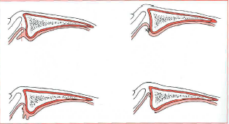
Inflammatory Fibrous hyperplasia:
Also know as denture fibrosis or epulis fissurata. If it is small size and we excised it and achieve primary closure that will not affect the depth of the vestibule, but if it is large and you try to do primary closure you lose the depth of the vestibule. So we just excise it and suture the edges of the incisions to the underlying periosteum and let it heal by secondary intention to preserve the depth of the sulcus.

Frenal attachment
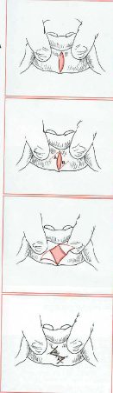
The frenal attachment is prominent fibrous attachment that could be with a narrow or wide base. If the base is narrow, make a diamond incision around it, remove the fibrous tissue with the periosteum and suture it, the first suture must be at the depth of the vestibule. We can use Z-plasty Frenectomy when the vestibule is shallow because it deepening the vestibule.
If the base is wide we can’t use the simple technique because it will reduce the depth of the sulcus. We use the Localized Vestibuloplasty with secondary epithelialization by making a ”V” shaped incision or by laser incision, then remove the fibrous tissue and the periosteum to prevent recurrence with a dissecting scissors, suture the mucosa with the underlying periosteum and leave it to heal by secondary intention.
We can use the CO2 laser to remove any excess fibrous tissues and the area will heal by secondary intention.

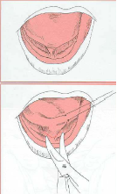
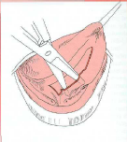
Lingual Frenectomy:
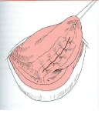
The lingual frenum attaches the tip of the tongue to the lingual surface of the mandible. It’s indicated for excision when it interferes with speech in young children or breaks the seal of the complete denture.
Under GA use the hemostat to compress the frenum for about 3 mins to achieve vasoconstriction, this will compress the blood supply to that area and you will notice the blanching. Retract the tongue either by sutures or by hand and make a transverse incision till you reach the tip of hemostat, undermined the edges of the incision the close. Be aware of the sublingual vessels and the mandibular gland ducts.

Sinus Lifting Procedure:
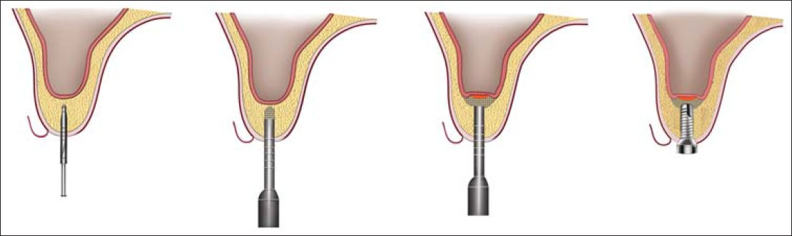
Used when there is no enough thickness of bone under the sinus for implant surgery. The minimum bone thickness needed for implant placement is 8mm (as the shortest implant length is 8mm). so when you have 4-8 mm of bone thickness left, this is an indication for indirect sinus lifting (without a direct exposure of the sinus. If less than 4mm thickness of bone is left, direct sinus lifting is indicated. (4mm is the cut point because it is the minimum height needed for primary stability).

Best wishes,
lina jihad qabaha

