X | Lecture No.
x/x/2015 | Date:
X | Doctor:
x | Done by:
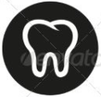
Preventive II
University of Jordan
Faculty of Dentistry
5th year (2015-2016)
Price & Date of printing:

.........................................................................................................................................................................................................................................................
Hand Out
Slide
Sheet

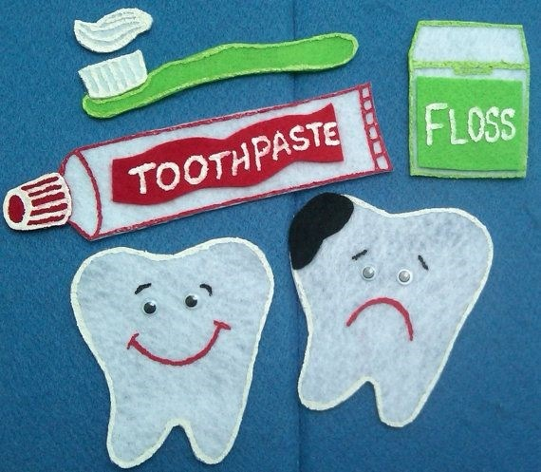
Designed by: Hind Alabbadi

we should always prescribe a CHX mouth wash or any other mouth wash after the prophylaxis which are scaling and polishing
a lot of dentists prescribe mouth washes for patients with gingivitis or any other periodontal disease without doing scaling and polishing which is WRONG
How is CHX administered ?
MOUTH RINSE
which is the most common
0.2% corsodyl
0.12% peridex
actually both concentrations have the same effect and since they have the same effect we prefer to go with the one that has a lower concentration
—
TOOTH PASTE
TOOTH GEL
the active ingredient in both of them is CHX both nearly have the same effect
—
SPRAY
CHEWING GUM
—————————
Anti plaque effects of CHX are DOSE related not CONCENTRATION related
which means the 0.2% has the same effect of 0.12% but if we had to dilute them because some patients can not handle the taste of the CHX their effects are going to be reduced so we need to prescribe them more
optimum dose =18-20mg
0.2% CHX 10ml X2 daily=20mg

0.12% CHX 15ml X2 daily=18mg

CHX ToothPaste Gel

Tooth paste ingredients inactivate CHX
the doctor tried to explain this point saying that usually the active ingredients of the toothpaste like sodium fluoride reduces the effect of the CHX a little bit and that is why when we prescribe a CHX mouth wash we ask the patient to use it after half an hour of tooth brushing using a toothpaste to get a better effect of CHX mouthwash so the CHX toothpaste is a compromised type of the normal toothpaste it means the CHX toothpaste does not contain all the ingredients present in the normal tooth paste
we do not prescribe it for any patient unless this patient needs an extra anti inflammatory anti plaque effect
same effect as MW
concentration 1%
—
Gels 1%
gels do not have most of the ingredients that are present in the tooth paste like detergents or abrasives so they just carry the CHX in a different vehicle
they are mostly used when there are deep pockets and we want to irrigate them using CHX so it is a good choice since it stays longer in contact with the surfaces than MW so they claimed it has better effect in those situations
——
KIN GINGIVAL PASTE
0.12% CHX
0.22% SF
so it has anti inflammatory , anti plaque , anti caries effects
————
CHX spray
mostly used in handicapped patients
but they found that it is better to use gels in trays which are applied by the dentist than using sprays for hand capped patients
————
CHX gum
it is a good discovery since it has the same effect as the mouthwash but it has a less staining effect
so it is a good method in long term users

Is the CHX safe?
yes it is since it has low toxicity and poorly absorbed by the GIT
—————
SIDE EFFECTS
1-brown staining of the teeth which can appear within two weeks in some patients especially the ones who have rough teeth surfaces , old fillings or demineralized surfaces
those staining are difficult to remove especially in the previously mentioned cases which may need a micro abrasion to get rid of the staining
2- supra gingival calculus formation

however the CHX has an anti plaque effect and the calculus does not form without the presence of the plaque but the plaque has high recurrence rate and the CHX increases the ph by suppressing the acidogenic plaque bacteria and the increased ph encourages the calcium and phosphate to participate and form calculus and it depends also on the dose as we said the negative effect of the CHX is dose dependent
1 and 2 are dose dependent
3-taste disturbances
some patients feel burning sensation
4-mucosal desquamation
some patients have ulcers related to systemic diseases CHX can help in preventing the infection but it is painful for them so it is better to combine it with a mouthwash that has anesthetic effect to relief the pain
3 and 4 can be decreased by reducing the conc. but using a larger volume to maintain a clinical efficacy
5-parotid swelling
by mechanical obstruction of the ducts

