12  Dent-2011.weebly.com | Lecture No.
26/12/2015 | Date:
Ahmad hamdan | Doctor:
Afnan abu mazroua | Done by:
Periodontics II

University of Jordan
Faculty of Dentistry
5th year (2015-2016)
Price & Date of printing:

.........................................................................................................................................................................................................................................................
Hand Out
Slide
Sheet

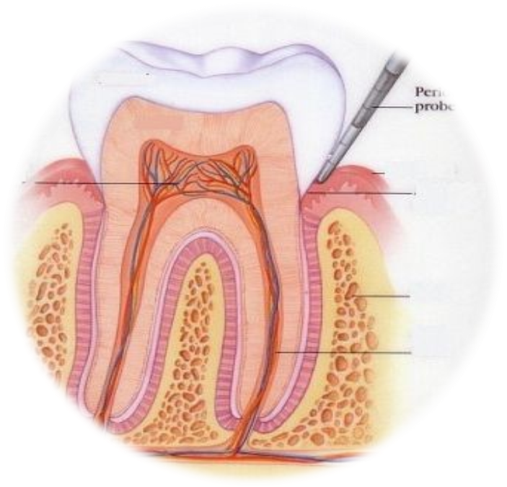
Designed by: Hind Alabbadi
Principles of tissue engineering

Tissue engineering is the dentistry we practice , composite , porcelain , amalgam , all dental filling that we use are types of tissue engineering .
When we talk about cytotoxicty of the dental materials , we are not talking about them stop the use of these products , but because certain effects that are harmful or toxic for the cells that may be present , and may be in the future we will discover that they have worse effect , but meanwhile at lest we can say that there is a certain gap between what is published and what are the results that you obtain from certain types of studies .
- As literatures say that amalgam by 2020 should stop being used , methacrylate that we use a lot _as part of composite _ has certain degree they are cytotoxicty or carcinogenicity , but the concentrations that we use in dentistry are safe . even so there is a minimal risk of it . and this happened recently .

- rather than dental materials we have bone grafts , membranes , implants , block grafts . bone grafts from iliac , symphesis are associated with high morbidity , with good success rate , but there is a risk of not having good graft integration , because it depend on lot of factors ; hygiene , smoking , and other factors that we can’t control , so at the end there are successful techniques , but still they can be associated with certain degree of risk , they are aggressive ,and difficult to learn such as sinus grafting , direct sinus lifting , distraction osteogenesis etc ..

- all this way of thinking had led to a change in the scientific community generally , and in dentistry specifically , (it started in other domains before dentistry) .

- there is an articles that was published in 2014 , it reflect what happened in the way of thinking , the article says : there was a very naive belief that the materials were topically inert , and it’s highly suggested now that this is misleading interpretation , because the materials could indeed change physically and chemically following implantation . any chemical materials change , all dental materials are affected by certain factors that influence it’s chemical or physical integrity , like wearing effect on composite . So biologically speaking no material can be considered as inert , which means that we have to start to look for biological alternatives or solutions for our biological problems .
This implied a shift or evolution from mechanical ( surgical removal of biological issue and replace it with other material ) to biological solutions , this employs coordination and a team work between multiple domains ; clinical dentistry , genetics , developmental biology ,bioengineering , biotechnology , physics , molecular biology , biopharmacology , chemistry , and computer sciences .

In 70th no one though that a doctor would go to an engineer to solve a problem in femur for example , that a doctor would go for an IT specialties to create a specific algorithm for specific criteria of a disease , or to make a software for 3D design of a molecule that carry specific growth factor for a cell in order to compact cancer , which are happening right now .
- so we have a shift from using medical devices and bone tissue graft to more complex approach that utilize bioactive , biodegradable synthetic or natural scaffolds combined with cells and biological biochemistry to functional replacement tissue in a diseased area .
- Regenerative medicine started in late 70 s , first 20 years they though if there is lost bone and they brought bone _ from other human being or other species _ or synthetic materials , it can replace the lost part . now we talk about more complex ideas , more sophisticated way of thinking .

all the previous led to the development of biotechnology ,
biotechnology is the summation of methods and techniques that are using as tools living organisms or their parts for specific proposes , it’s used in different domains ; food production , agriculture , pharmacology , medicine ( genetically modified food ) . one of medical examples is surgery by robots , and computer guided implant as a dental example.

**when you talk about biotechnology , you can get anything you want. It is very interesting.

- one of biotechnologies field is tissue regeneration . one of the examples an experience were a scientist implanted a cartilage cells subcutaneously of a nude mice ( nude mouse : are mouse that were modified to be immunily compromised by birth , which is a research method that was used a lot in pharmacology , biology , etc ) , in the experience they were able to create or reproduce the whole ear from tube cells . this was a result of a 35 years of hard work .

so what is regeneration ? regeneration is reconstruction of function , structure , and esthetic .

* The origin of regeneration :
- one of the histological stories that is present in Torah , a living creature that has 7 heads , you can’t get rid of him unless you cut all the seven heads together , if you cut only one head , it will regrow . due to the fact that no human can imagine things that

are not present , this indicate that this creature could be for real , and that the regeneration originated from nature .
- Hydra is other example of a microscopic organism , if you cut it in to two halves each half will give the other part .
- salamanders also have the capacity to regenerate themselves
- sharks have more than one set of teeth and have the capacity to regenerate their teeth through out their lives
- rodents have continuously developing crowns , by having continuously present external and internal reduced epithelium .
**All these are examples of natural spontaneous regenerations .

The aim of regeneration is not to have a perfect body , not to live endlessly , it is all about living long healthy life that can aid in success .

All the previous were the basics of regeneration in general , now we will talk about regeneration in dentistry.

Regeneration is to restore morphology and function of loss tissues in a way similar to that occurring during development . if it is not similar to what we have during development regeneration won’t be controlled ,because the factor responsible for regeneration is the same responsible for cancer .

Principle of regeneration : to mimic what happen during development with some differences
In development >> cellular condensation > spatial reorganization of cells > progenitor cells > differentiated cells .
In regeneration >> blood clot formation > inflammatory reaction > granulation tissue > progenitor cells > differentiated cells .
Inflammation is important in regeneration because no tissue loss happen unless there is a problem ; bacteria or necrosis . so the body try to clean and build a scaffold that contain factors, the factors hopefully attract all important cells , the cells make spatial organization and progenitor cells . but what happen in reality that during scaffold formation , we have other uncontrolled events which make healing more difficult . ( the easy healing is the healing of skin )

Tissue engineering :
- all what we do in our clinics are primitive ways of practicing tissue engineering ; fillings , bone grafts , implants .
tissue engineering is interdisciplinary domain ,involving biological sciences , and principles of engineering aiming to develop biological substitutes in order to restore , maintain and ameliorate tissue function and morphology . this definition was written in 1993 and it is still being used until now . the scientists who discovered this definition they established the very basic principles of what is now a day is accepted as separate domain .

it is an approach that utilizes specific biodegradable synthetic or natural scaffold , as well as advanced molecular techniques in order to replace tissue function . as we said last time some materials are taken from hip or other parts , other are synthetics , all these in some how practice tissue engineering . composite is an example of tissue engineering because when it started they studied the wearing , tensile strength and other properties of composite that make it similar to tooth structure . this is tissue engineering ; trying to engineer something to look like the lost tissue . as closer you are to the nature , the better the result you get .
- the goal of tissue engineering is functional biological structure , to achieve this goal the cells must be instructed to differentiate , and to and to receive positional cues , and to synthesize the appropriate extracellular matrix molecule in overall shape and dimensions of a diseased or missed tissue or organs , now it become complicated .

- components tissue engineering:
- stem cells
- scaffold
- signaling molecules .

- tissue that can be engineered until now are the cornea , cartilage ( to certain extend ) .

periodontal tissue engineering :
we talk last time about emdogain , PRP growth factor ( platelet rich plasma ) , and about bone grafting .
the ultimate goal is to make all the three factors work together to regenerate the tissue that we want . but is it enough ? we said last time , if I have a scaffold , cells and growth factors , and we said that certain factors in specific time can inhibit , on other time they can induce

BMP 2 ( bone morphogenetic protein ) is acquired for osteoblastogenesis _ stem cell to differentiation to osteoblast _ to start , then BMP 2 stop working until the cell reach apoptosis , it is the same factor that initiate the life of the cell and the same factor that end the life of the cell .
IGF2 ( insulin like growth factor ) is the same mandatory to initiate the bone formation and in the apoptosis .
So in addition to these factors I should understand the time sequence , and the appropriate environment .

Best of luck seniors :D

