10  Dent-2011.weebly.com | Lecture No.
22/12/2015 | Date:
Abeer Hadidi | Doctor:
Rawan Abu-Ghazzeh | Done by:
Radiology II

University of Jordan
Faculty of Dentistry
5th year (2015-2016)
Price & Date of printing:

.........................................................................................................................................................................................................................................................
Hand Out
Slide
Sheet

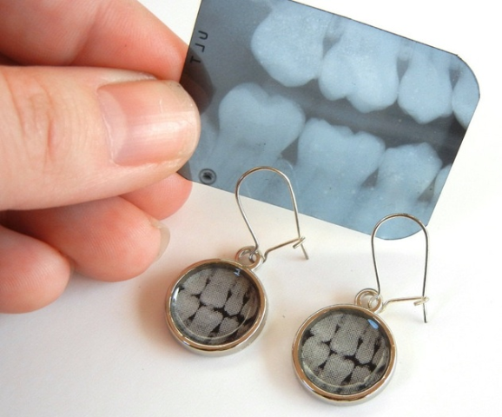
Designed by: Hind Alabbadi

Cysts
As we all know, a cystic lesion is a pathological filled cavity that is lined by epithelium. They arise from different cellular lineage and they have different reasons why, they also have different locations.
However, they have things in common such as:
1-periphery, where we expect a cyst to have a well defined structure. Ideally if it is not infected, it should be corticated.
All cysts are well defined, most cysts are corticated unless a secondary infection took place.
2- Most of them are round, oval, unilocular. Because most cysts expand by osmolarity, just like filling a balloon.
In the book, they might mention that some cysts are multilocular, and the Dr thinks they were referring to KCOT (keratocystic odontogenic tumor).
But most of our common cysts are going to be round, unilocular and single expansion pattern. Most of them are radiolucent, and sometimes dystrophic calcification will take place if they stay for a long time. A dystrophic calcification isn't caused by a mixed density lesion because as we said, a mixed density lesion is a lesion that actually produces a calcification. But when it comes to the common cysts, its just a cyst that lasted for years and years that lead to dystrophic calcification that will cause displacement in teeth or canal... etc.
It's more of a benign type of behavior. So it will cause displacement, and if it caused resorption it would be a horizontal resorption. So we would think of it like any benign lesion.
So our classification will be:
Odontogenic/ non-odontogenic/ pseudo cysts

Odontogenic cysts:
• The most common one is radicular cyst
• Followed by residual cyst
• Dentigerous cyst
• Buccal bifurcation cyst
• Lateral periodontal cyst
• Glandular odontogenic cyst
• KCOT
• Calcifying odontogenic cysts

Non odontogenic cysts :
• Nasopalatine duct cyst
• Nasolabial cyst
• Dermoid cyst
Pseodocysts:
• Simple bone cysts
• Aneurysmal bone cyst
• Mucous retention phenomenon

Radicular cyst:
A common cyst, it is an inflammatory process that is affecting the periapical area of a non-vital tooth. Sometimes this inflammatory process could actually be just a simple widening in the PDL space and sometimes it’s more resorptive pattern that could be a granuloma.
Sometimes an inflammatory process affects dormant epithelial cells in the area such as the cell rests of malassez that will lead to a cyst.
Most of the radicular cysts are asymptomatic and associated with non-vital teeth unless there is an association of a superinfection then it might be painful or associated with a discharge.
As we took before, how can we can differentiate radiographically between a granuloma and a cyst?
By the size, but as a matter of fact we can't, the answer for this question is that we cannot. But we can say that most probably it is this vs more probably it is that based on size. As it grows larger, most probably it is a cyst.
Also by the margins, because as we agreed, cysts are well defined and corticated. Granulomas don't have a cortical margin.
Differential diagnosis:
Anything that is associated with a non vital tooth might be granuloma. The idea is that when you do a vitality test and the tooth turns out to be non-vital, this cuts off a lot of things on the list. It is unilocular so by definition the epicenter is often around the apex of a non-vital tooth.
We see them more often in the maxilla, because the bone there is more soft. Just like any cyst, it is well defined and corticated. It can cause displacement, remodeling and sometimes expansion of the cortical bone.

Residual Cyst:
If a dentist extracted a tooth without taking a PA radiograph, and that tooth happened to have a radicular cyst, this same cyst will be called a residual cyst as the dentist removed the tooth and left the cyst in its place. So it is not different, it is technically in the same place and has the same look and it also has the same effect. Mostly because it is left for a longer time, so more complicatins take place. It is usually not discovered unless it becomes superinfected or if the patient needed prostho tmt and we took radiographs for him.
So that's one of the main reasons for take pre operative radiographs.
Now we will move from the inflammatory cysts to the developmental cysts.
Dentigerous Cyst:
It arises around the crown of an impacted tooth which are the teeth that are usually associated with dentigerous cysts.
If we think of syndromes that have more supernumerary teeth that happen to be impacted, then we might see dentigerous cysts in these syndromes.
Since it has to be around the crown of an impacted tooth, it has a characteristic appearance of being attached to the CEJ. Because it is simply a cystic degeneration of a follicle so it has to be attached to the CEJ. so if we see something surround the whole tooth, then we shall think of something else, as the dentigerous cyst surround only the crown.
Radiographically its very important to find CEJ to CEJ correlation because there are multiple lesions that can be located around the crown of an impacted tooth but not typically started from CEJ to CEJ

How to differentiate between a dentigerous cyst and a follicle?
- Size, which is very important. The follicle does have a margin so we can't depend on that. The cut off is 1 cm. So it is something that is a little bit larger than 1 cm.
BUCCAL BIFURCATION CYST :
Is a dentigerous cyst that is bilaterally and buccally on a developing 6, they are at the bifurcation area so that’s why they are called buccal bifurcation cyst. It is technically a neuro cystic degeneration of the residual of a follicle.
- It takes place in very young patients (younger than 20),
- Usually associated with the first molar.
- Usually Bilateral
- Sometimes it prevents the eruption of the 6.

What happens is that it is at the buccal bifurcation and it is growing and pushing the roots to one side, and the crown is pushed to the other side which causes tipping movement of the molar. The whole long axis of eruption will be changed.
Why is it interesting?
Because these are not impacted third molars that will be extracted with their cysts, this is a first molar that I would really like to keep especially in a young individual. A small opening is made and the tooth is left to erupt, the cyst will decrease in size until they are able to remove the cyst without sacrificing the tooth.
It is the location that actually helps the identification of a buccal bifurcation cyst.

Lateral Developmental Cyst:
t is the second type of developmental cysts that arises from cell rests of serres.
- it is asymptomatic.
- Most of them are in the mandible and usually in the premolar area.
- It is a teardrop oval shape, it usually starts very small.
- associated with a VITAL tooth.
Someone asked How to decide if it is a lateral periodontal cyst or periodontal bone loss?
The answer is that there is bone above it.

The dr showed this case, I took the information regarding this case from last year's sheet as the dr mentioned more details to make it more clear.

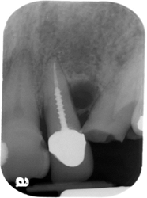
This radiograph is very interesting I can see root canal treated tooth with a post and lateral radiolucency it could be lateral radicular cyst because of a vertical root fracture (after the post) and this might need even more 3d imaging or even surgical exploration to see if the tooth is fractured, if not all I need to do is to curette this small lateral periodontal cyst.
ü It is much easier to diagnose if it’s a virgin tooth, I will make a vitality test to diagnose it ,if non vital then it’s a lateral radicular cyst so RCT and follow up, if vital curette the lateral peroidontal cyst and that’s it
ü Also if I was lucky to see a lamina dura this will help me to differentiate between a lat periodontal cyst(originated from cell rest of serres/developmental origin) and a lateral radicular cyst(cell rest of malassez/inflammatory origin)

Botryoid odontogenic cyst
There is a variance from the lateral periodontal that is multilocular so it became more aggressive and is called Botryoid. It is grape like. Most of them are asymptomatic but sometimes slight swelling might take place.

Glandular Odontogenic Cyst:
It's very interesting and rare, the dr saw only 2 real cases.
- They are very typical to the mandible, anterior of the mandible.
- they are really aggressive they don’t really behave like any typical cyst. However, histopathologically they are cysts.
Why are they called glandular?
Because they contain some salivary gland tissues.
That’s why even in histopathology, one of its differential diagnosis is mucoepidermoid carcinoma which is very interesting.
This is a cyst that’s not really behaving like a cyst, it is too aggressive of a cyst.
We will mention later that the mucoepicarcinoma in some variance especially infrabony it really behaves like a benign tumor sometimes from a radiographic perspective.
This cyst is really really rare, and if the dr saw it she will go for a biopsy because she will be thinking more of central giant cell granuloma. Or she might think of a benign local aggressive tumor.

KCOT:Keratocystic Odontogenic Tumor
It started as a cyst then it was classified as a tumor and then it was recently classified as a cyst back again.
- Clinically it has more aggressive features.
- Usually painless
- Has an antero posterior expansion

That’s why there is no swelling, it takes place later on.
It travels along the bone marrow spaces, when it becomes bigger, it can cause expansion, it can push the inferior alveolar nerve canal inferiorly. It can cause some resorption in teeth (very rare).
It has size variation, so we do a vitality test and if the tooth is vital we take a biopsy.
If we have a unilocular corticated well defined around an impacted tooth then it's one of three:
1- Dentigerous cyst
2- KCOT
3- mural ameloblastoma
If we see multiple keratocysts, I have to think about Basal cell nevus.
Basal cell nevus syndrome (Gorlin Goltz) syndrome :
multiple KCOTs, they come earlier in life and they are more aggressive. Basal cell carcinomas of the skin with rib abnormalities and skull features.
It is important because these kids must be followed up really well.
The dr mentioned a little girl that had basal cell, by the age of 7 she already had 3 or 4 operations to remove keratocysts. Those keratocysts don’t cause any buccolingual expansions, instead they expand anterior-posterior.
Sometimes you take periapicals and these PAs aren't really showing what's going on until they grow enough and you start taking safety margins. It's kind of a serious situation from a dentoalveolar perspective and from the basal cell carcinoma issue.
Basal cell carcinomas are not the worst, because they are accessible and if you get them really really early the survival rate is really great. So it is very important to know what you are dealing with.

GORLIN CYST ( CCOT):
It is one of those mixed density lesions, it is very interesting but not that common. It has the characteristic of ghost cells. It actually makes its own calcification, the calcification seen in the Gorlin is dental. So it is an official mixed density.

They are common between 10-19 years old and in the 60's. In general they are not common enough to get a very good statistic profile.
The dr shows a case of an impacted tooth surrounded by a lesion but this time it is the calcification that actually changes the whole differential diagnosis.

NON ODONTOGENIC:
Nasopalatine Duct cyst:
Heart shaped between the two central incisors, it’s a cystic lesion of that foramen.
How to differentiate between the foramen and the cyst?
If it is between 6-8mm then it is a cyst, its actually a good cut point
The other thing is what is it doing to the teeth, if the centrals are in their normal long axis then you are doing good, if the centrals are pushed even if the size is small, the I will start thinking it might be cystic.
Why is non odontogenic? because the epithelium doesn’t contribute in the tooth development in embryology, there is usually swelling in the area usually the anterior palate. If there was drainage, the patient might feel a weird taste in his mouth.
Where does the heart shape come from?
From the nasal septum, superimposition takes place for the anterior nasal spine.
It is an interesting characteristic feature in order to differentiate.

Nasolabial Cyst:
soft tissue cyst, it cannot be seen on a typical plain radiograph. If I suspect a nasolabial cyst, I should do clinical examination and then go for 3D imaging, MRI or CT if I need it.
One of its differential diagnosis is cellulitis due to a non-vital thing.
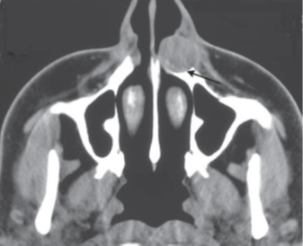
Looking at this radiograph we can see that on one side the nose is open and on the other side the nose is pushed. If I took a panoramic radiograph for this, we are basically gonna see nothing.
So soft tissue lesions are not seen on plain radiographs.

Dermoid Cyst:
Its actually a cystic teratoma. What is a teratoma? They are tissues that contain all the layers of embryology in an abnormal area.
It could be seen with empty spaces, its for sure a soft tissue lesion so it also needs 3D imaging. Its filled with it depend on what skin appendages do you have. There is dermoid and epidermoid that slightly differ from each other. They are really really rare in the oral cavity, they become most common in the nail spaces (not sure I didn’t hear it well). It's usually in young people (25 years).
Simple Bone Cyst:
A pseudo cyst. Why? Because it lacks te epithelium. So it's an empty cavity, it sometimes contains a tiny amount of fluid with no significance. The cause is hemorrhage with vo complete organization of the clot. The tmt would be to induce hemorrhage.
In literature it is mentioned that they can heal by themselves. That’s another thing to think about.
They are seen in young kids and are well known for their undulating border. It usually doesn’t cause any displacement or resorption. The book might mention that it can cause resorption but the dr doesn’t agree.

Aneurysmal Bone Cyst:
On the contrary an aneurysmal bone cyst is the most expansile cyst that happens in young individuals, its painful because it causes stretching to the periosteum. It is filled with vascular pools and blood. Most of them are younger than 30 and most of them are females, they are one of the giant cell lesions. It is unilateral.
A needle aspiration is usually done before a biopsy

Mucous retention phenomenon :
Basically a thickened mucosa at the floor of the sinus. very dynamic disease ( related to allergies, seasons changes ) it disappears by itself and reappears again.
It doesn’t affect any sinus structure.
In mucous retention phenomenon, the floor of the sinus is intact with no changes in its shape or position.
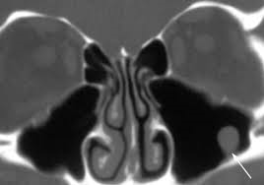
I can see the floor of the sinus intact then up to it I see this dome shaped and no cortex above it because it’s a soft tissue lesion but if I see the cortical border(floor of the sinus) above it then I would think of other odontogenic stuff
You have to know that it's not pathological.
It is isolated and only on one sinus with typical dome shape. It will disappear in few days.

I included some information from last year's sheet to make some points more clear.

GOOD LUCK
Rawan Abu-Ghazzeh

