6  Dent-2011.weebly.com | Lecture No.
//2015 | Date:
Abeer Hadidi | Doctor:
Ashraf saed faraj | Done by:
Radiology II

University of Jordan
Faculty of Dentistry
5th year (2015-2016)
Price & Date of printing:

.........................................................................................................................................................................................................................................................
Hand Out
Slide
Sheet

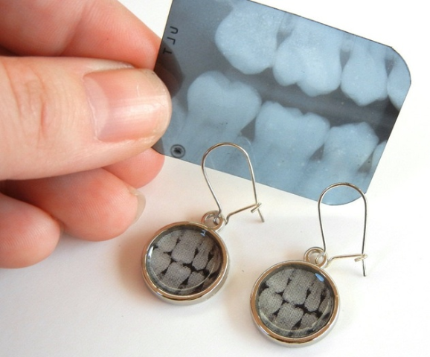
Designed by: Hind Alabbadi

bone and metabolic diseases effects in the jaws
Crc 2

1
It is a panoramic radiograph in adult patient. We have both right and left symmetry. Bilateral radiolucent lesions. On the right and left side on the posterior mandible, the lesion is large about 4-5 cm and it is ill defined.
Can we trace the lamina dura or cortices in the RX ? No.
We may think of generalized disease that affect the bone quality systematically ; for example, hyperthyroidism but why not hypophosphatesia or hypophosphatemia, because of brown tumor lesion which is related to hyperparathyroidism.
Generalized radiolucent: hyperparathyroidism
Localized radiolucent: brown tumor lesion which

2
It is a reconstructed panoramic radiograph. What is the difference between reconstructed and typical panoramic Rx? Reconstructed panoramic Rx is sectioned from 3D cone beam radiograph and there are no ghost, no spine, and no superimposition. We can see multiple circular radiopaque lesions on bone surface bilateral in the mandible as cotton wool appearance. What is the canucular bone disease that cause this lesion? Fibro-osseous lesions such as fibrous dysplasia, cemento-osseous dysplasia ( periapical cemental dysplasia and florid osseous dysplasia). Why not fibrous dysplasia? Because the bone loss in fibrous dysplasia is ill- defined and unilateral. Why no cement-osseous fibroma? Because of the appearance, it should be one and large that get beyond the boundaries and we can see the gross bone remodeling around the lesion (sclerotic border). It is the appearance of Florid cemento osseous dysplasia.

3

It is a reconstructed panoramic Rx showing lower permennet teeth with the rest edentulous area. The lower ant teeth show radiolucent around their apex. CT scan which panoramic Rx is sectioned from reveals well defined unilateral mixed lesion that is highly expandable because its push the floor of the nose and the sinus. Extended from the upper centrals to the left premolar ( size around 6-7). It does not affect the incisive canal. Fibrous dysplasia is wrong because it is well defined lesion. From dental health, it is obvious that the patient is not young. If the patient is young, you will see more radiolucent lesions. This is a typical appearance of any benign tumor "Cemento-ossifying fibroma". The doc was concerned more about the lowers because they are ill-defined, but with follow up, they were inflammatory in origin (chronic periodontitis).
4
It is a panoramic Rx for an adult patient. Many impacted teeth that is not related to mixed dentition. Usually, these impacted teeth are associated with physical impairment (bone quality, supernumeraries, path of eruption). Bone quality in the pic is really opaque, which is related to systemic disease called osteo-petrosis. These patients are at very high risk to infection because the bone has low vascularity. Radiolucencies around the apices are starts of inflammatory process. Management, we don`t extract just make sure there is no complication. Why not cherubism?
There is a panoramic RX showing bilateral multi loculer lesions. This is so typical for cherubism. Q: why ant displacement is not seen here? Because the pic is taken at follow up stage after treatment. At some point, all features appear then the patient undergoes treatment. Honestly, the lesion is so typical for cherubism. If it is unilateral, we may think of ameloblastoma, and chondosarcoma. Cherubism is never painful.

5
It is a panoramic Rx for 6 years old patient in mixed dentition stage. Let us compare the right and left mandible. The right is small and bulky with ILL DEFINED radioopace lesion unilaterally. Iinferior alveolar canal not look affected. Shifting our thinking from odontogeneic infection to a bone disease. So, what I can think about bone disease.>> 19. Fibrous dysplasia is a bone disease that genetically effect is there whether it has clinical presentation or not. It starts radiolucent then it became mixed then radiopaque stage.
6
20:40 <>>< It is a panoramic radiograph. There is a TARGET lesion on the periapical area of the molar and resorption of the roots. Is this a very typical for cementoblastoma? Cementoblastoma is a radiopaque lesion looks like a golf ball and they are associated with lower first molar, sometimes premolar in young individual that associated with extensive root resorption and pain. Nothing else could look like this. Cement-ossous dysplasia? No because cement-ossus dysplasia is not associated either with pain nor root resorption. ><>> 23:10 to 24

