A clinical appraisal of the scientific literature
You should be able to read a scientific article and if you want to be a good dentist or specialist you are going to read beyond the handout. You need to be able to look at the paper and say if the information in this paper is something I want to use or this is something that I am going to ignore.
Outline:
1-Componants of a scientific paper.
2-Types of studies.
3-The hierarchy of evidence.
4-Common mistakes in the literature.

1-Componants of a scientific paper:
This is just basic and every paper should go throw this sequences:
1-Intrroduction/ background.
2-Materials / Subjects & materials.
3-Results.
4-Discusion.
5-Conclusion. ( 99.99% of us only reads this part , and it's wrong :P )

Introduction :
It has information about certain topic.-
-It's outline of previous research related to present study (to do something different).
-It leads to aims and objectives of present study.
e.g. a study taking about a new type of fixed appliance and nobody else ever done this, so this is my objective and I am going to look at it.

-It is clearly stated goals or objectives.
e.g. a study taking about " a type of appliance which is better than other type in a tipping movement" this is a clear objective.
If the objective said that "this type of appliance is a better fixed appliance in general" this is not clear one and you know that it is impossible that you can statistically approve it; because it needs multiple studies to do it.
-Hypothesis – Null :
All statistical tests are based on Null Hypothesis, if the difference is significant so the null hypothesis is rejected, if the difference is insignificant so the null hypothesis is accepted (true).
e.g. relationship between sugar intake and caries incidence. Null hypothesis is: No difference in caries incidence between patients who take a high caries intake and patients who take a l low caries intake.
Question: If the null hypothesis is rejected does that mean there is a difference? No, it's not necessarily. The difference in caries between a two groups is due to more than a chance!!
مش بس صدفه هو في سبب !!

Ethical / Internal Review Board Approval
Anything that is done on patients needs approval. Approval for records taking, asking opinions and any treatments.
Notes:
* I need to get approval to ask you; because the question may be not appropriate!!
زمان كانوا يجيبوا المرضى ويصوروهم Ceph بدون Approval أما الآن فهو لازم وجود الـ Approval ووجود غرض دراسي للتصوير .
*

Materials / Subjects:
-This is one of main area in the study; a lot of studies don't go correctly throw it (a lot of errors)
-A detailed description of materials used including band names.
-A detailed description of how the sample was selected.
- Power calculation.

Sample selection
You need to apply this study to a population; the population does not necessarily mean the entire world. You have to identify what your population is, for example: my population is 5th year students at university of Jordan in the faculty of dentistry.
How the sample is selected? Is it representative?
By random sampling, that’s mean every person is the population has similar chance and if i chose someone it will not affect the chance of others.
For example: assume that the population is our class, so the random sample is every 3rd student or the students who set on an odd number.
patients that attended Jordan university hospital -orthodontic clinics is a non random sample. Or patients have a successful treatment also non random.

اختيار الطالبات المحجبات فقط في القاعة او الطلاب الي عيونهم ملونه ليست Random sample

When I can't do random sampling I go for convenience sample, for e.g. I selected a convenient sample of a patient attended my clinic in the hospital and I randomly place this fixed appliance on every 5th patient, so here the sample is not random but the treatment is random and this is called: convenience sample done on a treatment method of using a fixed appliance.

Power calculation:
You may read on a study that " Although the results of this study are statistically significant but they are Not clinically significant.
بعد دراسة طويلة وعريضه بتطلع النتائج clinically significant بس الباحث بقرر أنه لأ .. أو العكس . وهذا الشيء حدوثه نادر لأنه غالباً لا يحدث في الدراسات القوية بسبب استخدامهم للـ Power calculation

The idea of power calculation is about calculating sample size .
When you try to look at the difference between two things and the sample size of each group is 5 people it's too small and not power; because the sample size is too small. If you do a T test (which compare one group to another ) you need at least 20 person in each subgroup .
بتبدأ تحط 20 شخص بآخر Subgroup وبتطلع للـ المجموعة الفرعية الي فوقها حتى توصل لنهاية المجاميع الفرعية وبهيك بتحسب عدد الSample الكلي. (انظر للمخطط للتوضيح , لو جمعنا من تحت بفوق بكون مجموع ال sample الكلي هو 140 فرد
20

20
20

20
20
20
20

-In power calculation there is a formula (you don't need to worry about it) and it is based on the minimum clinically significant difference.
For example: you are doing a study about caries risk and sugar intake, your starting point is that the clinical significant need to be 5 DMFT ( decayed, missing, and filled teeth ) so you based on a clinically significant deference and you can use a graph like this :

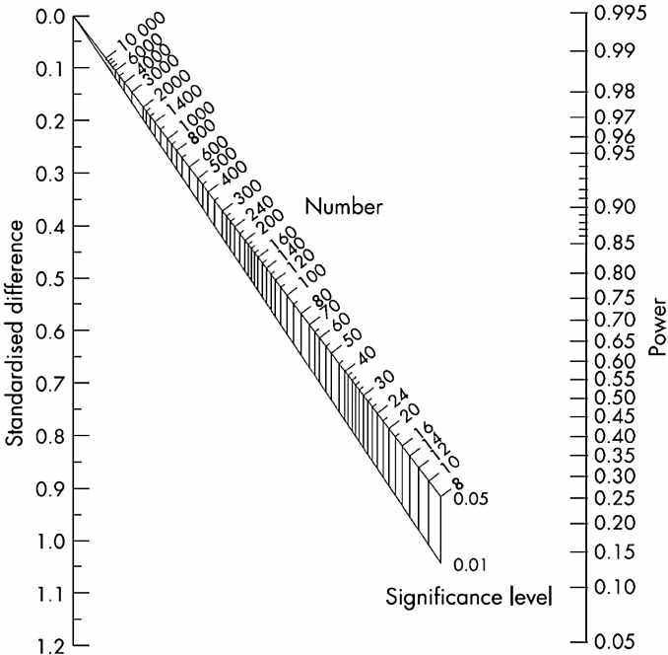

It's based on your clinically significant difference.

Graph for calculating sample size or power

Look at the graph above and note that:
The power of clinical studies needs to be around 0.8 = 80% which is about 120 subjects. When the power goes down the number of subjects (sample) become less and as the power goes up the sample size increase. So again our calculation based on a clinically significant difference.

Good Luck Seniors
Part 1

