Assessment of patients and treatment planning
*Patient selection for implants
Age doesn't appear to be an influence in patient selection nor a large number of chronic diseases such as diabetes,cardiovascular diseases,patients with long-standing steroids,etc.. so in each case you have to take precautions throughout the entire surgical prodecure and post operatively the same as any other patient.
Preoperatively, all local pathological conditions in any of the hard or soft tissues of either jaws should be treated before starting any implant treatment. Usually for observed lesions in soft tissues , you need to wait for 3-4 weeks while in bone you wait for one month so that tissues will have enough time to heal prior to fixtures placement.
Implant team:
There should be an implant team called "Implant Joint" that consist of oral surgeon ,prosthodontist,trained technician and oral hygienist.
Patients general assessment:
1-patient's complain
2-medical history
3-psychological assessment
4-social history
5-dental history
Local assessment:
It contains of extra-oral and intra-oral examination.The intra-oral assessment should include:
1-Type of mucosa :In the past,they preferred keratinized mucosa for implants because of its high success rate but nowadays ,both keratinized and non-keratinized can be used as we depend more on bone quality and the oral hygiene of the patient.
2-Health of remaining dentition and periodontium
3-The alveolar ridge form and shape
4-Related mucosal soft tissue attachment
5-Inter-arch space and inter-occlusal space horizontally and vertically
There are many modalities to help in assessment of candidates for implant treatment such as radiographs to screen for any retained root,unerupted tooth or pathological condition like periapical granuloma especially in partially edentulous patients.
Standard diagnostic views:
1-Panoramic x-ray(OPG) :used as routine prodecure for any implant patient.It is used to determine the length of the fixtures roughly using metal spheres (5mm) with surgical stent.
Length of the implant= actual sphere size (5mm) * bone height on x-ray
sphere size on x-ray
_You should take 2 mm margin of safety from any vital structure.
_magnification should be 1:1
But nowadays we prefer CT scan to determine the exact length of the implant.
How to use panoramic x-ray to determine the length of the implant?
You take a primary impression then you determine the position of the implant taking into consideration the space required between 2 implants and between an implant and a tooth.After that,you construct a surgical stent which is a translucent self-cured acrylic.Then you fix the metal spheres on the stent with sticky wax.Take the radiograph with the stent inside the patient's mouth and do the calculations according to the equation mentioned above.
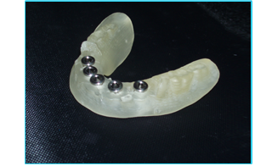
Surgical stent with metal spheres
2-Lateral cephalometric x-ray :to determine the inclination of the residual ridge especially in the mandible.It was used in the past.
3-Serial periapical x-ray (adjacent to the edentulous area): in partially edentulous patients to scan the whole teeth regarding the periodontal status.
Note:All diseases in the oral cavity can be transmitted to the implant except "CARIES". Gingivitis and periodontitis can be transmitted to implants as mucositis and peri-implantitis.
4-CT scan and Cone-beam CT scan

Additional assessment:
1-study cast mounted on articulators with teeth-wax up whether for single implant or multiple implants or full arch.
2-Magnetic Reasonance Tomographic: was used in the past but it is more useful for soft tissues .
3-Multiple Planner Computerized Tomography :very expensive,used mainly for plastic surgeries.
4-Ridge mapping: it is a simple prodecure to assess the width of the bone with the help of conventional method,osteometer or electronic device.
How to do ridge mapping manually ?
1-anesthetize the area you need to place your implant in.
2-use reamers or endodontic files with stoppers.
3-insert the reamer or the file from the three sides (buccal,lingual and from the top of the ridge )
4-once it touched the bone,stop and mark the reading with the stopper
5-take an impression
6-transfer your readings to a model of the ridge and cut the cast in cross section by a saw.The distance that the rubber stop is displaced reflects the soft tissue thickness. The soft tissue widths from the three sides are combined and subtracted from the ridge width to determine bone thickness.
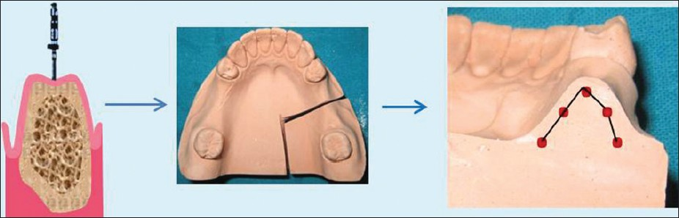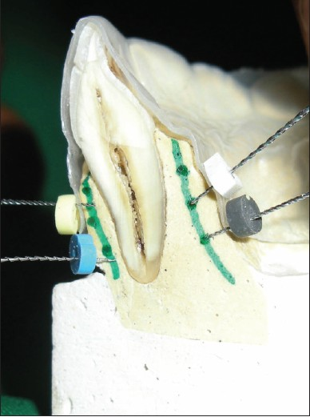
Osteometer: an instrument used for ridge mapping,very painful .It has three tripoding points and gives a direct measurement of ridge width.
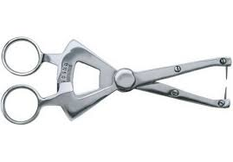
Osteometer

