Dent-2011.weebly.com | Lecture No.
17/11/2015 | Date:
Kefah | Doctor:
Rawan Majali | Done by:
Prosthodontics III

University of Jordan
Faculty of Dentistry
5th year (2015-2016)
Price & Date of printing:

.........................................................................................................................................................................................................................................................
Hand Out
Slide
- Sheet

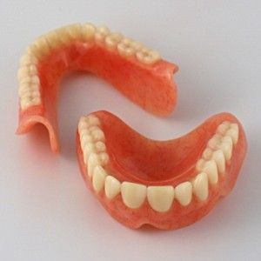
Designed by: Hind Alabbadi

Denture duplication

A duplicate denture is a second denture intended to be a copy of the first denture.
Before duplicating any denture, you have to do a proper examination and evaluation of its three surfaces (occlusal, fitting, and polish surface) also you have to assess phonetics, esthetics, and inspect any previous craze lines, fractures, and porosities. On the basis of this examination, the patient is then advised whether the existing denture should be duplicated or remade.

Fitting surface:
There are some signs that give you an idea about the fitting surface:
-Stability of the old denture.
-Status of the mucosa (ill-fitting denture causes hyperplasia and unhealthy mucosa).
If you found the old denture stable with healthy mucosa, then you have a good fitting surface and to make sure you can use pressure indicating paste.

Occulsal surface:
Checked by articulating paper, or visual examination inside the patient’s mouth, or patient’s complaint ( he can feel where he can’t occlude properly).

Polish surface:
Outside the patient’s mouth you check the quality of the acryl (presence of porosity and staining), the polish surface should have curvatures for the check muscles to rest on to aid in retaining the denture.
You can also check it by asking the patient to wear the denture and see if there is overfullness. Usually there is no complaint from the polish surface, especially if he’s a long-time wearer, as he became adapted to it.

So the proper examination from the first visit determines the proper treatment for the patient.

Treatment Options:

Fitting surface | Occlusal surface | Polish surface | Treatment Option?
okay | okay | okay | Duplicate if the patient is happy with it or it is desired by the patient to have a spare denture in case of accidental fracture of loss
unstability | okay | okay | Reline or rebase
okay | Not okay |  | Depends on the severity of the condition, sometimes it’s solved by selective grinding.  Sometimes you have to do remout and new setting of teeth on the side with improper occlusion.  Severe attrition of teeth (long time denture wearers): denture duplication with modifications on the occlusal surface
No okay | Not okay | Old denture wearer, adapted to it and he learned how to keep the denture in its place | Denture duplication with modifications on fitting and occlusal surfaces
okay | okay | Not okay | New denture

So it is very important to check the polish surface before you go for duplication.

The dr usually duplicates the denture whenever the patient is seeking a new denture, especially in lower dentures and the patient is a long-time denture wearer, because we don’t want to loose the adaptation that the patient has developed.
How does adaptation occur?
Proprioceptors send messegaes for the brain, to accommodate to new things and with years the patient will learn how to keep the denture in its place.
Young educated patients are easy to accept and adapt to new dentures, that’s why we think about duplication for geriatric patients.

Indications:
1. Very old patients, or patients with poor neuromuscular control.
2. Denture collectors: ask your patient which denture he uses most often, examine the denture, duplicate it and adjust if there was any problem.
3. (Spare denture) Emergency denture in case of lost denture.

Advantages:
1. Reduced number of clinical visits.
2. Reproduction of features and design on which the patient is adapted for.
3. Accurate alteration of undesirable features.
4. Simplified occlusal registration.

Technique:
All techniques are similar, except in the use of mould container and materials. Some of these methods are:
1. The flask method, which is the most common one.
2. The agar container method.
3. The soap container method.It is an easy and simple method, therefore , it will be discussed in details in this lecture.

Basically, a mould of the old denture is produced in an elastic material supported in a rigid container.

Soap container box:
- Armamentarium:
Alginate, Vaseline, Wax knife, Modeling wax, Rubber dam, and Cold cure acrylic.
- Steps:
-Select a soap box (dish) of a suitable size. Make two holes on one side of the soap box, that correspond to the wax sprues.
-Mix alginate, and fill one compartment.
- The denture is submerged in alginate, make the denture borders leveled with the borders of the soap box.
-Spread Petroleim jelly over alginate to prevent chemical adhesion with alginate on the other compartment, so that it’ll be easy to separate the two halves.
-The other compartment is then filled with a new mix of alginate, put some alginate on the fitting surface.
-Close the box properly until the material exits from the holes.
-Wait until setting takes place.
-Open and remove the denture.
-Fill teeth indentations with wax (directly by heating a roll of wax).
-The two halves are held together again using an elastic band or rubber dam.
-Cold cure acrylic is then poured down the holes or sprues to fill the space.
Note: you can fill the whole space including the teeth portion with cold cure acrylic instead of wax, and in this case you trim the acrylic during teeth setting.

Make sure to have excess material to compensate for the polymerization shrinkage.

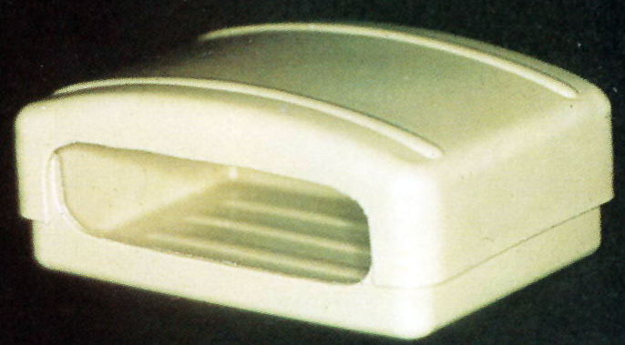

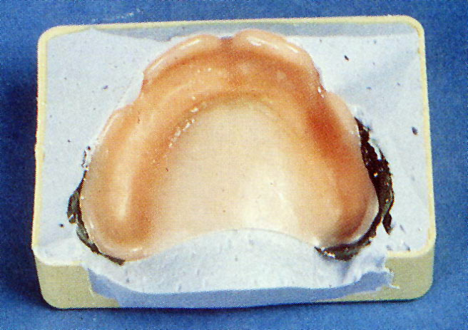

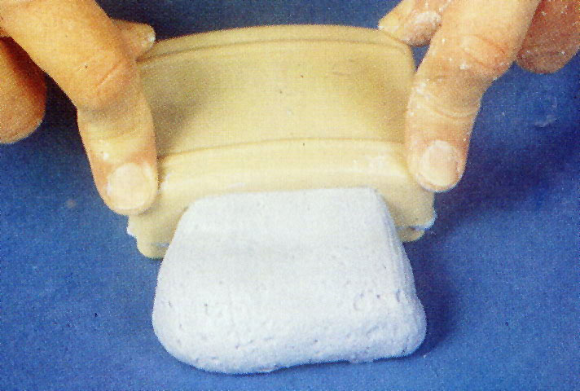

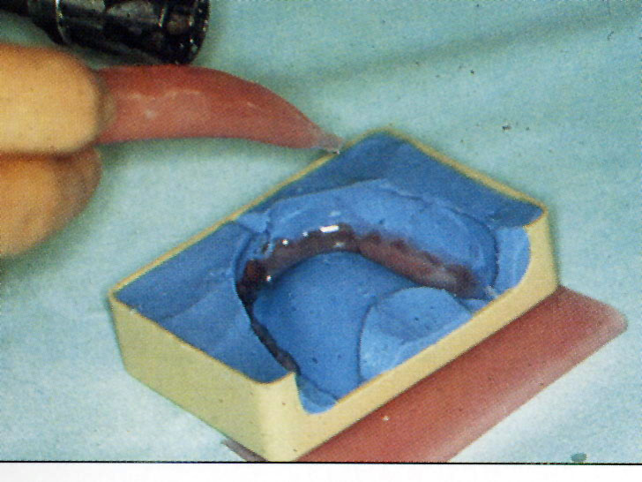
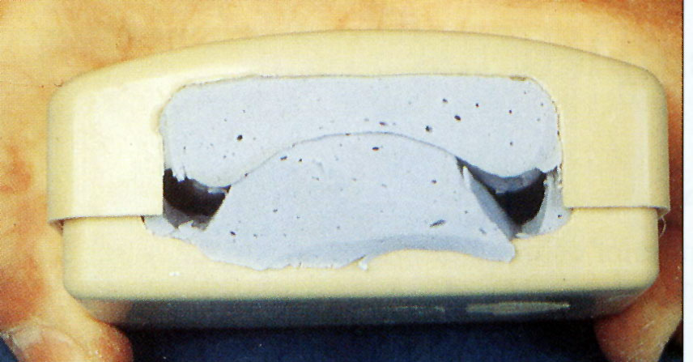
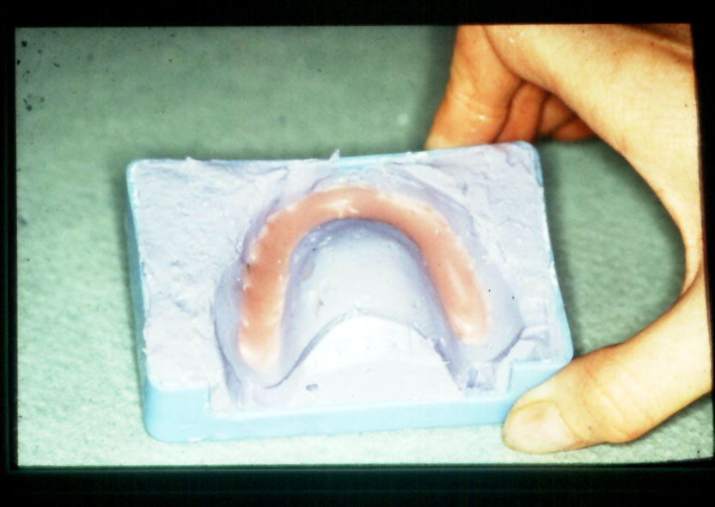
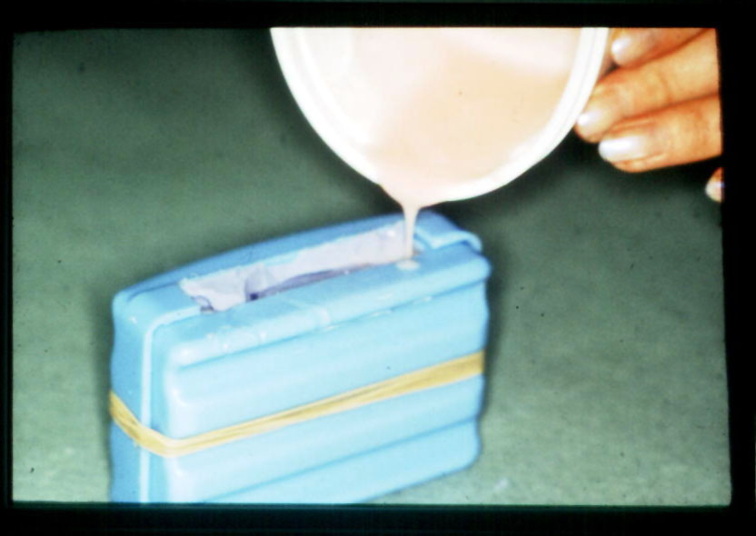

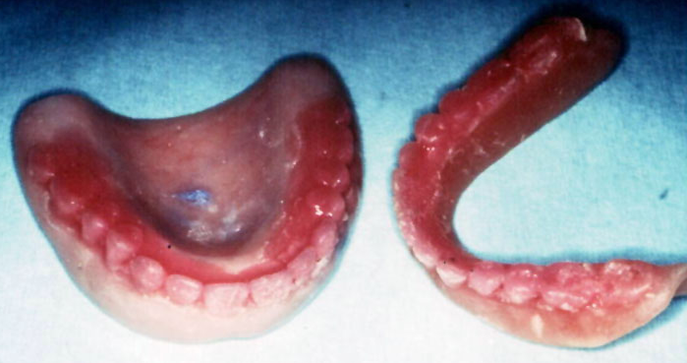

If no alterations are needed, the denture is placed on the articulator and the teeth are set in place of the wax. Then a try-in procedure is done.
If everything is okay, send the denture to the lab to be flasked and processed with routine laboratory procedures.

If any alterations are needed to the fitting surface supposing they do not change the occlusal relationship, an impression is made during the try in stage (wash impression) with light body material using the denture itself as a tray, and you can also use Polysulfide, Silicon, Zinc oxide.
To make sure we have intimate contact, this step is also done even if the patient is not complaining of the fitting surface or no alterations to the fitting surface are needed, since acryl is dimentionally unstable and some changes might occur during the polymerization of the cold cure acrylic.

The impression is made using the closed mouth technique to ensure that the occlusal relationship has not changed. The denture is then sent to lab to be processed in the conventional method.

If occlusal alterations are needed, they are also addressed at the try in stage.
Loss of VDO is common in old dentures. Sometimes the free way space could measure up to 20 mm. Reducing it back to the normal 4 mm is very hard even if it was gradual, as the patient might need a set of 5 or 6 dentures to achieve that gradual change and more clinical visits which is not consistent with denture duplication aim (to decrease visits), so it’s preferred to compromise. Reducing the FWS to 8 or 10 mm is considered acceptable.

So if the dentist decided to raise the bite, he should determine exactly how much he wants to raise during the first visit.
In the try in stage, first the dentist should make sure that the teeth are kept in their original location, as they make a part of the polish surface and it’s not in our plan to alter it.
Aluwax (aluminum containing wax) is used to raise the bite, it is soft when heated and hardens upon cools, making it ideal for occlusal registration. Some excess is used to account for the material that flows due to the occlusal force when biting on it. Then the denture is sent back to the lab for processing.

Good luck

