23 Part2  Dent-2011.weebly.com | Lecture No.
4/4/2016 | Date:
Dr.kefa7 | Doctor:
Ethar Nassar | Done by:
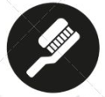
Prosthodontics III

University of Jordan
Faculty of Dentistry
5th year(2015-2016)
Price &Date of printing:

.........................................................................................................................................................................................................................................................
Hand Out
Slide
Sheet

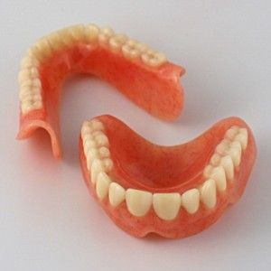
Designed by: HindAlabbadi

Polyurethane elastomers
Desirable properties :
- Elastic without compromising strength.
- Intrinsic and extrinsic coloration.
- Cosmetics results are better than silicon and MMA.
Undesirable properties :
- Not color stable ( UV light will alter the color ).
- Difficult processing ( needs exact measurements, if not exact , it will give us different properties).
- Poor compatibility with adhesive systems.
Methods of retention :
- Skin adhesive only.
- Engagement of the undercut plus eye glasses. (usually the undercut is not enough so we add the glasses).
- Osteointegrated implants.
In the restoration of auricular defect we always ask the surgeon to preserve the tragus as it guides in the position of the ear and it gives more natural look.
In the restoration of the nose we prefer that all the nose to be missing not part of it because the remaining part will give us a problem in the continuation of the edges and coloration.
We can also use implants for nasal defects so we have to consider the size and site of the implants that will properly retened the prosthesis . For the nose defect we can put the implant in the floor of the nose or the glabella.
Researches found that the bone of glabella is not suitable for implantation so it has high failure rate. So the implant in the floor of the nose is the main implants that we use. We put bar attachment to ensure proper retention for the prosthesis.
Method of master impression making : ( we will take the orbital defect as example )
- Drape and level the patient and cover the hair.
- Using a flowy material (polysulfide or light body ), apply a thin layer of the material on the whole area.
- Cover it with gauze.
- Then the gauze should be covered with adhesive the particular material used.
- We need something like a frame to hold the impression, so we use fast setting plaster to cover it.
- Once the plaster set, we can remove it as a one piece.
- Pour the impression to get the cast.
Sculpting :
- Select a globe(already made) that matches the opposite eye (size and color).
- Inscribe an arrow to help in positioning the globe.
- Waxup to fill area on cast.
- Positioning of the globe should be done at chair side ( that help in positioning it correctly ).
- Position globe (Ant/post; vertical; mediolaterally).
- We can put eyelashes to make it more naturally appearance.
- Send it for flasking (usually the globe is translucent and we make the coloration at chair side and on the day light for prober coloration )
In delivery usually the edges are showing so use eye glasses to hide the edges.
Intraoral defects:
Maxillary defects: (according to the cause )
- Congenital defects (Cleft lip and/or palate)
- Acquired defects (trauma/ gunshots)
Armany classification of maxillary acquired defects (the most common and used )
- Class I: resection is performed along midline of maxilla with teeth maintained on one side of the arch. ( not crossing the midline ).
- Class II: single unilateral defect posterior to remaining teeth. So we have more teeth to use to retain the prosthesis (also not crossing the midline).
- Class III: midline defect of the hard palate that may enclose part of the soft palate. The teeth is NOT touched.
- Class IV: the defect crosses the midline. Usually it is bulky and there is few remaining teeth so we have problems in the stability, support and retention. ( sometimes the defect reach the orbital floor).
- Class V: bilateral posterior surgical defect( the anterior teeth are save ).
- Class VI: rare surgical creation. Often resulted from congenital anomaly or trauma (one case presented experienced osteomyelitis following intubation injury).
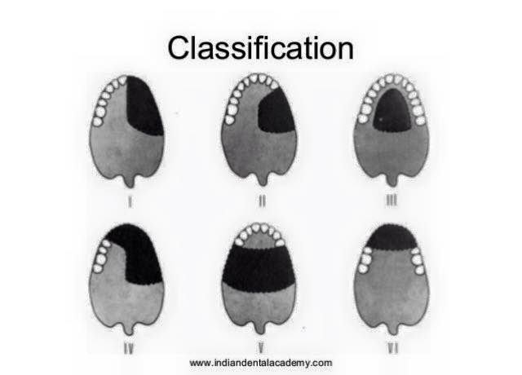
VEAU classification for maxillary congenital defects
- Class I : velum only defect.
- Class II : velum and hard palate defect.
- Class III: velum and hard palate with lip defect unilateral.
- Class IV: velum and hard palate with lip defect bilateral.

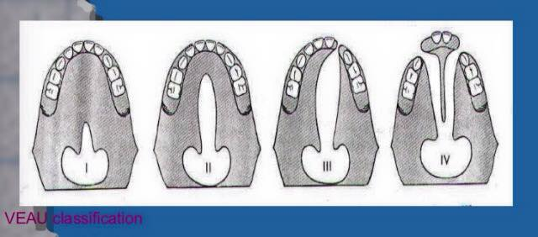
Good luck

