14 | Lecture No.
1/2/2016 | Date:
Dr. Kefah | Doctor:
Aseel Al-Momani | Done by:
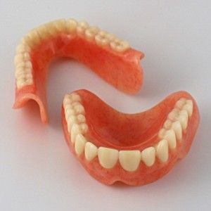
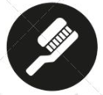
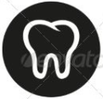
Dent-2011.weebly.com
Price &Date of printing:

Prosthodontics III

University of Jordan
Faculty of Dentistry
5thyear(2015-2016)
.........................................................................................................................................................................................................................................................
Hand Out
Slide
Sheet
Designed by: HindAlabbadi

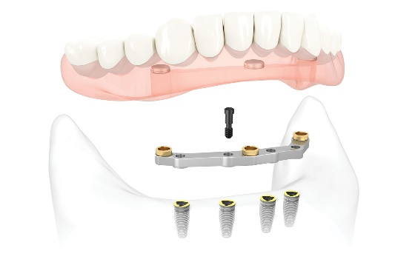
Overdentures

Overdenture is any appliance (removable, complete, or partial denture) whichis supportedby mucoperiosteumand few prepared teeth or roots or implant.
Not all cases are indicated for implants and fixed prostheses, 7asab el condition of the patient, the age, or bone status

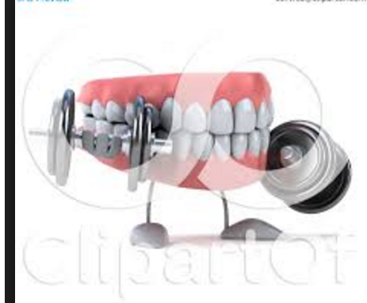
Advantages of Overdentures:
1- Alveolar bone maintenance.
2- Maintenance of proprioception.
3- Support for prostheses.
4- Increase retention and stability.
5- Reduction of psychological trauma.
6- More stable occlusion.

- Alveolar bone maintenance

Bone resorption rate in Maxilla & Mandible differs
(Bone loss)
A study was done, and they found that -over 7 years period- the mandible resorption rate of bone after extraction was 4 times more than in maxilla
Maxilla : Mandible
1 : 4
(7 years period study)

“Rum” did a study of bone loss over 5 years period, he comparedbetween number of patients wearing complete denture in lower arch and other group of patients wearing overdentures with only two canines preserved, he found that the amount of bone resorption in overdentures wearers was 0.6 mm and in complete dentures wearers was 5.2mm (in neighboring area of canine).

- Overdenture is one step before complete denture, (if a patient came to you and has only few teeth remains, youhave to do thorough examination, choose some of the teeth to preserve as overdenture abutments).

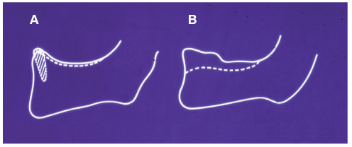
In this sketch the dotted line indicates bone resorption of mandible in 7 years
A: Root supported overdentures
B: Conventional Complete denture

The amount of bone resorption
Mandibular overdentures : Mandibular complete Dentures
0.6mm : 5.2 mm
(rum: bone loss over 5 years period)

- the dr showed us another sketch for a study that was done in Jordan,
tracing the amount of bone resorption, from profile radiographs of mandibular symphyseal region of 12 subjects, 2 days, 5 years & 21 years after extraction.

(what we all agreed that is most of resorption happens in the first 5 years, then it decreases,and the it differs between different individuals).
The resorption rate depends on different things, like bone metabolism, sometimes the nature of food that u eat affects bone resorption !

- After tooth extraction the Alveolar process is reduced due to bone loss, with great individual variation.

- How does overdenture preserve the alveolar bone?
(The Mechanism of Alveolar ridge maintenance)
The roots have the ability to express the compressive force into tensile force to the bone via the periodontal ligaments.(Which is more favorable for bone reposition).
So by keeping the roots and the periodontal ligaments, we’rekeeping this property (the conversion from the compressive force into tensile force) –as the compressive forces cause more bone resorption-.

- When abutment roots are properly contoured, this force is directed down the long axes through sharpey’s fibers.
when there is more than one tooth are present, the forces will be concentrated on teeth more than others, so I can’t guarantee that the whole load is directed with the vertical dimension of the tooth axes, -which is more favorable (with long axes as we know), torque forces are damaging-.
so if I want to use a tooth as abutment, I have to dome shaping it, (there should be 2mm only above free gum margin), by that I guarantee that the whole load is directed with the long axes of theabutment thus bone preservation.
one student asks that whether we need to do reline for the area that don’t have abutments _as what we said that the abutments preserves the bone on the area adjacent to it)- , the dr answered that she didn’t think of that before , but we
we should always make recall appointments for patients 3shan tt2kde enu el wd3 tamam

- Maintenance of proprioception (sensory feedback)
Proprioception : unconscious state that gives information about position and state of body parts. (sensory neve endings present all over the body)
There is more PDLproprioceptors in anterior region more than in posterior teeth.
Sensory feedback
a- Assistance in controlling masticatory forces.
b- Assistance in recognizing size and texture of objects placed between the teeth.
c- Assistance in monitoring the position of the mandible during function.(when you tell a complete denture patient to close in centric relation, everytime he will close at different position, but if he has a tooth or 2 , he will close at the same way every time, he will have a habitual closure).

- Controlling masticatory forces
A study showed that
- Anterior natural teeth can detect a load of 1 g.
-Posterior natural teeth can detect a load of 8-10g.
-Complete denture wearers can detect a load of 125 g.
The presence of abutments in overdenture prevent the load to reach 125g, because it is damaging to the periodontal ligaments and resorption will happen, so it helps in preventing the overloading on the area, It’s very important for the patient to detect the forces to preserve the ridge.

B- Recognition of size and texture
It can recognize the size and the amount of food particles presented in the mouth, and prevent swallowing of coarse particles.
(If you examine the dentures of complete dentures patients, you’ll find wear on all of teeth in a lot of them, and that’s because they swallow coarse particles, and that will cause damage to the GI tract also).
They compared between Complete Dentures patients and dentate patients
- Complete denture wearers were approximately 6 times less efficient in detecting a very small objects placed between teeth compared with dentate people.

- Support for the prostheses
The prostheses which is supported by properly distributed teeth provide direct support for the overdenture, so it’s better for the prostheses to be supported by natural dentition and muccoperiosteom than to be supported by just muccoperiosteom, it’s more stable, the more abutments that are properly distributed the better.

- increase retention and stability
A picture showing a cross section for overdenture abutment (dome shape)
Dome shape increase surface area more retention

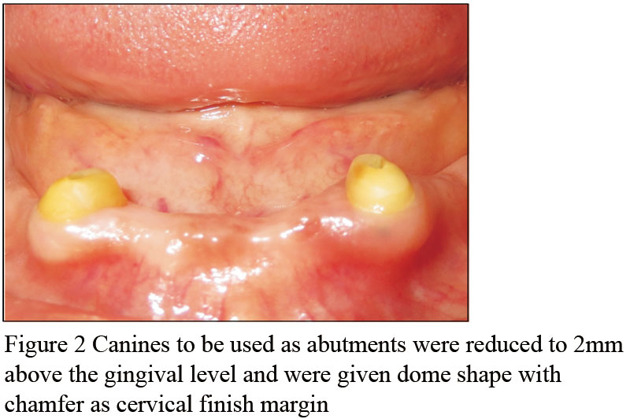

- Using properly distributed abutments will greatly increase stability of the prostheses. (by increasing the surface area vertically ,, more than one abutment adjacent to each other ,, so decreasing lateral movement).

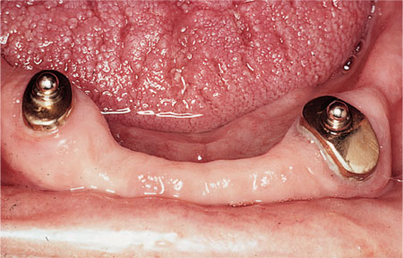
- Retention can be greatly increased, by using overdenture attachments of the abutment itself, as it provides additional retention by increasing surface area.

- why do we do dome shaping for the abutments, ?!
when you take the impression, there will be no sharp edges from the tooth or any undercuts , and when the patient wears the denture there will be no forces that is concentrated on the abutments.

- Reduction of psychological trauma

- Over60% of none denture wearers found the idea of having one is a very depressing condition.

- More stable occlusion

- Stable occlusal registration tray helps in obtaining registration, because of the abutments that is supported by, better than if it was supported by muccoperiostum because it’s compressible (sometimes more than 1-2 mm) which is important as the freeway space might be 2 mm, so it will be affected a lot. -compressible tissue gives no stable occlusion-.

Again as we said, overdenture allows the patient to open and close at the same direction because of the abutments than preserve the PDL proprioceptors.
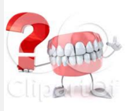
Indications for overdenture

- Should be considered on each occasion that decision to extract teeth & provide dentures is made. (Partial denture if is it possible is better, then overdenture then complete. Study your options well, don’t just decide to do complete denture before considering other options which are better).
Combination syndrome (CS):is a dental condition that is commonly seen in patients with a completely edentulous maxilla and partially edentulous mandible with preserved anterior teeth. This syndrome consists of severe anterior maxillary resorption combined with hypertrophic and atrophic changes in different quadrants of maxilla and mandible.

- Single complete denture.

The dr mentioned something about the
“combination syndrome”,
she said that we should know about it

- Cleft palate and surgical defects.

- The potentially unfavorable CD.

- Hypodontia (peg shaped laterals for example , we can remove the sharp angles or roundation, 7asb el case).

Contraindications
(she didn’t mention them , but here you are some points from the net :’D )
- poor oral hygiene
- rampant uncontrolled caries in the remaining dentition
- uncontrolled periodontal disease
- inadequate interarch space.

Disadvantages:
- Cost. (attachments , endo treatment for abutments,,,, )
- Bulk ( mainly when we do bone grafts because of bone resorption).
- Increase Patient responsibility ( when we prepare the tooth, dentin is more liable to caries, so it’s the patients responsibility to take care of his oral hygiene and to brush and fluoride )
And that’s it 😇😎
The Dr said that she will give us the titles to study them :’D
Best of Luck 💁🎩🎩

