5  Dent-2011.weebly.com | Lecture No.
4/11/2015 | Date:
Ahmad Almaita | Doctor:
Omar shams aldeen | Done by:
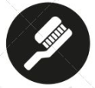
Conservative v

University of Jordan
Faculty of Dentistry
5th year (2015-2016)
Price & Date of printing:

.........................................................................................................................................................................................................................................................
Hand Out
Slide
Sheet

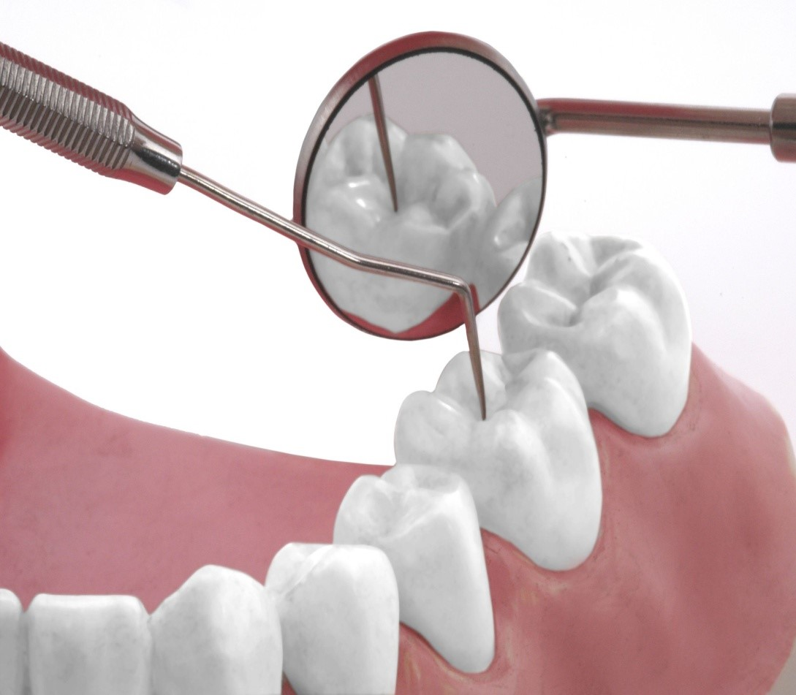
Designed by: Hind Alabbadi
Procedural errors in endodontics

Today, we will talk about errors in root canal treatment. We should know the errors, how to prevent and manage them. Errors can happen at any step of the treatment, and are classified to:
- Access cavity-related
- Errors during instrumentation
- Obturation-related
- Miscellaneous

- Access cavity-related

- Treatment of the wrong tooth:
- This happens a lot, it is embarrassing and not justified at all.
- The most common cause is misdiagnosis (due to inadequate history taking or poor examination) or inattention (identifying the offending tooth but treating another one by mistake!)
- Prevent this error by making correct diagnosis and marking the problematic tooth (especially if teeth look the same, eg: lower anteriors).
- If it happens be honest with your patient, inform him/her about the problem and complete the RCT for both the wrong and correct teeth.

- Missed canals:
- Very common canals to be missed are:
- Mesobuccal 2 of upper molars.
- 2nd distal canal in lower molars.
- 2nd canal in lower incisors (mainly lingual).
- 2nd or 3rd canal in premolars.

- We can prevent this by:
- Preparing adequate access cavity.
- Look for extra canals.
- Use magnification (surgical microscope or loupes).
- Take angled radiographs (2 radiographs).
- Take CBCT which gives accurate image but is expensive.
One of the dr’s cases showing PA of lower left 6 with hypercementosis. Pt presented with abscess, tooth can’t be extracted, we should do RCT but we can’t identify the canals. CBCT was taken and showed 4 canals.

- Damage to an existing restoration:
- This is common when we have porcelain crowns which can chip easily.
- Prevention :
- Use water coolant.
- Do not force the bur (let it cut its way).
- Do not place a ruber dam clamp on the gingival of a porcelain or porcelain-faced crown.

- Crown fracture:
  - Some teeth become weaker after access cavity and may fracture during preparation or between appointments.
  - We can prevent this by :
- Some occlusal reduction.
- Temporary cuspal coverage with GI if necessary.
  - If crown fractures we need to assess restorability (extract or proceed with RCT).

- Perforations:
- Defined as pathologic or iatrogenic communication between the pulp space and the oral or peri-radicular tissues.

- Causes :
- It can be iatrogenic like:
- Misaligned use of burs.
- Negotiating calcified canals.
- Overzealous (aggressive) instrumentation towards a curved root ending up with strip perforation.
- Inappropriate post space preparation.
- It can happen due to pathological causes like:
- Caries.
- Root resorption.

- Prognosis of perforations depends on:
- Control of infection.
- If no infection occurred the patient will only suffer of reversible inflammation (theoretically).
- Time (the sooner the management of perforation the better the prognosis).
- Size (the smaller the better).
- Location (coronal and apical have good prognosis, but crestal perforation are the worst) and
- Adequacy of seal.

- How to suspect a perforation:
- Sudden bleeding
- Patient may taste NaOCl.
- Take x-ray with a radiopaque instrument in the suspected perforation.
- Use apex locator or microscope.
- Upon periodontal probing, narrow and deep isolated pocket if old perforation.

- How to manage:
- First we should complete the RCT of the true canals.
- Then seal the perforation with materials such as GIC or MTA.
- If perforation is deep we might need to expose and seal it surgically by raising a flap.
- Surgical treatment.
- Orthodontic extrusion in some cases.
- Intentional replantation after extraction and treatment extraorally(treat the tooth outside then replanted again).

- Errors during instrumentation
- Ledge :
- Caused by instrumenting a curved canal with a rigid file not following the curvature of the canal.
- We will notice loss of working length.

- Management :
- We should use smaller flexible files and try to go with curvature of the canal.
- We shouldn’t continue with a rigid file because it will result in perforation.
2. Zipping and transportation:
- The result of the tendency of the file to straighten a curved canal (mainly using NiTi file because of shape memory).
- It results in over enlargement of the outer side of the curvature.
- Problem is that the axis of the canal is transported and the shape is changed it becomes hour-glassed so that the constriction is away from the apex.
- The obturation and apical seal of this error is difficult.

3. Apical perforation:
- Following the use of inflexible file in curved canals.
- It results in incomplete treatment of the infected canal apically and destruction of the root cementum.

4. Strip perforation:
- Aggressive instrumentation towards the inner wall of a curved canal.
- Very common in mesial root of lower molars.
- This should be prevented by doing anti-curvature filing technique, meaning brushing or filing the outer wall (safety zone) of the canal (not the inner wall = danger zone).

5. Apical blockage:
- Occurs because of packing of dentin or debris apically as a result of:
- Inadequate cleaning.
- Inadequate irrigation.
- Inadequate use of master apical file (MAF) during step back.
- It results in loss of patency and working length (WL).
- Complete disinfection of the most apical part of the root canal system is not possible results in constant inflammation.
- Recapitulation and patency filing with a small file are important to prevent this error.

6. Instrument separation:
- Instruments separate because of either:
- Cyclic (because of multiple use of the same file).
- Torsional (because of stuck rotating file) fatigue.
- Having a broken file in a vital clean tooth under aseptic conditions might not cause a problem.
- We can leave it providing that it makes a good seal apically.
- However, a broken file in the presence of infection in root canal system should be managed and taken out.
- Factors that affect management:
- Pre-operative status of the tooth .
- Vital and aseptic it will not cause problem.
- Necrotic and infected it will cause problem.
- Presence of apical pathology.
- Stage at which the file was separated
- Before or after cleaning and shaping of the canal.
- After is better.
- Which part of the root determines the treatment options (is it coronally or apically).
- Coronally is easier to remove.
- Which tooth it is, anatomy of root canal system, curvature or narrow canal
- Type of instrument
- NiTi is harder to remove.
- Management options:
- Retrieval (if we can see the broken part) by using a Stieglits forceps, Masserann kit (a hollow tube than can cut around the instrument) or ultrasonic tips (vibrations free the broken part).
- Bypassing by inserting a small file in any space around the separated instrument and trying to reach the apex and continue cleaning and shaping and ignore the broken part.
- Instrumentation and obturation to the level of the separated file.
- Surgical option like :
- Apicectomy.
- Root amputation and hemisection.
- Intentional replantation.
- Extraction

- How to reduce the incidence of instrument separation:
- Assess the case (do not start if too difficult).
- Straight line access (to reduce stresses on the file).
- Good irrigation and lubrication.
- Coronal flaring.
- Glide path to size 20.
- Single use of the files.
- Working length radiograph (very important to know the complexity and curvature of the case).
- Follow the manufacturer’s instructions.
- Do not force instrument inside the canal.
- Clean the file flutes.
- Patency filing to avoid blockage of the canal.

- Obturation-related
1. Over-extended root filling:

- Cleaning and shaping and obturation should end at the apical constriction.
- Upon obturation, it is common for the sealer to extrude out of the root apex, and is called “sealer puff”, which if slight is not a problem.
- Sometimes the GP cone is beyond the apex too, as a result of perforation or over enlargement of the apical constriction.
- This may be a problem if the cone or extra sealer ends up in the maxillary sinus or mandibular canal.
- This might result in nerve paresthesia and it depends on the type of sealer (resin sealer doesn’t resorb).
- Management is by surgery and retrograde filling.

- Under-extended root filling:

- Not a problem if the canal is well cleaned and shaped to the optimal length but filled short of it.
- This is important in non-vital cases, we should clean, shape and obturate to the full working length.

- Miscellaneous

1. Sodium hypochlorite accident:

  - NaOCl is the best irrigant because of its antibacterial effect, and it can dissolve organic debris.
  - However, it is caustic and tissue toxic, it can burn soft tissue if used inappropriately.
- Patientt will complain of severe pain and swelling.
  - To prevent this we should :
    - irrigate it gently inside the canal (no force or pressure).
    - Use low concentration (0.5 or 1%).
    - Use side-vented needles.
  - Management includes
    - Copious irrigation with saline.
    - Prescribing strong analgesics and antibiotics.
    - Applying ice packs but we shouldn’t leave the tooth open for drainage.
    - Surgical intervention may be needed.

2. Subcutaneous tissue emphysema:

- Collection of air below subcutaneous tissues.
- It happens when using a blast of air to dry a large canal (we should use paper points to dry it) or when doing surgery using high-speed handpiece.
- Rapid swelling and crepitus happen and there is a risk of infection (prescribe Ab).
- This is usually benign unless air enters the blood stream which causes embolism and might lead to death.

- Instrument aspiration and ingestion:

- Files and clamps can be either aspirated into the lungs or ingested to the stomach if rubber dam is not used or if clamp is not tied with a dental floss.
- If this happen, radiography of the thorax and abdomen is needed.
- It is managed by surgical intervention to retrieve the instrument.

أسأل الله العظيم رب العرش العظيم أن يشفي عباس شفاء لا يغادره سقما " "

Special thanks to Sakina Dashty

