5  Dent-2011.weebly.com | Lecture No.
5/11/2015 | Date:
Dr.Omar | Doctor:
x | Done by:
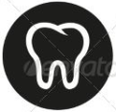
Preventive II

University of Jordan
Faculty of Dentistry
5th year(2015-2016)
Price &Date of printing:

.........................................................................................................................................................................................................................................................
Hand Out
Slide
Sheet

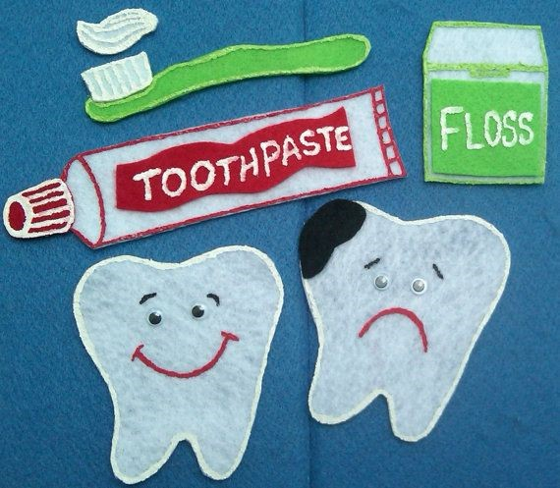
Designed by: HindAlabbadi

Theoretically ; what are the mechanisms of maintain plaque control ;
1- prevent the attachment of the bacteria to tooth surface '' prevention of colonization ''
2- removal of attached bacteria
3- antimicrobial ; this aims to kill the bacteria that formed on the tooth surface
We will focus on '' chemical plaque control ''
- Bisguanide antiseptics – Chlorhexidine ; most common one
- Quaternary ammonium compounds
- Phenolic antiseptics
- Metal ions
- Natural products
- Oxygenating agents ; it's release oxygen and help in killing anaerobic bacteria , the main used in NUG – necrotizing ulcerative gingivitis –
1- chlorhexidine ; Marketed initially for disinfection of skin and mucous membranes and used in medicine and srugery as presurgical skin preparation and remains used in this way todayMarketed as disinfectant for skin and mucous membranes , introduced in dentistry for presurgical disinfection of the mouth
- consider as Synthetic antimicrobial agent and it has broad-spectrum bactericidal against
1- Gram positive and Gram negative bacteria
2- yeasts and fungi
So we can give it to pt with periodontitis , bacterial infection and against candida infection
mechanism ;
- immediate antibacterial ; useful as presurgical rinse
- prolonged effect – for several hours
- Both bacteriostatic and bacteriocidal ; at the beginning there is high level of concentration so it gives bacteriocidal effect then the concentration level getting low so it gives bacteriostatic effect
- Positive charged CHX binds to
1-Bacterial cell wall , damage permeability barriers
2- Oral surfaces Hydroxyapatite tooth enamel ; making some kind of staining and that should take as side effect
3- Organic pellicle covering tooth surface
4- Mucous membrane
5- Salivary protein mouth but will not significantly reduce plaque in an untreated mouth.
- highly effective anti-plaque agent
- more effective in preventing plaque accumulation on a clean tooth surface
- Little or no effect on established plaque and established gingivitis where subgingival plaque has already formed

