4  Dent-2011.weebly.com | Lecture No.
29/10/2015 | Date:
Omar karadsheh | Doctor:
Jacob ismail | Done by:
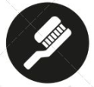
Preventive II

University of Jordan
Faculty of Dentistry
5th year (2015-2016)
Price & Date of printing:

.........................................................................................................................................................................................................................................................
Hand Out
Slide
Sheet

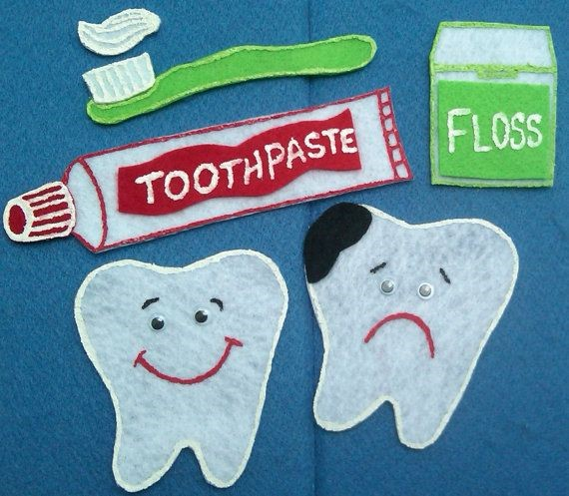
Designed by: Hind Alabbadi
Prevention of Periodontal Disease
Aetiology:
The clinical manifestation of periodental disease result from acomplex interplay between bacteria found in dental plaque and the host tissue.

Dental plaque:the soft deposite that form the biofilm adhering to the tooth surface

Factors affecting PD:
Local factors
Host factors
Host Factors modifying the immune response
- Smoking
Periodontitis is 2 – 5 times more severe amongst smokers compared to non-smokers
Smoking affect the immune response because the nicotine suppresses the immune response and reduce the number of immune cells.
It also affects the neutrophils and the types of bacteria in the pocket
- Diabetes (type 1 and 2)
2 - 3 fold increase risk of periodontitis
Implication of preventive:
Gingivitis is reversible but periodontities is not.
- Gingivitis is common in 90% of both children and adults
Children - 26%- 63%
Adults – almost 100% 1 mm attachment/bone loss
Prevalence and severity of PD increases with age
Important cause of tooth loss: Scotland - 55% caries 17% PD
Toothbrushes: Requirements of a Satisfactory Toothbrush:
- Have good cleaning ability
- Cause minimal damage to soft and hard dental tissues
- Having a reasonable lifespan (good wear characteristics)
- Non-toxic
- Handle size appropriate to the user’s age and dexterity
Head size appropriate for the user’s mouth
  - Adult – 2.5 cm
  - Child – 1.5 cm

When the diameter of the brush bristles increase the hardness will increase .use soft-medium toothbrushes, never use the hard brushes.
Brushing technique:
Bass technique most recommended by dentists
- Research shows NO particular method superior to any other
- Some patients can't accept new techniques, so try to modify their method not to change it completely.
What about children?
We advice our patient to start brushing their teeth from the time of eruption of the first tooth.
Stand behind the child and brush his teeth or only supervised them.
Frequency and duration of brushing:
- Effective plaque removal every second day has been shown to prevent gingivitis
- Twice daily brushing is consistent with maintaining good gingival health
- 2 - 3 minute duration is recommended
How much time of non brushing teeth that take to gingivitis happen? 4-7 days

Tooth picks:
- Triangular toothpicks are superior to round or rectangular like the shape of the embrasure.
Interspace Brush:
The doctor love it
- Used for tipped, rotated or displaced teeth, teeth with gingival recession
- Limited value except for surfaces adjacent to an extraction space
Sub gingival irrigation can give us better result than supragingival.
we can use it to deliver antibiotics , chlorehxidine , and other agents to the pockets.
Recall intervals:
Aim
- Prevent recurrence and progression of PD
- Prevent tooth loss
- Increase probability of diagnosing and treating in a timely manner other oral disease
1. Reinforcement of oral hygiene instruction
2. Supragingival scaling or root planing as necessary
Frequency?
3 month recall is favoured by most clinical trials
Polishing:
- Polishing enamel – reorientation of surface crystals to create a smoother surface
- Experimental studies shown polishing inhibits formation of pellicle, plaque and calculus
- No evidence that periodontal health improves

- Removal of fluoride from superficial layers of enamel is a significant drawback
We know that there are syndromes and diseases can affect the oral cavity and produce oral lesions or difficulties , like down syndrome , and sometimes our medical treatment might cause oral problems like in chemotherapy and radiotherapy ; the patient will have xerostomia .
Some patients can't take care of their teeth health ; parkinson , cerebral palsy ..
they know that they have to brush but they can't even grasp the toothbrush .
It's better to enhance the patient to clean his teeth rather than the care provider , because the care provider has more important things to worry about like the medication and the systemic problem …
it gives the patient self confidence when he do it by himself , so try to make your patient do it by himself , try to make it easier .
what are the difficulties that special needs patients might have ?
- The posture :
sometimes the can't actually stand up , so you have to provid7e a suitable wash place and mirror at their level .
- Some patient can't open their mouth :
we can give them a retractor to keep the mouth open while brushing .
- Some patients can't grasp the tooth brush :
they can use toothbrush with rubber balls (silicon putty) to give improved hand grip .
there are different sizes , choose the suitable one : the patient put his forehand and his fingers around it and wait until it sets , then it will become a convenient handle because it fits the patient hand .
- mentally handicapped person and those with low IQ : they can't go buccally , lingualy , 45 degrees .. we use "super brush" : it has 2 heads and sometimes it has a third head for the occlusal surface , it actually help the patient to have the 45 degrees and he can brush his teeth in short time .
- Some Patients can't accept your help : like the Autism patients
- Some patients can't squeeze the toothpaste
these handles are removable , you can open it and close it .
electrical tooth brushes are easier to grasp and they don't need that force from the patient .
disadvantages :
*vibrations sometimes cause problems to autism patients.
* they are heavy .
*powering on mechanism : sometimes patients can't press the power key.
Good luck seniors in your exams
Done by: Jacob Ismail

