6  Dent-2011.weebly.com | Lecture No.
19/11/2015 | Date:
Dr . Yazan | Doctor:
Ro‘aa Aloran | Done by:
Preventive II

University of Jordan
Faculty of Dentistry
5th year(2015-2016)
Price &Date of printing:

.........................................................................................................................................................................................................................................................
Hand Out
Slide
Sheet

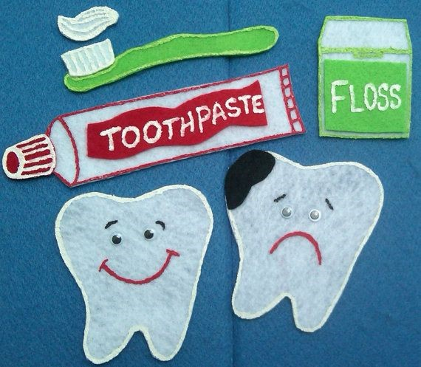
Designed by: HindAlabbadi

Detecting Oral Cancer

- Although examination of oral cavity easy for dentists and patients, most oral cancers are being diagnosed at advanced stage .
- There are 30.000 new cases diagnosed yearly.
- In Jordan oral cancer uncommon .
- 5 year survival rate is 50% but it depend on stage of diagnosis ( early diagnosis survival rate reach 90% , late diagnosis associated with low survival rate less than 50%).
- 5 year survival rate for localized disease like ulcer on the tongue without lymph node enlargement (distal metastasis) is 80%.
- 5 year survival rate for metastatic disease is less than 20%.
- As I said many cancer cases discovered at late stage.
- وبتاخر ال Antibiotic بيجي المريض عند الدكتور بفحصه وبحكيله استنى اسبوع او اسبوعين او بعطيه (
)metastasis او يصير Stage 2 الى stage 1 ممكن يتحول من cancer وبتتقدم مراحل ال diagnosis
- There are warning signs : any patient has red or white lesion or ulcer or lump for more than 2 weeks must think of cancer possibility .
- Again RULE R ( Red or white lesion) , U ( Ulcer) , L ( Lump ) , E ( Exceeding 2 weeks ) all these are possible signs for oral cancer .
- Other warning signs : difficulty in swallowing , ear pain (earache) without known causes , hoarseness , numbness of tongue or mouth also these are signs of malibnancy
- Most people and dentists don’t know how oral cancer looks like . they think that only lymph node enlargement suspicious for cancer, which is not true ( lumps such as polyp which is benign cancer and rarely to be as a malignant )
- Cancer المرضى بفكروا أي كتلة يعني
- There are many risk factors which increase the possibility of oral cancer , some of them are modified risk factors can be controlled ( Tobacco use , alcohol use , sun light exposure ) and unmodified risk factors ( Age ,gender , race ) .
- India and Pakistan have highest prevalence of oral cancer caused by tobacco chewing .
- Yemen also has high prevalence of oral cancer maybe due to sth called القات .
Examination :
- Head and neck exam should be a routine part of dental and medical check-ups
- Take a history of alcohol and tobacco use
- Follow up for patient with suspicious signs

- Extraoral examination:
- Examine lymph nodes
- Examine Lips ( if there is slight depression or ulcer or any lesion )
If we see any of these signs specially in pt with history of excessive sunlight exposure we must think of malignant.
Sometimes if we see lesion on the lip we may think of herpes but we ask the pt when this lesion appears if he says one month ago so its not herpes cuz ( herpes cant stay for a month) .
- We examine all mucosa surfaces systematically starting with labial mucosa , buccal mucosa then gingiva , with special concern to some areas such as ( posterior part of the mouth , tonsils , retromolar area, base of tongue , lateral surface of tongue)

- As I said any red or white lesion of more than 2 weeks without known cause is suspicious for oral cancer like leukoplakia of many types speckled , verrucous, nodular )
اكثر ) Risk of malignant transformation كل ما كان للاسم اضافات اكثر بكون ال )
- Homogenous leukoplacia has low risk of malignant transformation however speckled, nodular , verrucous leukoplakia has high risk of malignant transformation .
This small lesion we may ignore it and stays without treatment but it has risk of malignant transformation but we take in pathology that leukoplakia has low % of dysplasia but this not for every case , we might see leukoplakia with sever dysplasia ( قوية ما في علاقة
ووضع الخلايا ) lesion بين شكل ال
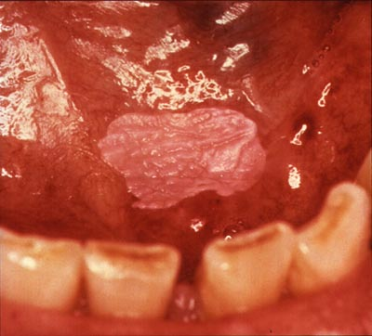 ( Homogenous lekoplakia )

excision بسيط بس لو اكتشفناها بكير علاجها SCC صحيح انها بسيطة بس فيها Lesion هاي ال )
يعني رح يكون معقد ) Radiotherapy and chemotherapy بينما لو اكتشفناها متأخر بصير بدها
( Leukoplakia with early squamous cell carcinoma) 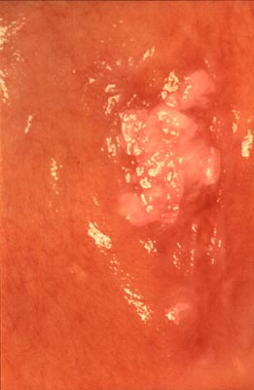

This lesion is suspicious cuz its unilateral , white lesion for long period its ( speckled leukoplakia) it has dysplasia but its not cancer so the management easy ( avoid risk factors, excision cuz its small ) .
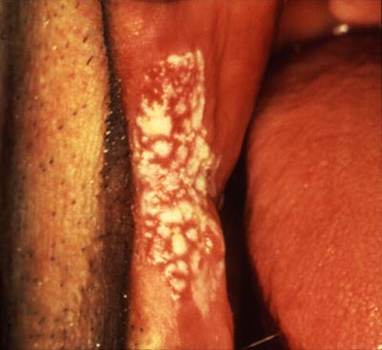

- Lesions with mild to moderate dysplasia no need for excision only avoid the risk factors
- Lesions with sever dysplasia we do excision
Screening tools for oral cancer :
- Visual inspection ( most important )
- Self Examination ( for pt at risk must follow up for lesion )
- Toluidine blue ( uptaken by cells with high proliferation rate but this tool has problems with sensitivity and specificity )

- Fluorescence imaging ( devices using ultraviolet light , areas with high DNA content appear dark so this lesion suspicious and need biopsy )
- Exfoliate cytology/Brush biopsy
- Saliva examination
Sensitivity for oral visual lnspection between 60 – 90 %
Specificity for oral visual lnspection between 70 – 100 %
Sensitivity more important in cancer diagnosis
يشخص الشيء لكن لا يميزه عن غيره من الامراض بعني ممكن يحكيلنا انو هون في Sensitivity (
بتميز الشي ) Specifity بينما ال بس احنا ما خسرنا شي cancer ويطلع اغلبه مش cancer

Toludine Blue Test :
- High false negative and false positive rates

Oral cytology :
- Lesion has to be seen before the sample collection
- biopsy ما في داعي ل Malignantواضحة انها Lesion يعني ازا كانت ال Diagnosis مش دقيقة وبتاخر
Saliva examination :
Lesion ويتعطينا فكرة ازا هاي ال Analysisبعملولها DNA,mRNA مثل Saliva بعض الجزيئات اللي في ال )
او لا ) Potentially malignant

Velscope: looks like light cure , neither sensitive nor specific .
) Normal mucosa مقارنة مع الDark تعكس الضوء اقل فبتظهر Thickened mucosa المناطق اللي فيها )
لانها تعتمد على كثافة الخلايا اللي بتيزيد عند Cancer الية عمل مثل هاي الاجهزة غير مناسبة لتشخيص ال )
( cancer يعني ما الها علاقة بال Friction keratosis Or Cheek biting الاشخاص اللي عندهم
معناته ما رح تبين على الجهاز وما رح atrophy بصير فيها Erythroplakia مثل Cancer وفي ال)
( High risk of malignant transformationنكتشفها مع انها تعتبر

There are many devices for cancer detection
مبدأ العمل: light with specific wavelengths for differential deflection of light

GOOD LUCK

I TAKE THE SLIDES FROM LAST YEAR AS REFRENCE FOR THE PICTURES

