Felt needs which are felt by the patients, so when the patient decide to treat the condition by going to his dentist it’s called express needs.
Comparative needs is when the patient’s comparing their needs (priorities)
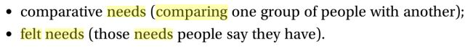Although it might be the best one, what are the limitation of the normative needs:
- It’s not objective
- It’s not represent the impact of life quality
- Ethically unacceptable because the patients didn’t make the choice themselves
- Paradoxical approach تناقض نفسها: example: when the experts decide to give a vaccine to all patient to prevent them from a disease, some of these patient will get the disease by taking this vaccine.

From the book: 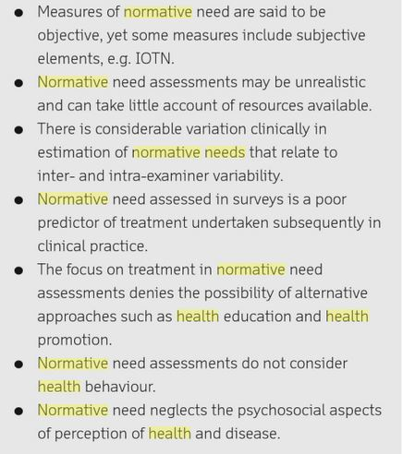

Socio-dental measures of oral health: so you determine the needs based on impairing disability and handicapped and how it affects the social life.
Types of need assessment:
- Functional assessment which includes eating, biting, and chewing
- Social interaction
- Comfort and pain free
- Self-image which is related to the esthetics
You have to consider all previous points when you assess the patent’s needs.
High quality dental care: according to Maxwell
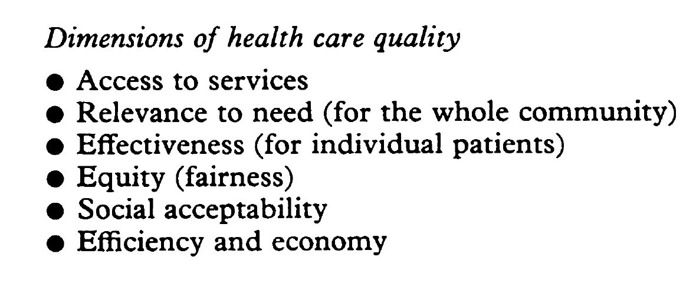

So when you are planning dental services you have to establish the objectives, define your standards, you plan???? Execute and re-evaluation.

There is a chart in the chapter that we have to study well.

