6  Dent-2011.weebly.com | Lecture No.
15/11/2015 | Date:
Murad | Doctor:
Misk Wahdan | Done by:
Periodontics II

University of Jordan
Faculty of Dentistry
5th year (2015-2016)
Price & Date of printing:

.........................................................................................................................................................................................................................................................
Hand Out
Slide
Sheet

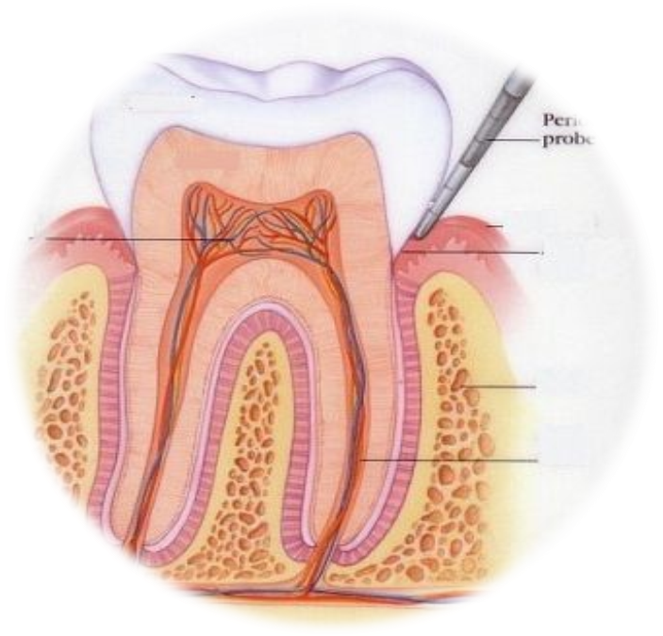
Designed by: Hind Alabbadi
Mucogingival Surgery

Outline:
1-Terminology
2-indications
3-etiology of recession
4-techniques to assess the mucogingival deformities .

Mucogingival surgery:
Surgical procedures to correct the relationships between gingiva(the keratinized part) and mucous membranes (non keratinized part).
These 2 parts meet at mucogingival junction.
Deformities require mucogingival surgeries :
a-attached gingiva deformities like recession
b-shallow vestibules
c-abberant frenum.
Recently they use broader term to include all the corrective periodontal surgeries we call it "periodontal plastic surgery" .which means the surgical procedures performed to correct or eliminate anatomic ,developmental or traumatic deformities of gingival or alveolar mucosa .
This broader term includes:
-periodontal prosthetic corrections
-crown lengthening
-ridge augmentation: means increase the size of defected ridge .
-esthetic surgical corrections
-coverage of denuded "exposed" roots surfaces , this is the major indication for this type of surgery.
-reconstruction of papillae.
-esthetic surgical corrections around implants.
-surgical exposure of unerupted tooth for orthodontic treatment, for example exposure of impacted canine should be done properly to expose and leave the area with little cosmetic bad effects .
We will not talk about all of these indications , we chose the older term which includes :
a-attached gingiva deformities like recession, when there is decrease" narrow zone of attached gingival" or absence of attached gingiva.
b-shallow vestibules
c-abberant frenum." Thick frenum"
Attached gingiva is the narrowest on the premolars and canines , and it is the widest in upper lateral incisors .
You have to differentiate between keratinized and attached gingiva:
Keratinized is the free gingival margin "the movable part" + attached gingiva"the non movable part"
While the attached gingiva is the area from the depth of the sulcus to mucogingival junction.
Previously they thought that once the attached gingiva is absent there is high risk of recession , but this was a wrong estimation and that was supported by human and animals studies, In order to establish a healthy gingiva you don't need a zone of attached gingiva around teeth ,you just need adequate plaque control even with the absence of attached gingiva .
Recession can be seen on a tooth and this tooth can be mobile or not and this depends on how much bone support is surrounding the tooth from other sites , so you can encounter a tooth with very much recession but no mobility is clinically observed.
So what comes first?! No attached gingival then recession? Or recession then loss of attached gingival?
We never intervene surgically just because the absence of attached gingival , the indication is only to enhance plaque control if it is hard for the patient access to clean the area .
Indications :
1-facilitate plaque control
2-improve the esthetic: if there is no attached gingiva there will be mucosa which is more reddish in color that will compromise esthetics .
3-Reduce inflammation around restored teeth : when there is less than 2mm of attached gingiva or absence of it we have to graft , because having crowns or restorative margins will decrease plaque control and the intervention surgically is important to maintain periodontal health .
4- to have gingival margin that binds better around teeth or implants :
Gingiva binds to tooth throught dentogingival fibers (septal, circumfrintial ,transverse )
Do not mix it with sharpeys fibers which is part of pdl that is inserted in cementum and bone.
Dr was showing us different clinical photos discussing the previous indications .
The last one is an overdenture implant retained prosthesis , there was a zone of mucosal folds without attached gingival that will work as plaque trapping shelves that need to be corrected to achieve better tight bound gingiva around implant .
In every overdenture case you intent to make you have to assess the amount of attached gingiva because after extraction it tends to shrink and that will affect the outcome of the implant retained prosthesis .
Gingival recession:
When the gingival margin is apical to CEJ ,so the root and CEJ are exposed .
Especially in lower or upper anteriors and in mixed dentitions you can misinterpret one tooth to have gingival recession while it is not ,this tooth has the gingival margin where it is supposed to be but RELATIVELY to the adjacent teeth it looks like a recession but in reality the adjacent teeth have CORONAL migration of gingiva .
Also in mixed dentition and crowding where there is a tooth lies buccally the gingiva will migrate apically but in lingually inclined teeth the gingiva will migrate coronal .
Causes of gingival recession:
1-Mechanical Trauma:
A)aggressive teeth brushing
B)Occlusion: Deep bites when incisal edges traumatize the gingiva and this trauma is very obvious ,while bruxism , malocclusion , crossbites never cause any recession (Never mention these in VIVA exam) .
C)- iatrogenic : finishing of a restoration "class 5"
D)piercing: tongue piercing will cause mechanical trauma
E)Factious: Self induced by pens ,toothpicks .. etc
Not all aggressive teethbrushers have the same degree of recession , this depend on predisposing factors" biotype ,prominence of roots " .
Canine is the most affected by mechanical trauma due to teeth brushing because of thin biotype and prominience of roots .
2) Plaque induced localized factors: for some reasons the patient skip brushing some teeth or these teeth cant resist inflammation such as having thin biotype or very prominent roots this will cause this clinical presentation.
3) Generelized destructive periodontal disease :it affects inerproximal surfaces , all around the tooth .
The recession is one of presentation of clinical attachment loss .
Note: Frenum is not an actual cause for recession , since it is a band of connective tissue without conractibility.
So the predisposing factors for gingival recession are:
1-thin biotype :very thin buccal plate, long teeth with triangular cylindrical shape , highly scalloped following the CEJ if a flap is made, fenestrations in the buccal bone will be noticed . while in thick biotype you notice :
-squarish teeth , the buccal plate is Flat not that scalloped
--if a flap is made ,you will notice thicker buccal bone

2-high frenal attachment: only in the case it attaches the gingival margin
3-Prominient roots
4-orthodontic treatment
uncontrolled torque movement on the roots
____________________________________________________
Gingival recession classification :- most important issue in the classification is the presence or abscence of proximal attachment loss , whether there is pocketing or papillary recession .
we should start by probing papilla area , if the embrassure is filled with the papilla and probing depth is 2-3 mm , then its normal and no proximal attachment loss .
what we need is not the position of the tip papilla , we should look for proximal attachment level and we check that by probing .
- Miller classification :
1) Miller 1: The recession is isolated to the facial surface , doesn't extend to the mucogingival line, no proximal attachment loss .
2) Miller 2: the same as type 1, but the recession bypasses he mucogingival junction
3)Miller 3 : proximal attachment level is coronal to buccal tissue level ,it also extends beyond mucogingival junction
4)Miller 4: proximal attachment level is at or apical to buccal tissue level.

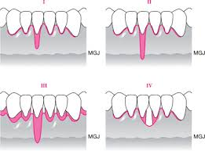
Note:
can use radiograph to see the bone level . you
This classification helps in determining the prognosis of root coverage procedure.

--Miller 1,2.....predictability of root coverage procedure is 100%,due to good blood supply .
--Miller 3......predictability is 50%
--Miller 4......unpredictable ,we dont do anything ,and there will be negative architecture "crater", very poor prognosis for root coverage .
Shallow vestibule :
The most predictable way to deepen the shallow sulcus is grafting , we deliver bone from hard palate . the other surgical techniques has unpredictable results.
Abbarent frenum :
If it interferes with prosthesis
If it interfere with gingival margin
These 2 only indications to intervene surgically regarding frenal attachments .
Ridge augmentation :
When we need augmentation apical to gingival margin ,the objective will be is creating a zone of (attached gingiva) not to cover the root and we do that by tissue grafts while augmentation
Coronally is to achieve root coverage

The last topics will be discussed in details next lecture
Good luck seniors

