05  Dent-2011.weebly.com | Lecture No.
02-11-2015 | Date:
Nicola Barghouth | Doctor:
Angy A. Kokash | Done by:
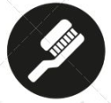
Periodontics II

University of Jordan
Faculty of Dentistry
5th year (2015-2016)
Price & Date of printing:

.........................................................................................................................................................................................................................................................
Hand Out
Slide
Sheet

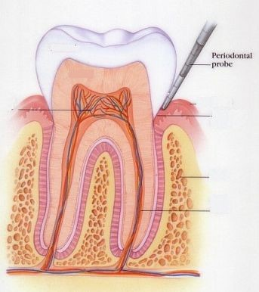
Designed by: Hind Alabbadi

*Notes about the exam;
1- It’s of an essay type.
2- 1st lecture- gingivectomy by laser & gingivectomy by chemotherapy aren’t included.
3- 2nd lecture- focus on classification of flaps based on what describes them, discuss one of the flaps in details, steps of the surgical procedure should be in mentioned in order, i.e. you can’t mention creating an incision without providing the patient with anesthesia at first.
Management Of Osseous Defects
"Resective Osseous Surgery”
*Lecture outline;
1- Definition of osseous surgery including osteoplasty and osteotomy.
2- Classification of infra-bony pockets.
3- Biological width.
*Definitions;
1- Osseous Defect
It’s a concavity or deformity in the alveolar bone involving one or more teeth.
A)Why is it a concavity?
According to the anatomy and contour of bone surrounding the root and found to be of a scalloping pattern around the CEJ.
B)What is a deformity?
It’s resorption of bone in an irregular pattern or shape.
2- Osseous Surgery
The process of recontouring and eradication of angular bony defects and craters.
It is all the procedures designed to modify and reshape defects and deformities in the bone surrounding the teeth.
A)Angular Bone Defects correspond to the scalloping shape of bone around CEJ.
B)Bone resorption starts as vertical then becomes horizontal, so every vertical bone loss will end up having a horizontal component.
*When to decide whether to go for a flap surgery or not?
According to;
1- Accessibility or visibility of the bony defect itself.
2- Regenerative capability of the tissues.
3- Possibility of pocket reduction or elimination.
4- The operator must also decide whether this procedure will improve the
prognosis of treatment or not before getting the patient into the whole
dilemma of surgery.
*It is important before any osseous surgery to determine the morphology of any osseous defect as accurately as possible.
Means of detecting the level of bone disruption include;
1- Topography in a single plane.
By inserting the probe vertically in the depth of the sulcus to locate pockets with bone resorption.
2- Routine probing- linear measurement.
A)The probe is the main instrument, we all use; to locate pockets.
B)A pocket of 6mm; indicates the presence of a bony defect as it’s apical to the bony crest area.
C)A pocket of less or (no more) than 5mm; here, there’s no bone resorption.
3- Radiographic Materials to follow bone resorption configuration.
A)By inserting a gutta percha point inside the pocket, here this point will follow the slopes and deviations of bone resorption (depth, shape and extent). However, the probe is rigid, so it can only record the vertical pocket depth only.
B)Silver points can be used for this purpose as well, due to its flexibility (these are like K-files and reamers).
C)However, this method follows a spatial line or plane, thus; its limitations include; the inability to know the number of involved pockets and amount of bone resorption.
4- Visualisation of the defect itself at surgery time.
*Classification Of Bony Pockets;
A)Periodontal pockets with their base apical to the crest of the alveolar bone are called Infrabony Pockets, which are subdivided into;
Type | Description | Location
3-Wall Defect | 3 intact walls  1 is defected | Interdental Area
2-Wall Defect | 2 intact walls  2 are defected | -Interdental area  -Most prevalent type  -Crater-like defect
1-Wall Defect | 1 intact wall  3 are defected | -One variant of it is called the cup-shaped or saucer-shaped defect  -Multi-bony defects; may include more than one type of defect  -Compound defect; may have all walls
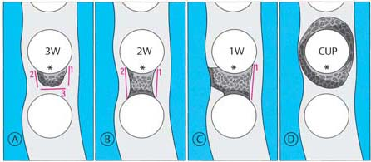
B)The prognosis of each case depends on the “vertical height of bone resorption”.
C)The “Cup-shaped” defect’s prognosis may not be always extraction, as in fixed prosthodontics rule that says; “if the crown to root ratio is 1:1 then go for it”, the same applies here.
D)For the illustration attached above, it is irrespective of the type of bone resorption.
Good Luck …

