10  Dent-2011.weebly.com | Lecture No.
13/12/2015 | Date:
Murad Shaqman | Doctor:
Aseel Salh | Done by:
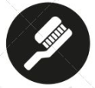
Periodontics II

University of Jordan
Faculty of Dentistry
5th year(2015-2016)
Price &Date of printing:

.........................................................................................................................................................................................................................................................
Hand Out
Slide
Sheet

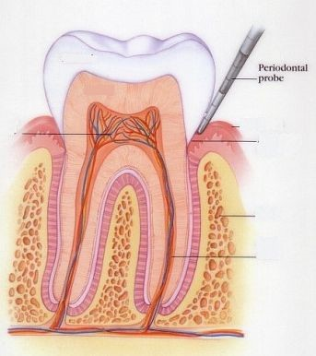
Designed by: HindAlabbadi
Periodontal Restorative Consideration 1
In this lecture we will talk about how to avoid like this situation
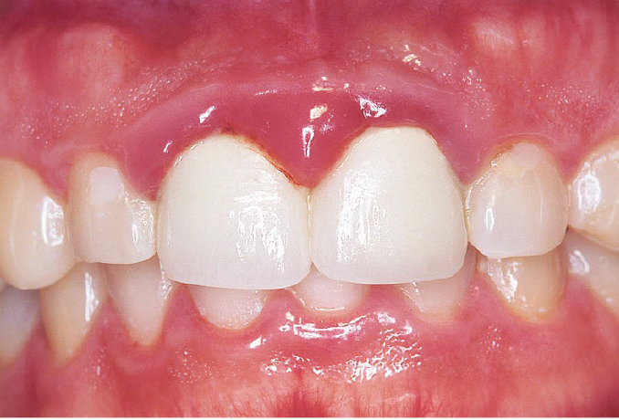
How to make sure any restoration you do it not cause harm for gingiva or compromise your treatment, even you are happy in those crowns the patient will not be happy ,its short and square in shape
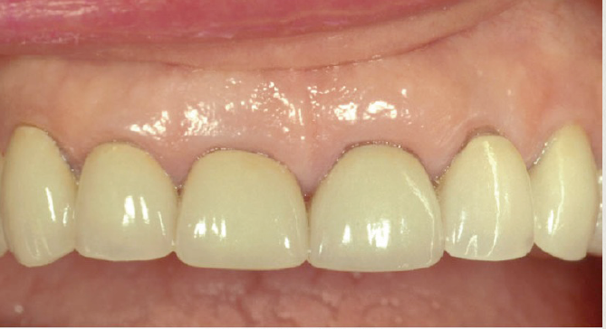
It’s important lecture because most of us will be restorative dentist, so its relate to us in every day practice .
Preparation of periodontuim
Periodontal health is a pre-requisite for successful comprehensive dentistry
1. Control periodontal infection
2. Address residual eﬀects of periodontal disease, some time we control the infection and still we have pocket and swelling for example
3. Techniques and procedures in anticipation of esthetic and implant dentistry in order to optimize our treatment as much as we can

We can’t do any type of restoration in this case (A) , there is calculus and inflammation but unfortunately most of us see the calculus only .so if you want to remove calculus do scaling and polishing and that’s it but the inflammation still present (B). There is subgengival calculus, it missed when we do scaling after healing we have shrinkage and it will show (arrow)

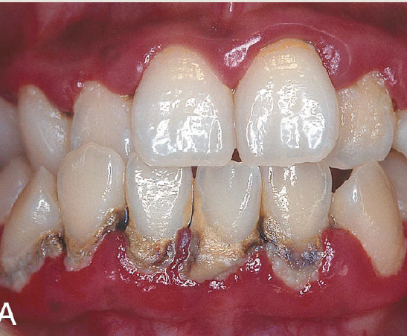ion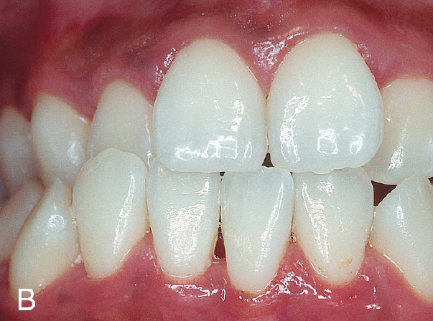
You should think in periodontal therapy as establish periodontal health .
Calculus doesn’t splint the teeth , the mobility increase after treatment due actual instrumentation and the mobility will subside after a while .
If we have bridge of calculus over the teeth, the teeth will have cracks because is still moving .
Rationale for therapy
1. Establish stable gingival margins
In case you are doing veneer and you have inflammation ,some time when you do cord packing the biofilm will disturb that cause cretin degree of healing and shrinkage in next visit when you seat the veneer it will be short .

2. Healthy gingival tissues that facilitate the restorative procedures
-Have inflammation mean you have bleeding so will affect :
Composite restoration ,matrix band placement ,cord packing , making impression
Wedge placement maybe reduce bleeding .
-staining of teeth will comprise the shade selection of composite.

3. Certain periodontal procedures provide adequate tooth length for retention and access for restorative procedures
like crown lenghthing

4. Periodontal therapy could result in repositioning of teeth.

One of signs of periodontal disease is pathological tooth migration – distobuccal migration for teeth mainly incisors- after periodontal therapy we have spontaneous repositioning

2 theories explain :
- When we lost the support from bone , the tongue will push the teeth .
-presence of inflammation cause shifting of teeth
It’s not well understood and we don’t know why the spontaneous repositioning not occur in all cases

5. prognosis :without the initial periodontal therapy we can’t take decision to extract he teeth or not except in advanced cases .

6.Traumatic forces placed on teeth with ongoing periodontitis may increase tooth mobility, discomfort and possibly the rate of attachment loss. high occlusal forces will exaggerate the bone loss .
7. Orthodontic treatment in the presence of periodontal infections may result in negative detrimental outcomes

8. Successful esthetic and implant procedures may be diﬃcult or impossible without the specialized periodontal procedures developed for this purposes .

Sequence of Therapy:
1-Control of active disease
2- Pre-prosthetic surgery

1- Control of active disease
-Oral hygine instruction , antibiotic (local or systemic ), chemical plaque control using mouth wash ,host modulating factor
Mouth wash present in 2 forms : 0.12 in USA AND 0.2 IN Europe and Jordan there is no difference between them .both we use them for 30 sec ,twice daily for 2 weeks .
Doxycycline can use as antibiotic or host modulating factor
Doxycycline as antibiotic we give 100mg 1*2 for 14 days
Doxycycline for cretin period of time is drug of choice to treat periodontitis but nowadays if patient not allergic to penicillin we give : amoxicillin 500mg 1*3 for 10days and metranidazol 250mg 1*3 for 10days
If pt allergic we give Doxycycline or erthomycin (azethromycin ).
Note: if pt allergic to penicillin we don’t give him cephalosporin because usually the pt is allergic to cephalosporin too.
- Doxycycline as host modulating factor 20mg 1*2 for 3 months then break then 3 months
Its work on immune cell ,no antimicrobial effect its sub anti microbial effect .
-Emergency Tx (abscess ,endo-perio lesion ,pain )
- Extraction of hopeless teeth ,advanced cases so you take decision before initial periodontal treatment .
- Oral hygiene measures
-Scaling and root planing
-Reevaluation after 2 weeks
- Periodontal surgery
-Adjunctive orthodontic Tx when spontaneous repositioning not occur .

2- Pre-prosthetic surgery
-Management of mucogingival problems (recession ,no attached gengiva)
- Preservation of ridge morphology after extraction
-Crown lengthening procedures
-Alveolar ridge reconstruction

Case: ( from last year sheet because I don’t undersand what dr said )
they put a collagen sponge just to hold the tissue then they put the temporary bridge right away ... the temporary pontic enters 2mm inside the socket & has ovate upper border (as if the tooth is emerging from the socket not only saddle on top of the tissue), so the tissue will take the shape of the ovate pontic.
You should use special impression techniques to capture the soft tissue profile because the original techniques focus on capturing the finish lines (not the soft tissues).
The final restoration doesn't look like a pontic, it looks like a tooth emerging from the socket. Note that the inter-dental papilla is still there because what determine the level of the papilla is the level of inter-dental crestal bone at the adjacent tooth.
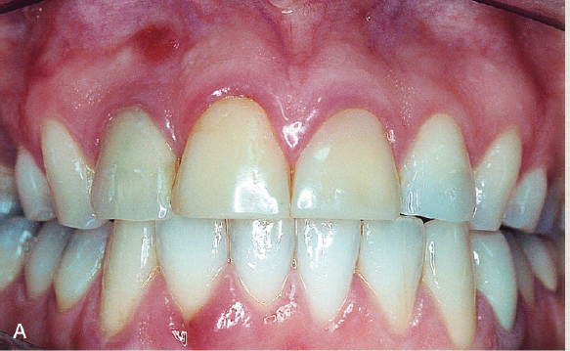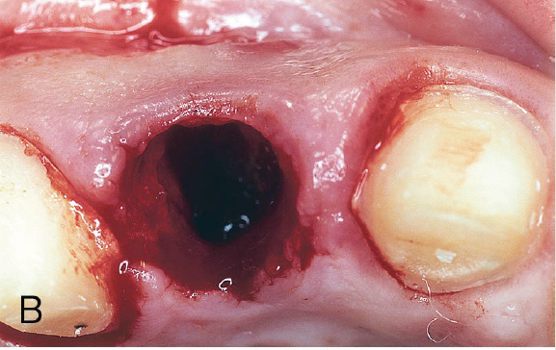
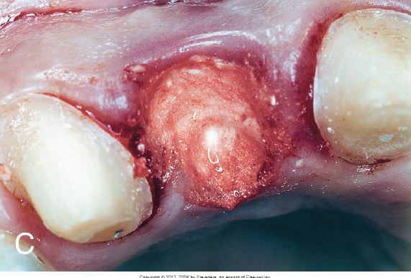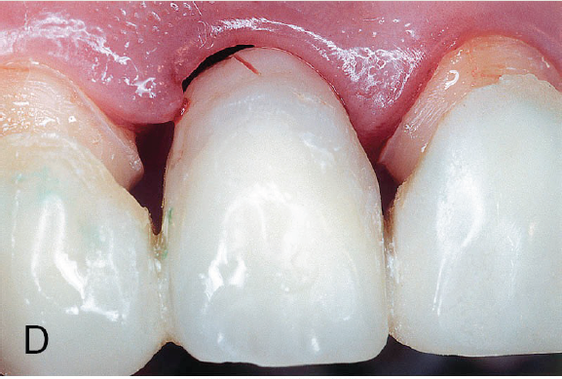
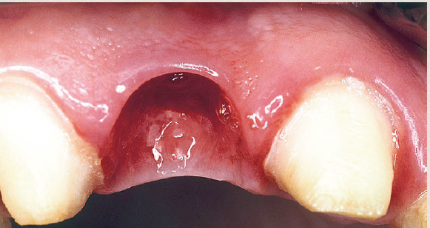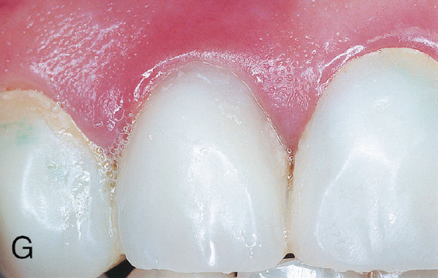

Case :
Cavity extended to crown and root
we remove caries on crown and root then restore the crown cavity only and make new CEJ then we put connective tissue graft . we don’t restore the root the root cavity because the connective tissue graft suppose to adhere to root surface .
one of success criteria for connective tissue graft is no pocket , if we have pocket the connective tissue graft not adhere .

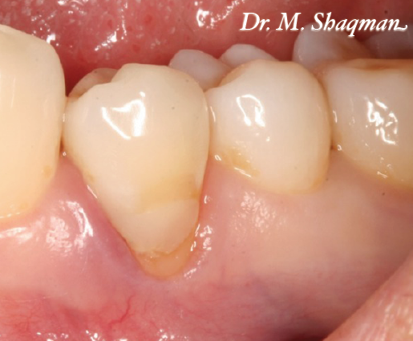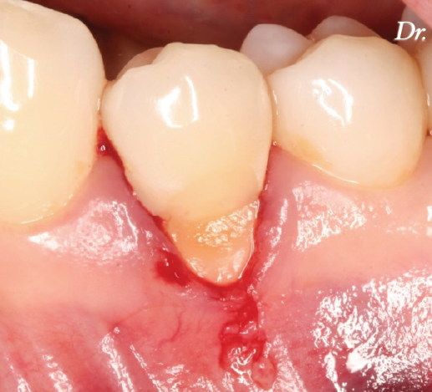
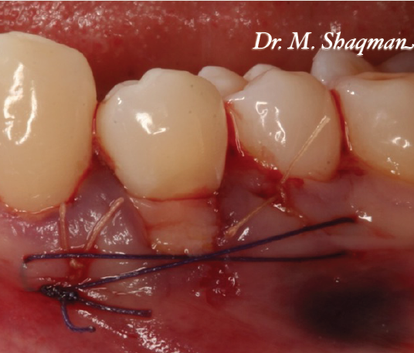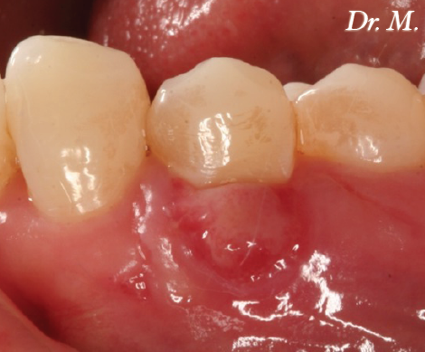
- Preservation of ridge morphology after extraction :
Case :( from last year sheet because I don’t undersand what dr said )

In this case, the patient wasn't happy with her proclined lower teeth (the 2 laterals). What options do we have here ??? Orthodontic treatment >>> the patient wasn't willing to do orthodontic treatment so we extracted the 2 laterals and prepared the canines and the centrals then we did ridge preservation (bone graft); to preserve the ridge shape and to avoid excess shrinkage then we seated the temporary bridge.

Note that we didn't extend the temporary pontic inside the socket because if we did so, we would keep the gingival margin as it was before.

(slide #44) this picture is at the follow up stage, notice the staining on the
temporary bridge due to chlorhexidine mouth wash.

(slide #45) notice the ovate shape of the tissue at the pontic site after healing.

Finally (slide #46) we inserted the permanent bridge (this bridge is made of zirconia so the color matching isn't perfect).
Notice the neck of the right lateral incisor, we made its color more pinkish to improve the appearance and match the gingival level at the other side (because even after grafting, still there is some deficiency in the gingival margin).
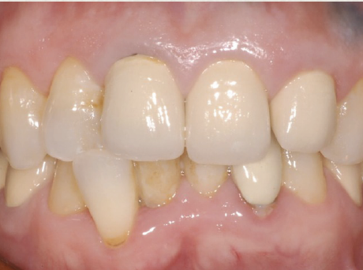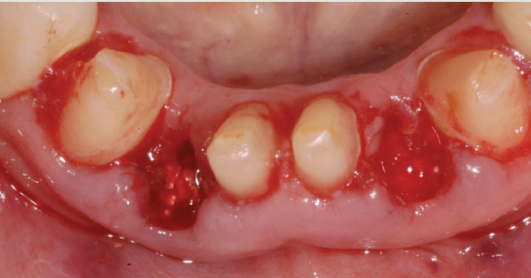

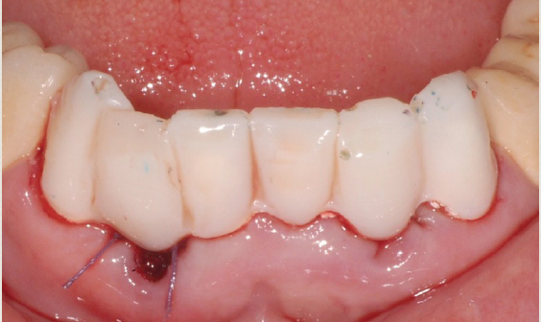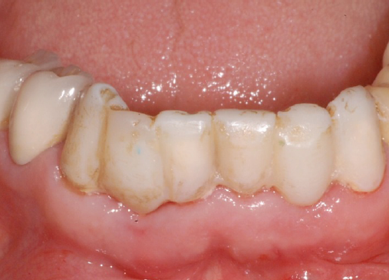

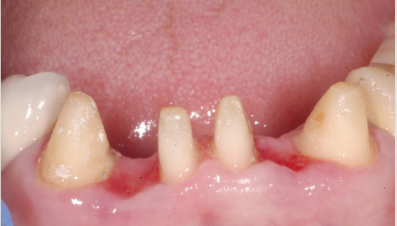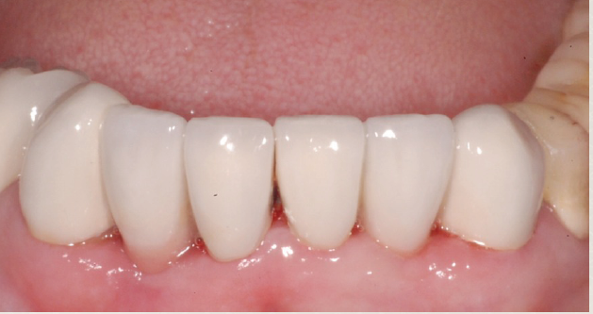

Clinical Crown Lengthening procedures
Indication :
1.To provide retention form to allow for proper tooth preparation, impression procedures, and placement of restorative margins.
2. To adjust gingival levels for esthetics.
3. To preserve the biologic width.

The biologic width: deﬁned as the physiologic dimension of the junctional epithelium and connective tissue attachment
relatively constant at approximately 2 mm (±30%)
Bone “sounding” is used to determine the biologic width for a speciﬁc site.
How to determine the biological width ?
Example :
- probing depth 2mm
-force the probe to crestal bone 4mm (bone sounding)
Biological width 4-2=2mm
Note: before we do bone sounding we give LA .
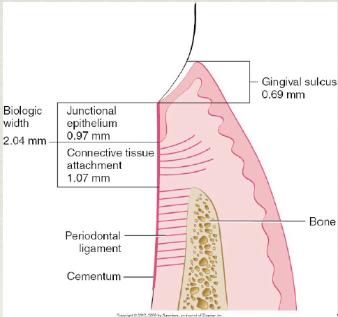

Biological width is junctional epithelium and connective tissue
Biological width not involve sulcus
What happen if we invade the biological width ?either one of two
1- Chronic persistent inflammation ;most common to occur
Swelling ,redness and bleeding
2- attachment loss ; recession or pocket .
Contra-indications of Clinical Crown Lengthening procedures
1. Surgery would create an un-esthetic outcome.
2. Deep caries or .acture would require excessive bone removal on adjacent teeth.
3. The tooth is a poor restorative risk
4. Signiﬁcant invasion of the furcation area is anticipated

Good luck

