6 part 2  Dent-2011.weebly.com | Lecture No.
5/11/2015 | Date:
Dr Suha | Doctor:
Aseel Al-Momani | Done by:
Pediatrics II

University of Jordan
Faculty of Dentistry
5th year (2015-2016)
Price & Date of printing:

.........................................................................................................................................................................................................................................................
Hand Out
Slide
Sheet

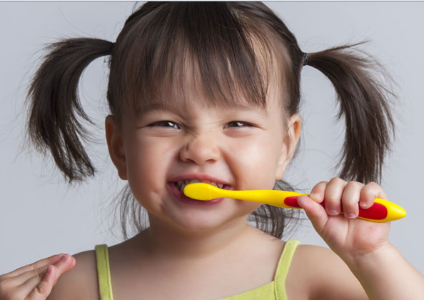
Designed by: Hind Alabbadi

Clinical procedure
- Do we need Local Anesthesia?
Most of the times we don’t, it’s a little bit uncomfortable because we put the SS crowns subgingivally, but most children can tolerate it, if the kid couldn’t tolerate it, we can use topical anesthesia or soft tissue infiltration buccally and lingually. (But most of the time we put SS crowns after we do pulpotomy so the tooth is already anesthesized), But in general if you’re planning to do SS crown we don’t need Local anesthesia.
- Most of the time SSCs are fitted immediately following pulp treatment
- Manipulation of the gingival margin can cause some discomfort.
- It is sometimes possible to use only a topical anesthetic, such as benzocaine ointment on the gingival cuff. -Although topical anesthetic taste can cause some discomfort for the child-.
- Caries removal and appropriate pulp treatment (i.e indirecet pulp capping, pulpectomy or pulpotomy) should be completed if necessary.

Preparation
The preparation is very simple
- Sufficient occlosal reduction to avoid significant occlusal prematurity.
- Occlusal reduction should follow the contours of the tooth.
- Occlosal reduction is carried out to obtain clearance of approximately 1.5 mm
- Interproximal reduction is needed most of the times
- Approximal reduction to allow the SS crown to be seated beyond the maximum bulbosity of the crown. (So the preparation should be beyond the pulbosity of the crown not higher because make it higher than the bulbosity will create a ledge and the crown won’t be seated properly).
- We use Fine tapered fissure bur or needle bur. (we don’t want a finish line to be that clear like in ceramic and PFM crowns).
- It’s important to cut through the tooth away from the contact area to avoid damage to the adjacent tooth, (especially when we preparing an E and the 6 is already erupted we must be
Careful not to damage the 6, sometimes we don’t do interproximal reduction distally so that we don’t damage the permanent molar.

- The bur should be angled away from the vertical so that a shoulder is not created at the gingival margin.
- SSCs are not closely fitting, therefore the preparation doesn’t have to be precise.
- The gingival finish line should be a feather edge with no ledges or steps detectable and should be approximately 1mm below the gingival margin.
- The preparation should finish with a smooth feather edge cervically with no step or shoulder.
- If a step or ledge is present it will be difficult to seat the crown. (y3ni if u choose the correct size, then when you try it, it doesn’t go in, if u check proximally u will find a step, when u remove it , the crown will go in easily).
- The preparation should be rounded off with no sharp line angles.
- Buccal and lingual preparation is not necessary and may be detrimental for retention. (if we prepare the crown will be very loose).

Crown Selection
- A crown should be selected that is a tight snap fit.
- The kit that we use in the clinics is 3M
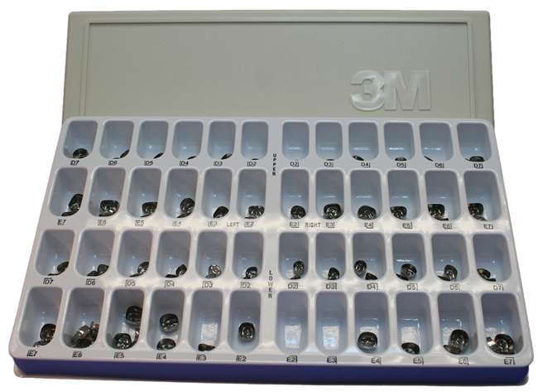
Left right

- Upper Ds and Es , from sizes 2 to 7

- Lower Ds and Es.

- The crowns in this kit are anatomically trimmed and contoured cervically (better retention) require little or no modification and are easy to use.
- Other types of SS crowns have little or no cervical contouring (straight cervically) and routinely require extensive modification.

- Choosing the correct size is assisted by measuring the mesio-distal dimensions of the tooth, or contralateral tooth, with dividers or a graduated periodontal probe. But most of the times you try it clinically, you look at the tooth and try a crown if it doesn’t fit, you try another one until you find the correct size.

- To seat the crown on a prepared tooth that is placed lingually and rolled over the preparation to the buccal margin.
- If we have a tight contact we try to push it over the tight contact side first, then the other side.

- A crown will often make an audible “click” as its springs into place over the gingival undercut area.
- Firm pressure is usually needed to seat the crown.

- The marginal gingiva will blanch somewhat with a well fitting crown as it seats.
- The crown margin should be located approximately 1 mm subgingivally both to give retention and a good cement seal. And there should be at least 1mm sound tooth structure above the gum line to provide good retention, (if one wall of the tooth is totally subgingival the tooth will be non-restorable probably because even the SS crown won’t be retentive).

- If excess gingival blanching is seen the crown might need to be trimmed.
- Trimming can be done with crown scissor or with abrasive wheel. (the 3M crowns usually don’t need this reduction) we don’t like to do reduction because we won’t be able to restore the proper contour for the crown).
- Work away from the patient’s face with proper eye protection.
- The edges are then smoothed and polished with an abrasive wheel.

- After trimming, the crown will have greater cervical opening. (straight cervically, with no contour). so It must be crimped (re-curved) to regain its retentive contour. By crimping plier or we can just use Adam’s plier.

** Although it has been customary to recommend trimming of crowns where gingival blanching occurs, there is no evidence that this practice reduces post cementation

complications. (a lot of times we accept the crown even if there is gingival blanching, u see the patient in the next visit and everything is fine).

- Over trimming of the crown margin should be avoided, as this may affect retention if it results in reduced adaptation of the crown margin into undercut area.

Cementation

- The crown should be cemented with a luting cement.
- we can use Glass ionome, zinc polycarboxylate and zinc phosphate cements.
The best material is glass ionomer because of the fluoride release property, if not present we use zinc polycarboxylate.
- The specific choice of cement does not significantly affect retention.

- SS crowns are not a tight fit except at the margin, so a larger than normal volume of cement should be mixed, and put inside the crown not just at the periphery.
- As the crown is seated over the tooth, excess cement should be seen to flow out from the margins.
- If excess cement is absent from the margins, it is an indication of an inadequate volume of cement which may lead to early failure of the crown.
The child may feel discomfort because of the cement taste, so u have to prepare the child by telling him that he will taste smth “7amed“ , and try to collect the excess cement immediately.
- Mirror handle or band pusher may be used for complete seating.
- All excess cement should be carefully removed and a piece of knotted dental floss used to remove excess cement interproximally.
Occlusion
- Check Occlusion
- The primary dentition has the ability to adjust to (accommodate) a slightly opened bite of 1 mm or so over a few weeks with no adverse effect.
- The patient should be advised that there may be some temporary gingival discomfort when local anesthetic wears off. You can tell the parent to give the child Revanin in case of discomfort, bus most of time they don’t need it.

Gingival Condition
** Studies have failed to show any increase in supra-gingival plaque accumulation associated with SS crowns except in instances where crowns with defective margins have been placed, or where excess cement has been retained.

