15  Dent-2011.weebly.com | Lecture No.
8/2/2016 | Date:
Dr.kefa7 | Doctor:
Farah Al-hares | Done by:
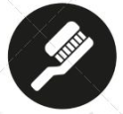
Prosthodontics III

University of Jordan
Faculty of Dentistry
5th year (2015-2016)
Price & Date of printing:

.........................................................................................................................................................................................................................................................
Hand Out
Slide
Sheet

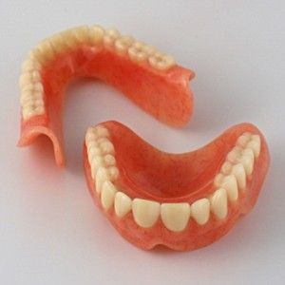
Designed by: Hind Alabbadi

Over-denture 2
Today we will talk about the steps of over denture.
We start with examination and treatment plan :
Patient's medical history: this is very important because the patient will need perio treatment and surgery(extraction) and endo before constructing overdenture. For example a patient who had radiotherapy we have to wait (8 months-2years) before doing any dental treatment for him.
Dental history : important to know patient's attitude towards dental treatment , and to know the cause of his teeth loss if it was due to periodontal disease or caries.
Extraoral examination .
Intra-oral examination : important for abutment selection .
Radiographic examination : periapical x-rays for abutment teeth.
Mounted Study casts.

Criteria for abutment selection:
* Periodontal consideration.
* Number and location .
Tooth morphology.*
* Alveolar bone support.
Endodontic consideration . *
Economical status of the patient. *

**periodontal consideration :
1.active gingival or periodontal disease should be treated.
2. eliminate pocketing of more than 3mm.
3. half of the root should be supported.(not less than 6 mm of root should be supported by bone).

** number and location in the dental arch :
According to number : we should select abutments as much as we can.
According to location :
1. distribuation in whole arch.
2.opposing to natural dentition.
3. avoid neibouring abutments. (it causes wedging effect)
** root morphology :

the teeth most frequently used to support a maxillary overdenture are :

: 1.canines
(Long wide roots , its location at the corner of the mouth and have the highest number of proprioseptors among all teeh)
2. central incisors
3.second premolar
4. first molar (the best one regarding security in the jaw, the disadvantages are : they have low number of proprioseptors , difficulty in endo treatment , more costly to the patient , most of the time they have furcation involvement so it is rare to do ambutation and roundation to a posterior tooth unless it is already endo treated and has a good bone support we would keep it otherwise we use anterior teeth as abutments for the reasons that we mentioned previously in point 1)
5. other maxillary teeth

*the Quadrilateral distribution is the best distribuation (it means that abutments are located opposite to each other in way that is sufficient to support the overdenture )

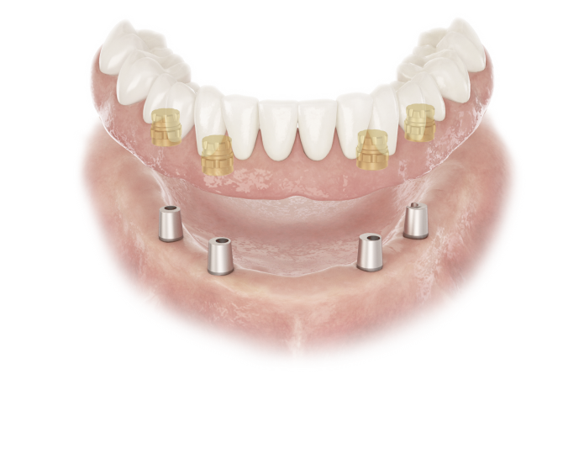

We have the tripodal distribuation but we have to be careful about the distribution of the abutment that we should have two abutments posteriorly and one anteriorly to prevent rocking and instability.

We have to avoid diagonal distribution (one area is supported by hard structure and the other by compressible tissues.)

When we have two neibouring abutments we should select one of them according to "which one of them is easier to do endo for it" ,so I should keep the one with the patent root , straight morphology , less costy , and the one that has calcification (because we don’t need to do endo for a calcified tooth).
Alveolar bone support :
Radiograph assessment of remainng alveolar bone must be made.
Minimum of 5-6mm of bone support should be present .

Sequence of treatment :
1.examination
2.surgery
3. perio treatment
4. treatment of abutment itself after selection
5. preparation of abutment to make it dome shape
6. denture making.
Preparation of abutment :***
We make dome shaping because it is easier for impression making, and because if we have sharp edges we will have stresses that will lead to fracture of the denture , also it gives us better support and stability .
Abutment length
For maxillary anterior teeth :2mm
For mandibular anterior teeth :3mm
Why ? for aesthetic reasons , if the upper was 3mm then the teeth should be longer and that would be ugly.
>> to avoid swallowing or suffocation of the amputated part while cutting of the abutment we have to perforate the crown and put dental floss through the hole and tie it on my finger .
So
1.crown sectioning
2.dome shaping : when we make dome shaping the orifices of the canals will be visibleso I should cover it with amalgam plug , GI (for fluoride).
3. metal coping if necessary.(cover it with metal) :
Indications for metal coping :
1.when the abutment tooth have inadequate length or contour
2.the presence of natural dentition opposing overdenture abutments.
3.if patient with a bruxing tendency leaves the overdenture out of his mouth at night.
Preparation for metal coping :
If I have to make metal coping for only to mimic dome shape we don’t need the length of the post to be more than 4 mm. but if we need to use attachments , the length of the post should be 6 mm.
We have two techniques : direct and indirect.
We need gates gliden , burs and the kit of preparation
We have to start with round bur , then make the finish line with chamfer bur then we put retraction cord , then I have to paint the end of serrated pen with adhesive because the polysulfide needs adhesive then we take the impression . we have to send wax serrated pen with the impression .
Direct technique : I will build it up inside the patient's mouth using dura lay (resin). Dis advantage of dura lay : dimensional changes.

Done by : Farah Al-hares
Good Luck seniors !

