17  Dent-2011.weebly.com | Lecture No.
24/2/2016 | Date:
Dr.Zaid Baqain | Doctor:
Aseel Saleh & Lyn Smadi | Done by:
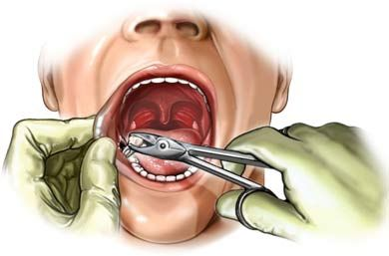
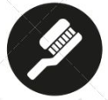
Oral Surgery II
University of Jordan
Faculty of Dentistry
5th year(2015-2016)
Price &Date of printing:

.........................................................................................................................................................................................................................................................
Hand Out
Slide
Sheet

Designed by: HindAlabbadi

Dento alveolar injury
Before Dr start the lecture he mentioned that The viva exams will be on this period (18-22/5/2016
As GPs we will face trauma cases regularly, so we should know how to manage trauma
Trauma is common especially in childhood and adolescence ,almost 40 % of boys 30% of girls suffered from dento alveolar trauma ,its more in maxillary anterior teeth specially if it proclined.
Male 2 times higher than female
We have 2 peaks of ages:
In primary teeth : 2-4 years (start walking and there is no enough balance )
In permanent teeth: 7-10 years (start learning how to ride bicycle , playing outside)
Aetiology:
falls ,violence ,abuse ,sport ,motor vehicle accident ,mediacal procedure during laryngyoscope
More than 5o % of non accidental injured (child abuse) children have orofacial injury
Predisposing factors:
- increased OJ : more than 4mm , class 2 div1
- Insufficient lip closure(incompetent lip ):because lip protect the teeth
- Accident prone children : you see these children always fall

Classification of dentoalveolar injuries :by andreasen 1981
- Injuries to the hard dental tissue and pulp
- Injuries to the periodontal tissues
- Injury to supporting bone
- Injury to gingival and oral mucosa

Injuries to the hard dental tissue and pulp
- Crown infraction (without loss of tooth structre) like craze line ,crack
- Uncomplicated crown fracture ( Fracture enamel/dentine)
- Complicated crown fracture with pulp exposure
- Complicated crown-root fracture
- Root fracture
Slide #6 show examples for fracture types, diagnosed clinically and by radiographs

Injuries to the periodontal tissues:
periodontal tissues: hold the tooth to alveolus
- Concussion: no loosening
- Subluxation: loosening on the tooth without displacement
- Extrusive luxation : partial displacement of the tooth upwards
- Subluxation
- Intrusion: movement of the toot inward
- Avulsion: the whole tooth comes out
- lateral luxation: movement of the tooth to one side and it may lead to cracks or fracture of the socket
Concussion: when you eat and you bite on something hard ,then your teeth become painful ,actually what happen is edema due acute trauma ,the tooth become tender to percussion .
Slide #8 show examples for Injuries to the periodontal tissues

Supporting bone injuries :
- Comminution: the socket is intact and has so many cracks , occure in intrusion and lateral luxation
- Fracture of the socket wall
- Fracture of the alveolar process(teeth out of occlusion)
- Fracture of the jaw
Slide #10 show examples for Supporting bone injuries :

Injury to the gingiva and oral mucosa:
- Laceration
- Contusion
- Abrasion

Management:
History :
We should take history very careful and it should include :
- Who?
- When did it happen?
- Where did it happen?
- How did it happen?
- What treatment was provided ?
- Anyone noticed any tooth fragment beside the pt ?
- Is there any loss of consciousness ,nausea or vomiting to diagnose head injuries
- Is there any change of the occlusion ?
If there any discrepancy between the history and clinical findings >> think in NAI and child abuse
If there is a Loss of consciousness or missing tooth fragment: we need to take chest x-rays because we should know where the fragment due risk of aspiration .
Examination:
Extra oral :
We examine all face, scalp and neck in systemic way to discover any life threatening condition
Intra oral:
Check Mobility, Percussion, Color of the tooth, Vitality test even it not sensitive and occlusion by asking pt to occlude to know if there any intrusion .
Radiographic examination
Radiograph is a must in trauma cases but we should take it after history and examination
periapical x-rays : long cone technique, two different angles coz if the beam didn’t penetrate the plane of the fracture line u will not see it
Occlusal x-ray: when pt cant open his mouth ,detect root fracture and displacement , lateral soft tissue
OPG: jaw fracture cases
In trauma cases “One x-ray is not enough
In severe cases of truma maybe we need cone beam CT ,but always start with good quallty of periapical x-rays
Treatment of primary and permanent teeth –Dr skipped it
There is table in slide #22 the Dr focused on it
-In crown root fracture we should know its level
-Nowadays when we do extraction we try to preserve the bone as much as we can specially buccal plate because we think in implant .if you break the buccal plate during extraction you should tell the patient we need second surgery to do bone graft .
Facts on root fractures
- 80% remain vital
- Coronal displacement related to loss of vitality
- Apical fragments always vital
- RCT in middle and apical 1/3 fractures to the coronal segment only then we follow up the pt maybe we need apexectomy .
- Pulp obliteration is a common post trauma finding due to intra pulpal bleeding after trauma
So the management depend where the fracture occurs, if it coronal and mobile the tooth will be extracted

Root response to trauma in different ways :
- Calcification
- connective tissue
- Bone and connective tissue formation
- Contamination if fracture coronally and communicate with gingival crevice

Injuries to the periodontal tissues:
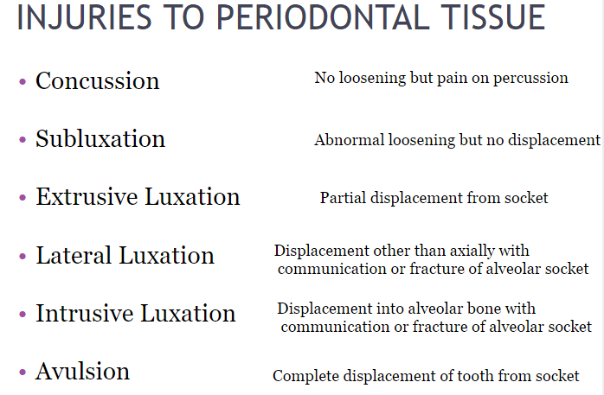

When Trauma and damage to PDL was sever we will have more damage to pulp that’s why :-
-when we have intrusion we will have necrosis
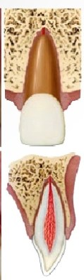
-in avulsion we interest in a time where the tooth stay out socket because it will affect the vitality of PDL

Concussion
edema in the PDL cells
Managed by occlusal relief, soft diet for a week, no need for Antibiotics, NSAID to relief pain, if the tooth is tender to percussion ,you might use functional splint .

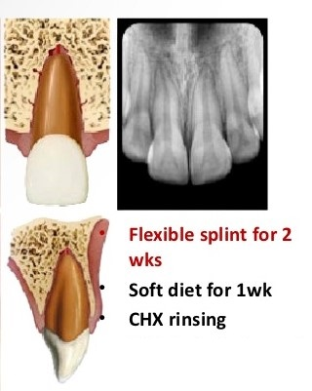
Subluxation:
edema and rupture of some PDL cells
managed in same way of Concussion but the chances of use functional splint more .
-in the tooth has an open apex u don’t need to splint
wide open apex if there is movement the blood supply will not be cut BUT if we have closed apex any movement will cut the blood supply and necrosis will happen

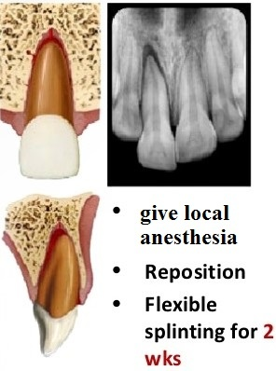
Extrusive subluxation :
rupture of the PDL fibers
managed by give LA to do gentle repositioning ,functional splint for 2 weeks , we give antibiotics and mouthwash ,Rct if needed and we instruct pt to eat soft diet for 2 weeks .
Splint
1 –rigid
Not allow any movement lead to ankylosis, we use composite only
2- functional
Wire and composite on one tooth after and before, it allow tiny movement which important to maintain the vitality of pulp.
Also we can use the aluminum foil that present on x-ray film to splint the teeth .
Antibiotics (VIVA QUESTION )
Rule of antibiotic choice : 1) effective 2) safe 3) cheap
-Amoxcillin :broad spectrum AB
adult dose 500mg 1*3 ( one pill every 8 hours )
if pt allergic :
-clindamycin
600 mg in day (4 pills in a day)
Best analgesic is ibuprofen 400 mg , maximum dose 2400 mg ,but we sure the pt doesn’t have history of active GI disease or kidney disease .
Ibuprofen should be taken after eat and pt should drinks a lot of water.

Generally speaking, if there is mobility we use functional splint for 2 weeks to prevent ankylosis. Micro movement is helpful for periodontal regeneratin. If there is rupture in the periodontal ligament and there is bleeding you give antibiotics>>what antibiotics do you give? Amoxicillin.
If the patient has concussion and pain… what pain killer do you give? Ibuprofen.
- Mouth wash
- Root canal treatment if required
- Always soft diet
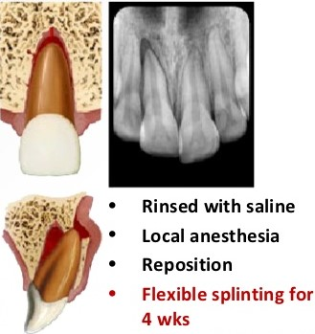
** Lateral subluxation
- You need to give local anesthesia to reposition
- Because there is a possibility of presence of fracture you might need a functional splint for more than 2 weeks. Anyway, you need to see the patient after 2 weeks and what do you do? You take an X-ray. Before you remove the splint you have to take an x-ray.
- If there is an alveolar fracture and you know that, you will need to do a rigid splint because you need to allow the bone to heal.
- Antibiotics, and mouthwash
- Soft diet

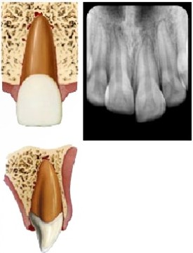
** intrusive luxation
- In cases of closed apex the chances for the loss of vitality is higher
- You need to reposition and stabilize (How to do that? You give local anesthesia and using forceps you pull it out slightly , or by orthodontic extrusion )
- You have to put a functional splint
- You need to think about the loss of vitality; usually the pulp becomes non vital so you have to start the root canal protocol (non setting Ca(OH)₂ dressing then GP) we’ll not talk about it in details.
- There is a suggestion to start the root canal treatment early
There is evidence that if a patient came having intrusion with a closed apex and you start immediately after you reposition and stabilize and you opened an access, extirpate the pulp and you put antibiotic and steroid medicament and after 2 weeks you provided root canal treatment you minimize the chances of root reactions.
Antibiotic and steroid medicaments minimize the chance of infection and inflammation and thus minimize the chance of root reaction to the inflammation.
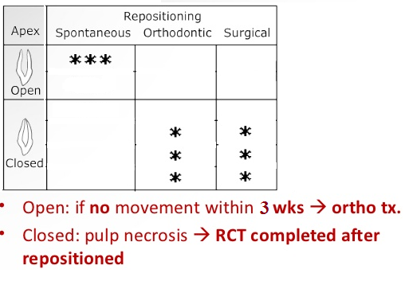
For all types of trauma the immediate management is good, but later on you have to deal with sequel related to root reactions.
In cases of intrusion, if you start your root canal early the chances of root resorption or ankylosis become less
- In cases of intrusion with open apex
- You have the option, depending on how much it is intruded, whether you want to leave it to erupt alone since the root is incompletely formed or you can refer it to the orthodontic department to be pulled slowly or you can do disimpaction and surgical repositioning.
- You need a functional splint
- The pulp extirpation protocol depends on your judgment for the degree of intrusion; sometimes a child came with severely intruded tooth and the crown is barely seen, and sometimes the intrusion is very minimal that you decide to leave it to disimpact and follow it up in this case if it doesn’t disimpact in 3 weeks you will start thinking about an ortho movement (you need to monitor in these cases).
- These cases are not easy to deal with; when it comes to an actual patient setting in front of you it’s not easy to take the decision. However, as long as you go along one of these rules of management it will be fine.
** Avulsion and replantation
- Replantation should always be attempted.
- Prognosis depends on the extent of damage to the pulp and periodontal ligament.
- The PDL of the avulsed tooth is still there with the cementum and you want to maintain the vitality of the cementum
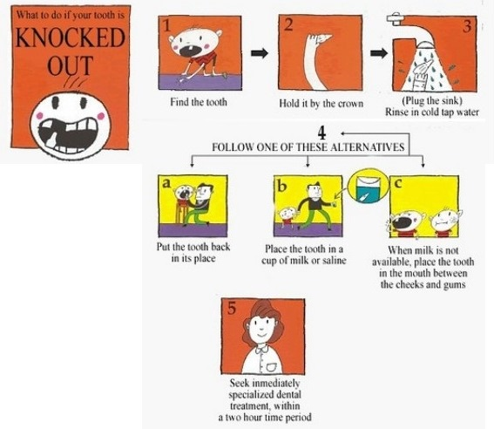
- This depends on the extra alveolar storage medium and time.
- Best transport medium: leave it in the socket, milk (if a parent called you saying that his child’s tooth was avulsed and asked you what to do? Told him to wash it and put it back in in the socket if they can’t do that told him to put it in milk (low fat or whole fat) ), special storage medium, saliva (if the patient is an adult and can put it in his mouth) and normal saline (the worst from these options but can be used).
- Own socket and milk are the ones that are more readily available. Don’t open a milk bottle and put the tooth inside since it will be very difficult to take it out :P

** Replantation procedure
- You have to be careful not to handle the root and hold it from the crown
- Rinse it with normal saline and now while you’re working you keep it in normal saline because it’s few minutes only until you start replanting the tooth.
- You have to give local anesthetic, you irrigate the socket, you remove clot and debris (Don’t use currete to do debridement for the socket that way you will remove whatever periodontal ligament still there)
- Hold the tooth from the crown and place it back in the socket.
- You need to do non rigid fixation because if you do a rigid fixation ankylosis will occur.
- Place it out of occlusion and you take an x-ray
- Give antibiotics and you have to make sure the patient had received tetanus vaccine before. (because the tooth might have been contaminated with soil for example)
- In follow up you always take radiographs.
- Always in your clinics keep a stainless steel wire to be able to deal with these cases and to do fixation. Have more than one type of wires; rigid and flexible. Functional splint is curved and you fix it on one tooth from each side. If you fix the wire on 2 teeth or more from each side it’s more of a rigid fixation. In functional splint you need to make sure there is still micro movement and you take it out after 2 weeks.
(EAT: extra alveolar time). There is a debate about the EAT some people said it’s 45 mins and others said it’s 2 hours. Generally, the temptation will always be in you to try so either EAT was 45mins or 2 hours you can try, however the shorter the better.
- In cases of open apex, the chance of keeping the tooth vital is still there. you do the same protocol of management and you observe because revascularization is possible and you perform root canal treatment when signs and symptoms, such as discoloration, pain, swelling, acute dentoalveolar abscess, sinus tract is observed or any sign indicating that the tooth is dying, happen.
- In cases of open apex and EAT was more than 2 hours. 2 hours EAT will make the chance of revascularization almost impossible. The difference here that if you’re in doubt about EAT you need, after the general protocol mentioned before:
- to open up the pulp in the same visit and put the antibiotic/ steroids
- and then after 2-3 weeks start with a non setting Ca(OH)₂ dressing
- and then you review until there is apexification to fill Gutta Percha.

For example, a child came with avulsed tooth and EAT was 3 hours and the tooth was with an open apex, you hold the tooth, rinse it with normal saline, replace it inside the socket, put functional splint and you should open the pulp in the same visit, do pulp extirpation and put (AB/ steroid) medicament, then you see the patient after 1 week (max 2 weeks) and you open the pulp again and put non setting Ca(OH)₂ to achieve apexification and review the patient every 3 months until there is an apical stop and then you do the root filling(GP).
- In cases of closed apex: (the difference here is that we don’t need long time because no apexification is needed like in cases of open apex)
- You put intracanal medicament, first 2 weeks, then
- Put non setting Ca(OH)₂.
- GP
(You follow this protocol to prevent the resorption in the root.)
- If dry storage time was more than 1 hour then:
- Remove cementum and PDL (periodontal ligament)
- And you place the tooth in either citric acid, stannous fluoride solution or anything for 20 mins to disinfect the tooth and remove the cementum (dead cementum).
- Then you replace the tooth and you can do the root canal outside before replacement in the socket.
How to remove PDL? You do curettage for the socket and using a blade shave the cementum on the root.

- You need to take regular x-rays and to do regular follow up
- What happens if you noticed in the follow up that the root is undergoing resorption? You keep the Ca(OH)₂ and you change it regularly until it becomes hopeless then you take it out.
** Root response to trauma
- Periapical inflammation: the easiest one, if acute dentoalveolar infection happens you do a root canal treatment.
- In cases of open apex the root could become stumped; arrest of root development happens.
- Root resorption
- External inflammatory resorption
- internal inflammatory resorption
- pulp canal obliteration (calcification)
- the worst type of root resorption is ankylosis, the most serious esp in children because it also affects jaw development.
**Root resorption
- External inflammatory resorption:
- It occurs due to necrosis in the root caused by necrosis in PDL.
- Usually it happens within 3 weeks of injury, unlikely to happen after 1 year >> this is very important
- Most likely to happen with intrusive and replantation >> most severe types of trauma
- What do you do? Immediate extirpation of the pulp, debridement, non setting Ca(OH)₂
- Even after this management the resorption could continue. Even If resorption continues you leave the tooth because resorption could stop with non setting Ca(OH)₂.
- Pulp canal obliteration (calcification):
- It happens frequently in injured teeth, 35% of injured teeth.
- It doesn’t affect too much; the tooth becomes yellow or opaque.
- You don’t need to manage it
- Ankylosis:
- Most severe type
- Usually it happens with replanted teeth with extended extra alveolar time esp in dry conditions because damage to PDL and cementum happened.
- Usually it starts happening within 2 months to 1 year, and it’s slowly progressing. After 1 year it’s unlikely for it to be ankylosed.
- High metallic sound on percussion.
- Don’t do anything for it
- The problem is when you want to extract it
Using early medical treatment to the pulp reduce the chances of ankylosis.
** Injuries to the supporting bone
- Repositioning
- Rigid splinting for 4 weeks because there is fracture
- Antibiotic, soft diet, chlorhexidine mouth wash, tetanus check.
- Pulp survival of the tooth; you treat the fracture first then you take care of the teeth. Pulp survival more likely to happen if repositioning achieved within 1 hour.
Splinting using composite (a rigid fixation) is challenging; it’s difficult to achieve dry field.
**Splinting
- Splinting as soon as possible
- The purpose of splinting is to help you to achieve PDL regeneration (Healing of PDL).
- There are some examples in the slides. there is an arch bar which is an example of rigid fixation and is usually used in cases of intra alveolar deformity
** Soft tissue injuries to the oral & maxillofacial surgery
- Initial evaluation and resuscitation
- You need to arrest bleeding
- Tetanus
- Management
- The face and orofacial region is unique; it’s highly vascular and thus healing potential is good. The golden hour or the golden period doesn’t exist; in other regions the sooner the suture the better in order not to loose vascularization, and this doesn’t apply on facial wounds.
- What’s really critical in facial wounds is the facial nerve. You always have to examine the facial nerve and report any sort of paralysis in any of its branches before you even give the local anesthetic. If you don’t report it preoperatively the patient may claim that your suturing and debridement caused damage to the facial nerve. So it should be reported.
** Tetanus
- If the patient didn’t take any booster, when do you worry about tetanus? You worry about Tetanus if there was soil or manure (زبن) , devitalized tissue (necrotic), or deep puncture wounds. You need to ask the patient about tetanus.
- If the patient didn’t take Tetanus vaccine in the last 5 years he has to take Tetanus booster.
- If the patient didn’t take Tetanus vaccine at all (is not immunized), then he will undergo special regimen and will receive immunoglobulins.
** Types of soft tissue injuries:
- Abrasion (خدش)
- It occurs as a result of friction, usually it’s denuding the epithelium and occasionally involves deeper layer
- Painful
- Bleeding is usually minor
- If it was a superficial abrasion: use any of the disinfectants that are compatible with human use and use copious normal saline >>> and generally, you don’t do a dressing, just leave them to heal on their own.
- If it was a deep abrasion: you need local anesthetic since you might need aggressive cleansing use a surgical brush or a tooth brush (the wound might be contaminated with soil or anything that is difficult to clean (زفتة) ), you need antibiotic ointment and a light bandage.

- Contusion
- It differs from abrasion that in contusion the skin is intact and hematoma occurred underneath.
- Usually as a result of blunt trauma.
- You have to put ice on it
- In maxillofacial region you should make sure there is no underlying bone fracture (for example in zygoma, maxilla, mandible). It could actually indicate a bone fracture. You need follow examination.
- If it’s an expanding contusion then it might be a bleeding vessel and will need special and urgent attention.
- Lacerations
- There is a violation to the epithelial and subepithelial tissues and there is bleeding.
- You need to stitch in these cases.
- Is caused by sharp objects
- If it was combined with dentoalveolar trauma you treat the fractures first, dentoalveolar trauma and then you look after the laceration.
- Management: you clean >> debride; you might use surgical brush with disinfectant >> you achieve hemostasis using electrosurgery >>> then you do suturing.
- Sometimes when there is a laceration and the object that caused it is dirty, and the laceration has ragged margins and is dirty, you need to clean it and you need to excise these horrible edges before you suture it.
- Closure
- What matters to you as a GP, small laceration in the mouth do you suture or not? It makes a big difference even for a child, so you need to decide
- Generally, any laceration inside the mouth if it doesn’t bleed >> no sutures are needed. Because saliva has a lot of healing potential.
- If there is a continuously big gaping laceration you will think about suturing.
- It depends on the depth and location.
- The most difficult wound is that involving the vermilion border at the mucocutaneous junction. It is extremely important because it’s an aesthetic area. When stitching you should put the one at the mucocutaneous junction first to do alignment if there was a difference even 1 or 2mm will leave mark to the rest of the patient’s life and it’s very difficult to fix later.
- When the laceration is involving more than one layer (mucosa, submucosa, and muscle) you start with deeper layers first. If it was involving the lip, you start inside out, because out is aesthetic.
- When you reach skin you need more filament non resorbable sutures, you always use very small sutures in order not to leave mark polyne nylon. In muscles you need resorbable stitch (vicryl for example). In mucosa it doesn’t matter what you use, but usually you use silk or vicryl.
- In lip you start with mucosa then muscle then skin.
