11 part 2  Dent-2011.weebly.com | Lecture No.
31/12/2015 | Date:
Abedrahman Shqaidef | Doctor:
Dalia Waia | Done by:
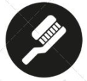
Orthodontics II

University of Jordan
Faculty of Dentistry
5th year (2015-2016)
Price & Date of printing:

.........................................................................................................................................................................................................................................................
Hand Out
Slide
Sheet

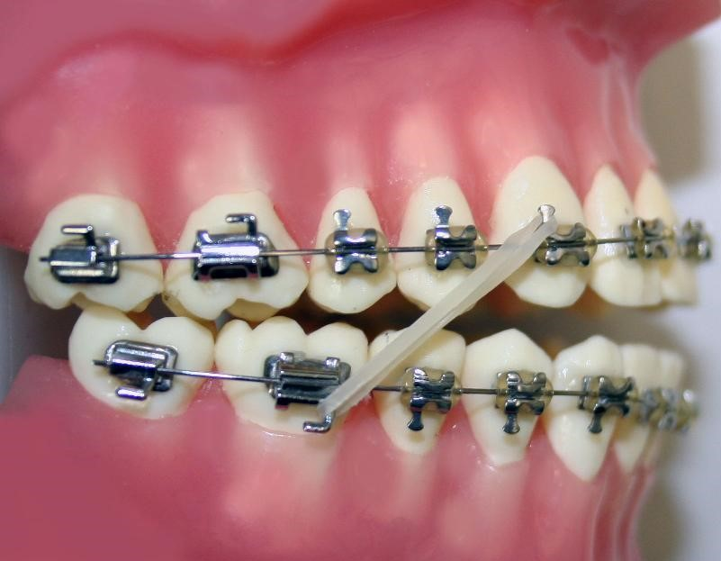
Designed by: Hind Alabbadi

Intraoral assessment
(Starting from page 11 in the slides-note that the entire lecture is about 2 patients, a male and a female)
We check the patient's overjet, overbite, any crossbites, etc... We are not going to go through this because we already know it. The first pictures are of the patient Megan and this is how she bites. She has a class III incisor relationship, negative overjet, generalized crossbite, and mild crowding in the upper and lower arches. The guy is a typical class II div II malocclusion; with retroclined upper incisors and slight crowding in the upper and lower arches. Now that we finished examining the patient we need to move to the next step and plan.
Planning
We have to properly diagnose and then to plan well and know what we are going to do for our patients. In orthognathic surgery we start planning from outside to inside so one should look at the patient from the outside and think about the surgeries that will improve his outer appearance and then move to the inside and fix his teeth. We don't fix teeth without caring about the outer appearance.
For the male patient: the type of surgery to be done is advancement of the mandible and nothing for the maxilla. As we said, he is a class II div II patient and if we procline the upper anteriors we might provide a little support for the nasolabial angle. For this patient in the anterior-posterior dimension I have to move the mandible forward. We don’t need to do anything in the vertical nor the transverse dimensions.
An important question is how much should we advance the mandible? Does it depend on the ANB? It doesn't. We don’t treat patients according to numbers. These are the normal values. We move the mandible until it reaches the zero meridian line and until he has a good esthetic profile. But that brings up another question: in surgery we move bone, what happens to soft tissue? It's going to follow bone but the ratio is different. Each area in the face moves at a different proportion. In the mandible generally it’s a 1:1 ratio, if I move the mandible 1 mm soft tissue is going to follow by 1 mm as well. In the maxilla if I move it 1 mm the soft tissue will follow two-thirds of this distance. That’s why we have to do more bony movement in the maxilla. This is very important in the diagnosis and planning. So for this patient we need to move the mandible forwards approximately 8 mm. We look at the incisal show to determine whether we should move the maxilla vertically but in this case we don't need to.

For the female patient: In the anterior-posterior dimension, we need to bring the mandible backwards (not much-5mm) and the maxilla forwards (by 7mm). Vertically do you have to change anything? The increased lower facial height should be corrected but if we do impaction for the maxilla it will affect the incisal show so it is better not to do anything. In the transverse dimension, an asymmetry is present so we need to change it. As you set the mandible back you set it at an angle to correct the transverse relation at the same time.

Most common types of surgeries (in brief):
- Le Fort 1
Used to advance the maxilla
Basically the cut is under the nose all the way to the tuberosities and then the maxilla can be moved forwards but we can't move it backwards. Moving it backwards is too complicated and the mandibular condyle would interfere with that as well so we don’t set back the maxilla using this procedure.
- BSSO- Bilateral sagittal split osteotomy
The most common surgical procedure for the mandible. We can move the mandible forwards and backwards using this one. Plates are used for fixation of the mandible.
- Segmental Osteotomy.
In all previous surgeries we did not do anything to the teeth. (An example in the lecture) In this patient who has an anterior open bite and proclined upper incisors. I want to bring his teeth back and at the same time I want to do impaction only for the posterior part of the maxilla. So what we do is extract one premolar then in surgery we remove blocks from the maxilla. The surgeon is going to segment the maxilla into different pieces. There are important demarcating lines which indicate where to cut inorder to get those segments.

Sequence of treatment
History and examination->Planning->Presurgical orthodontics->Surgery->Post-surgical orthodontics.

Pre-surgical orthodontics
Pre-surgical orthodontics cannot be done with removable appliances. We always use fixed appliances. The aim of it is to place the incisors in a correct anterior-posterior, vertical, and transverse position which allows the surgeon to perform proper surgical movements.
It constitutes of four components:
- Decompensation
What is dento-alveolar compensation?
It is when the dentition tries to mask the skeletal problem. The female patient is a class III patient. Dento-alveolar compensation manifests as retroclination of the lower incisors and proclination of the upper incisors. So you find that the upper incisors in relation the maxillary plane are 120 degrees (proclined) and the lower incisors to the mandibular plane are 79 degrees (retroclined). For that patient we need to move the maxilla forward and the mandible backwards so the overjet will increase during the surgery.
We can't move the jaws like that, so what we will do is remove the dentolaveolar compensation and we do decompensation. Lower incisors proclination and retroclination for the upper incisors so that the overjet will be very little and that way after surgery it can return to normal values. It is very important to tell the patient before we start that they will look worse during the treatment.
As mentioned, the male patient is a class II div II and the surgery will be in the mandible. The mandible is going to get advanced by 8 mm so how much overjet should we have before we send him to surgery? 10 mm. 2 mm overjet and 8 mm for the surgery. So we have to do proclination for the upper incisors and retroclination of the lower incisors. One of the major mistakes that used to happen in the past is that they used to take a ceph and do analysis for that they would find that this upper incisor is 91 degrees so what do they do? They would procline it until it reaches 109 degrees (the normal value), but we don’t care about these numbers. What we care about is the advancement of the mandible until we achieve an overjet of 2mm eventually. We care about surgical moves.
The male patient had a massive overjet before surgery.
2- Alignment and levelling
Alignment: relief of crowding. The patient before surgery should have well-aligned teeth without any crowding.
Levelling: we should have a flat occlusal plane. The occlusal planes should all be at the same level. It would be easier for the surgeon to move the jaws and get the proper occlusion that way.

We have two exceptions for this where we don’t do full alignment and levelling:
(Page 17) Patient is Abdullah and his chief complaint is that he has an anterior open bite. He has a reduced incisal show. The treatment plan was to bring down the upper anterior teeth surgically not orthodontically. Why? If I do orthodontic treatment and do extrusion of the incisors then the results would be very unstable and relapse will most likely happen. He is also a class III so you need to move the upper incisors forward. If we do alignment and leveling what will happen? He has three occlusal planes, if we put a continuous wire then extrusion of the incisors will happen so you will not need surgery anymore. Instead, we can bend the wire so this way we can create multiple occlusal planes and we don’t do leveling and alignment. The patient will then undergo segmental osteotomy. He will end up with a normal overbite.
Note: The doctor mentioned only one exception…

3-Arch coordination
Remember in functional appliances when we do advancement of the maxilla we will end up with a crossbite because you would be moving the wider part of the mandible forward towards the narrower part of the maxilla. A similar principle lies here:
If I only moved the mandible forward everything will be in class III. In that case I should anticipate the occurrence of crossbites. So at the end of the treatment we will do expansion posteriorly. How do I make sure of this expansion? By taking study models for the patient and articulate them and check whether he will have a crossbite or not. If he will then expansion will be needed.
For this female patient will I need expansion or not? (Page 19)
No. I will move the mandible backwards and maybe the crossbite will be relieved altogether. So for these patients and for other patients where it would be easier to relieve the crossbites after surgery we postpone the arch coordination until after surgery in a phase called post-surgical orthodontics.
4-Creation of space for osteotomy cuts if segmental surgery is required
For patients who will undergo the osteotomy procedure. Where will the grooves be were the surgeon will get the saw and cut? We have to create a space before this type of surgery. For Abdullah (page 19) this space was created by using a Ni-Ti push coil which will push the teeth away and will create a space.

Preparation for surgery.
We did the treatment plan for the patient and orthodontic treatment and now it is time to prepare him for surgery. How will the surgeon know how much to cut or move? You can give him numbers but during the surgery he will not be able to tell. In Model surgery we take an impression and facebow record and mount on the articulator. (Page 21 for reference) Let us assume that we only want to advance the maxilla. We mount the casts and then draw lines. Then we get a saw and we cut and move the maxilla as we want it and measure the difference between the lines before and after. You can do the same thing in the vertical dimension as well.

