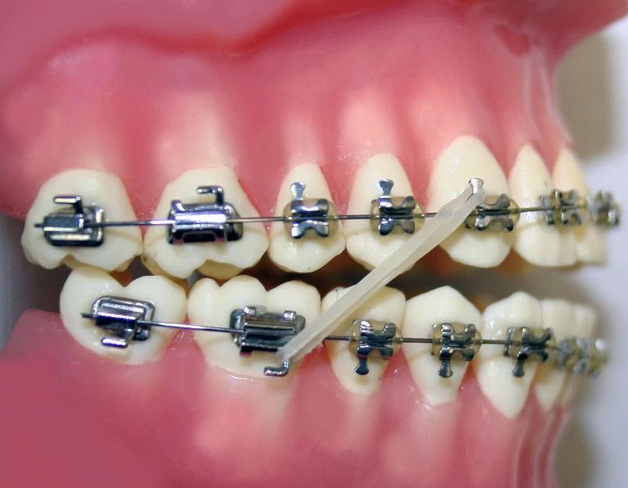

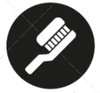

4 | Lecture No.
29/10/2015 | Date:
Dr.abedalrahman shqaidef | Doctor:
Fida'a AL-masaeid | Done by:

Last week we talked about class 2 div 1 , today we are going to talk about class 2 div 2 .
Lecture outline:
- Definition.
- Aetiology/features.
- Management .
Mainly we are going to talk about features and aetiology .
Definition:
- Lower incisor edge occlude posterior to the cingulum plateau .
- Upper incisors are retroclined .
- Overjet reduced.
Aetiology:
- Skeletal
- Soft tissue
- Dental factor
Skeletal:
Anti-Post:
- Pic: class 2 div 2 / if we put our lines(Frankfort and zero meridian ) it is very mild class 2 .
- Another pic : he has class 2 div 2 but if we look to him he has very sever class 2.
- Third pic : class 1
- So Class 2 div 2 can be with mild or sever class 2 skeletal and can be with class 1 skeletal and even class 3.
Generally speaking Anti-Post skeletal relationship is not really related for the etiology of malocclusion . it is feature more than etiology of class 2 div2 .( note : Anti-Post etiology in class 2 div 1 ).
Vertical :
We put Frankfort plane with mandibuler plane >> in all cases in the slides the lines cross posterior to occiput >> so these patients have anterior growth rotation of mandible.
- We can say 95% of patients class2 div 2 have anterior growth rotation of the mandible .
- صورة ممثلة أجنبية : she has class 2 div 2 ,if we look to maxillary mandibuler plane angle >> they are parallel >> she has anterior growth rotation of mandible >> effect of this we can see it by lines ( from glabella to subnasal / subnasal to menton ) >>reduced lower facial height >> result in deep bite .
- Anterior growth rotation not always cause reduction in lower facial height or deep bite .
- كارول سماحة : she has anterior growth rotation ,, if we look to facial proportions we can see they are equal >> she has long ramus >> square face.
she has anterior growth rotation but this anterior growth rotation not result in reduced lower facial height.
- So anterior growth rotation not necessarily cause deep bite or reduced lower facial height .
- If we look to these three patients ( كارول سماحة , الممثلة الأجنبية , واحد أشقر (>> all of them has class 2 div 2 >> all of them have prominent chin .
!بس أعالجهم class 3 لازم أدير بالي عشان ما أخليهم !
- الممثلة الأجنبية : typical class 2 div 2 , prominent chin , square face , high lip line .
- What is more important for us ,usually these patients have strong muscles ( well developed masseter muscle ).
- They do study >> patients with anterior growth rotation and patients with posterior growth rotation and they measure biting force >> they found that the biting force result for anterior growth rotation 3-4 times more than biting force result from posterior growth rotation.
- Class 2 div 2 Patients have increased Gonial angle ( angle between ramus and body of the mandible ).
Transverse :
Generally speaking the only patients have asymmetry are class 3 patients .
- Class 2 div 2 have another problem >> they usually have a broad maxilla( wide and short at the same time ) and narrow mandible >> in dental feature this can make cross bite (scissor bite ).
Soft tissue:
- High lip line >> retrocline of upper and lower incisors
- Strong muscle ( high muscle tonicity )
- Soft tissue is the MAIN cause of class 2 div 2.
- Pic : right lateral incisor not retrocline because it is not covered by the lip .
- Another pic : retroclined centrals and two laterals are not covered by lip >> it is TYPICAL feature of class 2 div 2 .
- The main cause of soft tissue hyperactivity of lower lip >> lower lip try to push everything backward and in the same time these patients have prominent chin and prominent nose sometimes!
Dental factor :
- Crown root angle ; angle between long axis of root and long axis of crown >> another main reason of class 2 div 2 this angle is REDUCED>> so the incisors tip back>>in this case it is not lip effect .
so these two factors are the main reasons to have class 2 div 2 more than other things which are features of malocclusion .
- Arch length : we draw line between mesial surfaces of sixes in both sides and vertical line to incisor edge . to compare the effect of retroclination of incisors >> the arch length reduced in class 2 div 2 >> result in crowding ( generally speaking the crowding will be in anterior segment in upper or lower arches ).
- Broad maxilla and narrow mandible >> scissor bite.
- Deep bite >> not result because anterior growth rotation only but also because retroclination of upper and lower incisors ( sever deep bite can result in trauma and maybe rescission of labial surface of lower incisor ) .
- Moler relationship >> they usually have class 2 buccal segment relationship .
Management :
Options are : Accept / Growth modification / Camouflage / Orthognathic surgery
We look at patient’s 1- age 2- concern 3- profile
- The special feature of class 2 div 2 malocclusion is chin prominent .
- Pic : chin is problem >> if we do advancement of mandible >> patient will look class 3 >> so we have to do surgery called chin plastic .
- Pic : no esthetic problem ,, mild crowding ,, no trauma from overbite >> so accept .
- Pic : class 2 profile ,, prominent chin but not sever >> if I try to treat this patient I will try to push mandible forward >> to push the mandible I can use functional appliance >> in this case I will transfer this patient to class 2 div 1 by proclination of upper incisors ( functional then fixed or I will put z –spring in removable appliance ) .
Smart Q ; how to take bite of this patient ?? I will do reverse overjet ^^
{ in patient mouth the overjet 2mm , if I will do advancement of mandible 8mm ,,overjet will be -6 ,, so I will procline upper incisor 6 mm }.

- Pic : class 2 div 2 with prominent chin ,,she is growing ,, shall I do advancement of mandible ??of course no because she has prominent chin . problems in patient mouth : crowding + deep overbite .
How we can treat deep overbite ??
- Proclination of upper and lower incisors .
- Flat anterior bite plane ( when overeruption of posterior teeth >> overbite reduce ).
- Intrusion of incisors : bypass arch wire ( we use it to intrusion of incisors ).
Every action has a reaction >> if there is intrusion in anteriors there is extrusion of molers >> the easiest is to do extrusion of molers rather than intrusion of incisors >> with new technology we can use mini screws to do intrusion .

Another problem is crowding ! how to provide space ??
- Enamel stripping .
- Proclination ( 2 in 1 >> space and reduce overbite )
- Extraction.
- Distalization :we don’t like distalization in this case , because when we distalize we make open bite anteriorly .
- Pic : if I want to relieve crowding in lower arch by extract premolers >> retroclination of lower incisors >> increase overbite and make the treatment more difficult >> the second problem these patients have strong muscle so space closure will be more difficult after extraction.
- So in patient class 2 div 2 last thing I will think to do is extraction in lower arch.
- Pic ; the best method to provide space for this patient is proclination ( space and reduction overbite ) and I put bite tapers to do flat anterior bite plane >> extrusion of buccal segment >> reduce overbite .
- Pic : class 2 div 1 ( proclined upper incisor ) so proclination is not solve the problem >> we have to do extraction in upper arch only and reroclination of upper incisor .
- Pic : chief complain of patient is chin >> so surgery is the treatment
Before surgery I will increase overjet (بخلي منظر المريض أسوء عشان الجراح يقدر يحرك الفك)>>then we do advancement of mandible.

Retention :
Problems in class 2 div 2 patients:
1-RELAPSE deep bite because there is no stop for incisors >> to avoid this IIA have to be approximately 130-135 to have stop and prevent over eruption .
- How I can do IIA 130-135 ??
-by Torque : am just move the root and crown fixed.
-by proclination : crown and root move .
2- other problem is Stability : rotation of laterals >> high relapse so I will put bonded retainer .
The Last thing regarding stability there is something called equilibrium theory >> lower incisors between tongue which try to push it forward and lips that try to push it backward ,,, if we do proclination of lower incisor we over power this equilibrium .
Another theory : lower incisor originally not touch lower lip ,, they are totally covered by upper incisors ( actually we do not have equilibrium theory ) however once we procline lower incisor I have to provide patient with bonded retainer to be in the safe side .

Good Luck

