8  Dent-2011.weebly.com | Lecture No.
3/12/2015 | Date:
Zaid Al Bitar | Doctor:
Mohammad Basel | Done by:
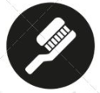
Orthodontics II

University of Jordan
Faculty of Dentistry
5th year (2015-2016)
Price & Date of printing:

.........................................................................................................................................................................................................................................................
Hand Out
Slide
Sheet #

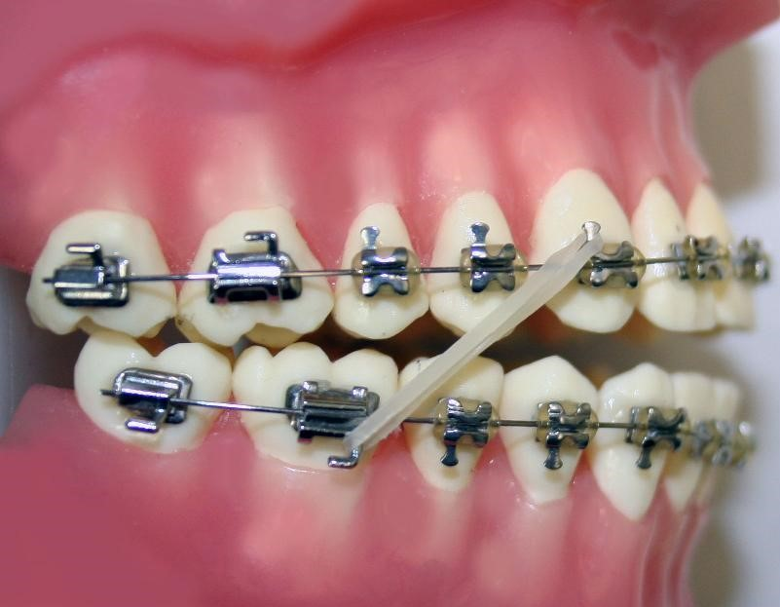
Designed by: Hind Alabbadi

Retention and Relapse
Usually the orthodontic treatment is of no benefit, if it wasn’t followed by retention, Why? We will go through the reasons of this failure during this lecture.
Bear in mind that the patient has to know about the retention as a part of the treatment plan before the establishment of the treatment, that is because some patients simply refuse the treatment when they know that they will wear a retainer for a long time.
What to know from this lecture?
1) The definition of the retention, relapse and stability.
2) The factors affecting the stability.
3) How to plan for retention.
4) The types of the retainers.
Lets start with the definition of stability:
It is the property of teeth to be in a fixed position or state, with resistance to change.
Usually the continuous tooth movement is a part of the growth change, so even if the person did not get orthodontic treatment his teeth won't be in a full stable state.
Many studies have shown that the patients will have teeth movements despite the fact that they got or didn’t get orthodontic treatment, one of the examples is the late lower incisors crowding.
The relapse:
Is a return to the original state or close to it, following the correction of a feature of original malocclusion.
The factors contributing to the stability and relapse:
1) Factors that are related to growth.
2) Related to occlusion.
3) Related to soft tissues.
4) Related to periodontal and dental state.
Starting with: A) the factors related to soft tissues:
We all know that teeth are living in a balance zone, especially the lower ones, the source of the higher amount of forces is the tongue, and the stabilizing factors are the periodontal ligaments, So what to consider during treatment planning?
To get a better stability it is wise to treat the lower arch within its balance zone, that’s why the usual protocol are to accept the lower arch (when it can be accepted), and to treat the upper depending on that.

So, The orthodontisits usually tend to accept the position of the lower labial segment due to this narrow zone of balance with few exceptions, that will be mentioned now:
1) If the lower incisors were trapped against the palate.
2) Class II division II cases.
3) In the presence of the sucking habit; they are retroclined so we can procline them.
4) In the cases when we are preparing for a surgical intervention (class III cases); decompensation then surgery.
(Even in those exceptions we can't tell the exact amount of proclination we can provide).
Now the width of the lower arch, the best choice is to accept the width and form of the lower arch, and to build the treatment plan on that existing width.
The overjet; its correction depends mainly on: 1*the lower lip line; It must be covering one third of the upper incisors, and on 2* the lips competency.
And now let's talk about: B) The Occlusal factors:
Occlusion is considered one of the most important stabilizing factors, that is because some cases depend mainly on the present pattern to be stable after the treatment.
For e.g.: the correction of the Anterior crossbite; the stability depends on the presence of a good overbite at the end of the treatment.
Another known example is the correction of the posterior crossbite; the stability here depends on the presence of good intercuspation at the end of the treatment, so you have to notice if there is anything that will prevent this intercuspation (like wear in the posterior cusps) at the end of the treatment because this will compromise the stability.
Other occlusal consideration is the stability of the overbite; and this depends mainly on two after treatment factors; 1) the interincisal angle and 2) the Lower incisor edge to the centroid.
C) The growth:
This is considered one of the most important factors; especially in the cases that will be mentioned below:
1) The class III cases; its short term stability depends on the presence of overbite, while the long term one depends on the growth.
2) The vertical problems; some patients have severe growth rotations; usually a posterior one, in these cases the growth contributes to the relapse.
3) Late lower incisor crowding; here the growth is implicated in changing the desired results, this is because the longer time the mandible takes growing compared to the maxilla.

D) The supporting tissues:
There are two types of supporting fibers; the principal fibers and the periodontal fibers.
According to researches; they found that the bone remodeling continues for one month after the end of the treatment, while the rearrangement of the principal fibers continues for 3-4 months indicating that the treatment won't be stable for that period of time.
Moreover the collagen fibers remodel for 4-6 months after the treatment and the elastic fibers are not stable for 232 days!
This indicates that the treatment won't be stable for at least 232 days! This is why the retention is one of the most important treatment steps.
In the cases of correcting the rotated teeth; the supracrestal fibers are considered one of the main causes of relapse.
Classic examples of cases where the supporting fibers are the main relapsing factors:
1) Median diastema due to high frenal attachment.
2) Rotated teeth; the supracrestal fibers as mentioned before.
3) Patients with periodontal diseases and attachment loss; those are way unstable cases.
Retention :
Is considered as one of the most important phases of the active orthodontic treatment, and it aims to stabilize the results achieved by the other active phases.
The patient has to wear the retainer for the proper period so the risk of relapse will be minimal.
أمامك مطبّ!
A very common VIVA question:
What is the rationale for retention:
1) To allow the recently formed bone and osteoid to mature.
2) To allow reorganization of gingival and periodontal tissues.
3) Minimize changes due to growth.
4) Permit a neuromascular adaptation to the corrected position.
5) To maintain the teeth in their unstable position for esthetic reasons. (In some cases the treatment won't be stable at all, but for aesthetics the patient is very happy to put a retainer if this will maintain the desired results.).
How do we plan for retention?
As we mentioned before, it is not a separate part of the treatment, so it is very important to be studied and decided at the time of treatment planning, ,make sure that there is no surprises during the treatment!.
After that you have to obtain an informed consent (which is very important in the US).
So initially you have to consider the original malocclusion while planning, and you have to consider if there is any need for adjunctive treatments to improve the stability, and then to consider the type and duration of retention, and the type of treatment and appliance to be used.
Usually the duration of the retention is related to the appliance used during the treatment; the patients using removable appliances usually need 6 months of retention (3 months of full time and another 3 of night time), this doesn’t mean that the treatment will be stable ever after, but this is the usual applied practice.
The functional appliances after correcting what is aimed to be corrected, the orthodontist usually do not stop it immediately instead they give to the patient to wear it at the night time until the growth declines to the adult level.
While the fixed appliances usually needs at least 12 months; 6 of full time and another 6 for night time aiming to decrease the late lower incisor crowding problem.
The adjunctive surgical procedures :
1) Circumferencial supra-crestal fiberectomy: this procedure deals mainly with the rotated teeth, we can severe those fibers with a surgical blade at the end of the treatment so they do not contribute to the relapse.
2) Labial frenectomy: here the clinician exise the fibers contributing to the diastema "not just the visible freny, it must include some of the deep tissues), When to remove it? there is a debate between the surgeons and the orthodontists, but Dr. zaid prefers to do it after the treatment, so the scar tissue aids in the stability.
Types of retainers:
The main used retainer after the use of fixed appliance is the bonded one , while there are many types used after the use of the removable appliances but the only mentioned ones will be the most common types.
Another classification is the : 1) Active 2) Passive; the active one is used in cases where some relapse has already taken place.
Lets talk about some specific types:
1) the Hawley retainer:
It has a labial bow (0.7 mm) and Adam clasps (0.7 mm), usually it comes with without any active part, but active parts can be added in some cases.
Its main advantage that it can maintain the expansion due to the rigidity of the Acrylic.
The main disadvantages:
1) speech problems; mainly in the adults.
2) Aesthetics are compromised due to the presence of the labial bow.
3) It surely needs the patients compliance.
2) The vacuum type:
A specific type of plastic is used.
Main advantages:
1) Aesthetics.
2) Clear.
3) More efficient; because it surrounds every single tooth.
4) cheeper than other types.
5) easier to construct.
6) more effective.
7) less likely to require repair.
Main disadvantages:
1) not that strong.
2) can not maintain the expansion, especially when there is sever expansion.
3) covers the occlusal surfaces, so it is not that good for settling.
4) needs co-operation.
Some clinicians add some modified wires to maintain the expansion, but the standard one doesn’t have.
How to construct it ?
1) Normal alginate impression.
2) Plastic sheet to construct the retainer.
3) the use of the vacuum; (heat and pressure) to form the sheet.
The bonded retainer:
It is a piece of wire that can be flexible or can be hard, and it can be bonded 3:3 or 2:2 or 1:1.
Advantages:
1) More esthetic; lingually placed.
2) No need for a very high level of patients compliance.
Disadvantages:
1) Plaque retentive.
2) Possible local relapse.
3) Undetected debonds.
4) Might cause some calcifications.

Usually this type of retainers is used in the basically unstable cases;
The main examples; the Lower incisor proclination cases, the rotated teeth cases, the combined ortho-perio treatments, diastemas and generalized spacings, and the severely palatally displaced canines.
How to construct it? (two methods).
1) Impression 2) Study model 3) Bond.
1) Just shape 2) Bond.
* the bonding is usually done using the flowable composite.
* Taking care of the retainer is done by the orthodontist for the first year, then the mission is referred to the General practitioner.
The usual durations for the use of the bonded retainers:
1) no need when the occlusion can maintain the results without the aid of the retainer.
2) Short term 6 months; usually with the functional appliances.
3) medium with fixed appliances (1-5 years).
4) Permanent patients with periodontal problems.
Remember that the retention needs more studies and researches to prove it beneficial effects.
Good luck seniors

