3  Dent-2011.weebly.com | Lecture No.
22/10/2015 | Date:
Abed Alrahman Shqaidef | Doctor:
Nour Al-Sobani | Done by:
Orthodontics II

University of Jordan
Faculty of Dentistry
5th year (2015-2016)
Price & Date of printing:

.........................................................................................................................................................................................................................................................
Hand Out
Slide
Sheet

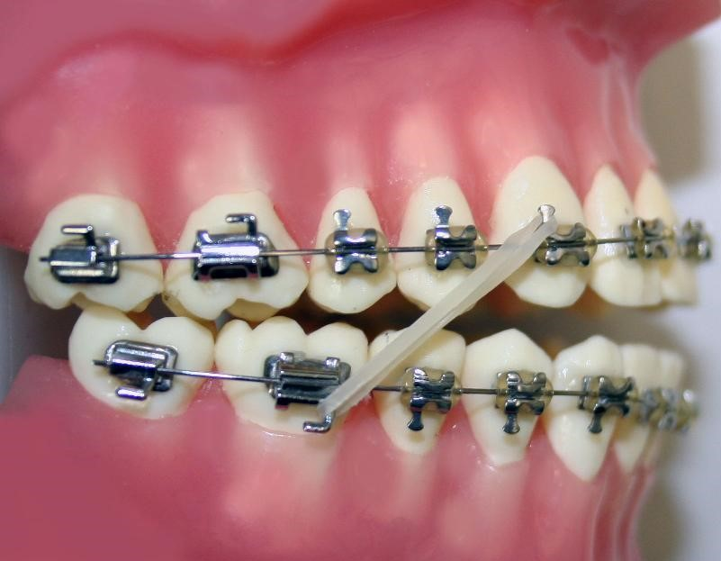
Designed by: Hind Alabbadi

Class II div I malocclusion
** The outline of the lecture:
- Definition.
- Etiology.
- Management.
- Retention.

** This lecture is purely from laura mitchell book .

- Definition:

- Class II div I malocclusion: is when the incisal edge of the lower incisors occlude posterior or behind the cingulum plateau of the upper incisors and the upper incisors is proclined or normally inclined with increase overjet. (This definition is according to British standard institute BSI).

- So there are three component of the definition :
- Incisal edge behind the cingulum plateau.
- Upper incisor proclined or average.
- Increased overjet.

** cingulum plateau : somewhere in the middle third of the tooth .

- Etiology :

- There are three factor that play a role in the etiology of malocclusion :
- Skeletal factor.
- Soft tissue factor.
- Dental factor.

** Let’s talk about skeletal factor :
- We always look for this factor in three plane :
- Anterio-posterior (A-P).
- Vertical.
- Transverse.

- A-P :

** There is a picture for a patient called Diana, she had an increased overjet, incisal edge behind the cingulum plateau and the incisor is average or proclined, so she is a class II div I patient.

- This patient had class II malocclusion due to retrognathic mandible.
- But how can we know that the cause is retrognathic mandible not a prognathic maxilla.
- First of all we look to the profile of the patient to know the type of malocclusion, so we draw a line passing though the glabella, subnasale and pogonion and see if it is straight ( class I ) , convex ( class II ), concave ( class III ).. According to that the patient had convex profile so she is a class II patient.

- Class II malocclusion could be either because of retrognathic mandible or prognathic maxilla and to determine that we took the Frankfort plane then we drop a line perpendicular to the Frankfort plane and at the same time its go through the glabella, we called this line zero meridian line.

- In normal way the chin should be on that line, so if it is posterior to that line it is a retrognathic mandible, if it is anterior it is a prognathic mandible.

- In this patient she had the chin posterior so she had class II div I malocclusion due to retrognathic mandible and this is the most common cause of the skeletal class II malocclusion.

** A picture for another patient , she is a class II patient, if you look to the A point and B point when u use your fingers you find that the maxilla is a head of the mandible more than 2mm.

- For this patient if we draw the zero meridian line we find that the chin is on that line so it is in the right place, so here the malocclusion is due to prognathic maxilla.

- To be sure that the problem is in the maxilla we look to the naso-labial angle (normal 90-110), we find that it is reduced so we have a prognathic maxilla.

- So this patient has a class II malocclusion due to prognathic maxilla and this a less common cause than the retrognathic mandible.

- Are all patients with class II div I incisor have class II skeletal?? Is it possible that the patient has class II div I incisor with class I skeletal??

** The answer is yes, the cause here is either because of habits or because of dental factor (will be explained later in this sheet).
** There is a picture for a class I skeletal patient and has a class II incisor.

- Another picture for a patient has a class II skeletal and class II div I incisor due to retrognathic mandible (the way to determine is explained above).

- The second plane in the skeletal which is the vertical :

- Clinically we measure it according to the LFH(lower facial height) , and the Frankfort mandibular plane angle.
- Frankfort mandibular plane angle gives us an idea about the growth rotation of the mandible.

- We have to type of rotation in the mandible it is either posterior growth rotation or anterior growth rotation.
- In normal way these two line should intersect on the occipit (which is behind the mastoid process) , if they intersect anterior to it we will have posterior growth rotation, if posterior we will have anterior growth rotation.

- Back to Diana she has an anterior growth rotation, and this growth rotation will bring the mandible forward and this make the class II malocclusion less sever.
- So the anterior growth rotation works with us because its make the malocclusion less sever, and luckily most of the patient with class II div I malocclusion have anterior growth rotation but not all of them.
- Other patient has a class II div I malocclusion with posterior growth rotation (the chin is setting more backward) and this make the malocclusion more sever (it works against us).

- If we look at the lip for those two patient , we see that both of them have an incompetent lip, but Diana has incompetent lip with lip trap because she has an anterior growth rotation so the distance between the two jaws will become less ,so the lower lip can be trapped behind the upper incisor...if we compare it to the other patient who has a posterior growth rotation we find that she doesn’t have a lip trap because the posterior growth rotation increase the distance between the two jaws so she can’t bring the lower lip behind the upper incisor.

** The role of the soft tissue will be explained later in this sheet.

- Transverse :

- We look for symmetry in the face, for that we drop a line passing through the glabella, subnasale and the middle of the chin and we totally ignore the nose .
- Generally speaking patient with class II div I don’t have asymmetry (but not in all patient of course), this problem is more noticeable in patient with class III malocclusion.

2. Soft tissue factor:
- Patients with class II div I are more likely to have incompetent lip because of the increase in overjet, they try to bring these lip together to achieve anterior oral seal to help them in swallowing.

- The patent with incompetent lip try to achieve anterior oral seal by three way :
1. Lip to lip with muscular effort (activity).
2. Lip to upper incisor and this lead to lip trap, the effect on malocclusion will be proclination of upper and retroclination of lower incisors. So this will increase the severity of malocclusion.
3. Tongue to lower anterior, this will retrocline the lower incisor and decreasing the severity of class II div I malocclusion. Sometimes it will cause an anterior open bite and this increase the severity.

- Back to Diana, as we said before she has class II div I malocclusion due to retrognathic mandible with anterior growth rotation and lip trapping.

** as we said before Diana has a lip trap because of the anterior growth rotation of the mandible and here the soft tissue play a role in the etiology of the class II div I malocclusion and increase the severity of the malocclusion.(as we said the lip trap will procline the upper and retrocline the lower and by that the overjet will increase).
** In this patient there are two etiological factor for class II div I:
1. Skeletal due to retrognathic mandible
2. Soft tissue factor duo to lip trap.
- In another patient who have a class II div I malocclusion with posterior growth rotation of the mandible, we said that she can’t bring her lip behind the upper incisor and she doesn’t have a lip trap and this because of the posterior growth rotation of the mandible, so here there is no role for the soft tissue in the etiology of the malocclusion in this patient.
** this patient will try to achieve the seal by muscular activity and sometimes by advancing the mandible forward with the muscular activity, and this will help us because the lip will try to retrocline the upper incisor decreasing the severity of the malocclusion.

** So lip trap works against us by increasing the severity, while the seal by muscular activity works with us.

- Dental factor :

- If we have crowding in the upper arch this will increase the severity of class II div I malocclusion by increasing the overjet , because when there is a crowding in the upper arch the central will tend to go more anterior to create a space by that the overjet will increase.
- If the crowding was in the lower arch the severity will decrease, as in the upper the lower incisor tend to go more anterior and by that decreasing the overjet.
- There is a picture for a patient has a mild class II malocclusion by looking to his profile, but when you examine him intraoraly you find that he has a massive overjet , and this is because he has a missing incisor in the lower arch , so the other incisor tend to retrocline to close the space and this increase the overjet.

** So spacing in the lower arch, crowding in the upper arch increase the severity of class II malocclusion.

- Thump sucking, it will procline the upper incisor, retrocline the lower, anterior open bite and cross bite.
** there is a picture for a patient he is skeletal class I but has a thump sucking habits,he end up with class II div I malocclusion .

** So thump sucking increase the severity of class II div I malocclusion.

** Management of habits:

1. Try to talk to the patient and advise him to stop it.
2. Wrap his thump to his hand.
3. Habit breaker appliance.

** If the age of the patient is 5 and he stop the habit the anterior open bite will be improved by itself, this can happen until the eruption of upper central incisor.

- Management :

- Treatment options :
1. Accept.
2. Growth modification.
3. Camouflage.
4. Surgery.

- Treatment options depend on:
  - The patient age.
- The severity of the malocclusion.
- Facial appearance of the patient (sry I couldn’t hear it very well, I will check it )

- The age :

- We use the functional appliance at the age of growth spirit (11-12 years of age).

- There is a concept know as early treatment of class II div I, this treatment starts at age 8 -10,the people who advice to start the early treatment says that because :

1. If you start the treatment at this age you can gain more skeletal effect, so in the future this patient won’t need any orthognathic surgery or anything else.

2. The risk of trauma, the patient has increased overjet, so they aim to decrease the risk of trauma.

3. Psychological point of view, the kids teasing him at school.(there is a study made in the university of Jordan by orthodontist about the most thing that induced teasing to the child, the result was teeth).

** There is a randomized clinical study made to see the difference between the early treatment at age 8-10 and late treatment (11-12) for class II div I malocclusion.

** so they make two groups of patients with class II div I malocclusion, one group get an early treatment and the other get late treatment, the study takes 5-6 years to finish.

** The results: following completion the treatment little difference if any was detectable between the early and the late treatment regarding the quality of the final result.

** Also the patients who start earlier take longer time for treatment, they get bored from the treatment and they have poor oral hygiene.

** Now we don‘t provide early treatment for the reason of skeletal effect.

** regarding trauma:

- In theory the patient with incompetent lip and increased overjet is exposed to a direct trauma on his incisor.
- In studies when they do surveying they found that there is a higher incidence in the patient with increased overjet to have a trauma to the upper incisors.

- In the above randomize study they found that the patients who undergo an early treatment had more trauma than late treatment patients.
- So we don’t provide treatment purely for trauma, not absolutely it is still a reason to do an early treatment. (In viva don’t say we never provide an early treatment because of trauma).

** regarding the psychology:

- In the same randomized study they found that the patient who gets an early treatment they improve self esteem, so the psychological impact is very important.
- If a 9 year patient attend to your clinic and says that children in the school teasing him, you have to provide a treatment for him.

- So the psychology is the only absolute reason to provide an early treatment.
** So generally speaking we don’t provide an early treatment for class II div I malocclusion.

- Back to the treatment options, how the age will change my decision here?, it affect my decision in the growth modification .
- If the patient is young I will go for growth modification but not always, it depends also on the type of malocclusion.
- Surgery becomes an option if the patient is above 18 years.

- the severity of malocclusion :

- The second factor that affect my decision of treatment.
- There is a picture for two patients, both are young, one of them will be treated by functional appliance (growth modification) and the other by fixed appliance (camouflage).so it depends here on the severity of malocclusion.
- Another two picture one for a patient has a mild class II while the other has a sever class II , the first one will go for camouflage and the other for surgery.

- Facial appearance of the patient:

- A picture for a patient has the etiology of the malocclusion in the maxilla (prognathic maxilla), so if I decide to make an extraction I will make it in the upper, I try to retrocline the upper incisor because the etiology in the maxilla.
- Another patient but here the etiology is in the mandible (retrognathic mandible), here I won’t make extraction in the upper, I will do advancement in the mandible forward or try to procline the lower incisor or advance them forward if the patent won’t go through surgery.

- A picture for a patient attends the clinic and the main concern for her was the increased overjet, she was a class II div I malocclusion due to retrognathic mandible with a posterior growth rotation also she had an incompetent lip and she achieve the anterior oral seal by muscular activity (so the soft tissue has no role in the etiology in this case).

- Intraoraly she had spacing in the upper arch and crowding in the lower.

- The question is: if this patient age was 9 years do you provide her with treatment?
** the answer is no except if there is a psychological factor, so we told her to wait until she become 12 years of age, in another word we wait until she become in the early permanent dention stage.
** The treatment option for this patient is growth modification by using a twin block to advance the mandible forward, after that we provide her with a fixed appliance.

- Another patient attends to the clinic complaining that her anterior teeth are above each other with no other concern about the profile the skeletal...Etc.
- She is a class II patient due to retrognathic mandible
- She has an impacted canine on one side and there is no space for it in the upper arch.
- Know we need space for the canine and for the overjet, means that the crowding in the upper arch make the case more difficult to treat and increase the anchorage demands.
- The treatment option for this patient was camouflage with extraction in the upper arch.

- A picture for patient attends the clinic complaining about her chin, she does through surgery.

4. Retention:

- The opposite of relapse which means that we go back to where we start. And to prevent that we need retention.

- patient before the treatment has incompetent lip and after the treatment ends with competent lip has a good stability, because it will prevent the upper incisor from retrocline again and increase the overjet (the lower lip now has a control on the upper incisor).

- If the patient after the treatment is still having an incompetent lip or lip trap, there is a high chance to return to where we start. So I have to make sure that the patient end up with a competent lip.

- the cause of incompetent lip in some patient is either because of short upper lip or increase vertical proportion, even at the end of the treatment those patient will not have a competent lip so the stability here is very bad.

Sorry for any mistakes… good luck

