11 part 1  Dent-2011.weebly.com | Lecture No.
31/12/2015 | Date:
Abed Alrahman Shqaidef | Doctor:
Ala'a Khubazan | Done by:
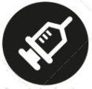
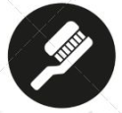
Orthodontics II

University of Jordan
Faculty of Dentistry
5th year (2015-2016)
Price & Date of printing:

.........................................................................................................................................................................................................................................................
Hand Out
Slide
Sheet

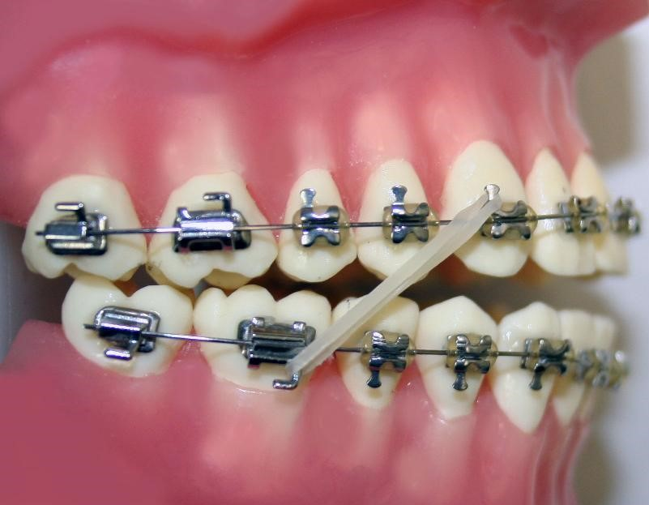
Designed by: Hind Alabbadi

>>> In this lecture we're going to talk about Orthodontic and orthognathic surgery .
As usual the treatment options are :
1- Accept
2- growth modification
3- Camouflage
4- orthognathic/ orthodontic surgery
>>Indications of orthodontic surgery :
1- to correct dentofacial deformity :
Definition of dentofacial deformity > deviation from normal facial proportions and dental relationships that is severe enough to be handicapping to the pt .
**Dental handicapping can be either : 1- esthetics problems
2- jaw functional relationships (mastication or speech )
In the slides :
Case > female pt , her chief complaint > esthetics
Male pt > his chief complaint > functional ( speech and eating , but the pt's age almost 40 and he looks fine and don't be like someone who can't eat ! , so usually mastication is not a problem but they have some of shyness , they can't eat outside the home because of their situation .

2- severe malocclusion : sometimes patient doesn't complain from anything but his malocclusion is very severe that can't be treated orthodonticly alone .
>>So 3 indications of orthodontic surgery :
1- esthetics ( most common one , 90% of cases due to esthetics )
2- function
3- severe malocclusion
>>Treatment objectives :
1- Acceptable dental and facial esthetics 2- good function 3- optimal oral health 4- stability

History :
1- most important thing is pt's concern ( it's important to know pt's concern to know what to treat , for example if pt comes to your clinic and his chief complaint is that his eyes not at same level so simply you can't do anything but if he complains from his chin we can go through surgery.
2-- pt's motivation, expectation and psychosocial status .
Pt's Motivation : ( if pt tell you that he can't work because his chin or can't get married also due to his chin , and everything bad in his life due to his chin , you must in first step asses him psychologically then go for dental treatment .
Pt's expectations : you have to know what the pt expect from treatment , and put limit to his expectations .
Psychosocial status : case in slide , for a nice female pt , from her point of view , she thinks that as she is an ugly girl and can't even look to her face in mirror, she actually exaggerated the problem , this pt has body dysmorphic syndrome , so be careful to this type of pt because even if you a perfect ortho treatment they will refuse it , back to our case ,she first is treated psychologically then we only do orthodontic treatment without surgery and the result was great .
3- medical and dental history .

Clinical examination :
1- full face assessment
2- profile assessment
3- smile esthetics
4- TMJ assessment
4-intraoral assessment
1- full face assessment :
We assess the following :
>1- symmetry , can be assessed by :
1- rule of fifth , we draw 5 lines , those must be symmetrical and equal and chin be in middle ,
In Slides : One case > chin in middle , symmetrical face
Another case > chin to right , asymmetry
2- we draw midline in middle of face and asses symmetry of two halves of face

>2- facial height , as we do in ortho clinic we divide face into thirds and see relation between them .
>3- canting of occlusal plane : we draw two lines ( intrepapillary line and another line that passes through occlusal plane ) , we bring tongue depressor and make the pt bite on it and compare it with interpapillary line , is similar to what we are doing in prostho clinic by fox plane .
Case : pt with canting in occlusion and everything deviated to one side .
Profile assessment :
We usually examine pt in his natural head position , so before anything we have to know how to set pt in his neutral position otherwise our measurement will be totally wrong .
Profile assessment is done by :
1- to know if cause of malocclusion is mandible normal , we draw zero merdian line ( which passes through nasion ) and perpendicular to frankfront plane , we look to mandible and see his relationship to this line , so in our pt has retrognathic mandible and girl prognathic mandible .
2- to know if the cause is maxilla , by two ways :
1- nasolabial angle ( if increased so prognathism of maxillary ) but this doesn't always work because depends on size of nose .
2- maxilla is not only teeth but it's a complex structure which contains ( zygomatic process , infraorbital process , alveolar process ), so if maxilla is backward , zygoma and infraorbital rim will be backward , so in our case, female pt has retrognathic maxilla and prognathic mandible . but male patient has retrognathic mandible only .
3- growth rotation :
male pt has anterior growth rotation
female pt has posterior growth rotation
4- smile esthetics : is determined by incisal show at rest and smiling
Both pt show full length of crown during smiling which is the normal show of incisal .
Because they have normal incisal show so both patients have normal vertical growth of maxilla . so maxilla vertically in right position .
5-TMJ assessment :
Dr shows a case and ask if there is any TMJ problem in this case or not , the answer is : we don't know !
There is no strong link between malocclusion and TMJ problems .
If the patient attend to clinic and only complaining of TMJ we can't do surgery because there is no guarantee that post-surgery the enhancement will occur .
But during ortho treatment TMJ problems will reduced , due to that during treatment the teeth become tender so pt who have bruxism , during ortho treatment can't clench because it's painful so reduce the stress on TMJ .
BUT remember we can't correct TMJ problems by surgery .
6-Intaroal assessment :
Do Assesment to : Overjet , overbite , incial relationships , crossbite , crowding .
Case : pt has : 1- generalized crossbite 2- class lll incial relationship 3- mild crowding in upper and lower jaws 4- increase in overjet
Another case pt has : 1- class ll division 2 incial relationship 2- retroclined upper incisors 3- slight crowding in upper and lower jaws >>>>>> features of typical class ll division 2 .

END OF FIRST PART .
GOOD LUCK IN FINAL EXAMS

