2  Dent-2011.weebly.com | Lecture No.
5/10/2015 | Date:
Sukaina reyalat | Doctor:
Dalia jibreel | Done by:
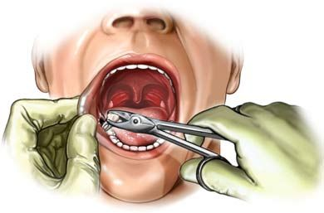
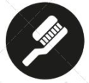
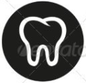
Oral Surgery II
University of Jordan
Faculty of Dentistry
5th year (2015-2016)
Price & Date of printing:

.........................................................................................................................................................................................................................................................
Hand Out
Slide
Sheet

Designed by: Hind Alabbadi

- Today we will continue talking about implantology.

- At the first the patients must know what are you going to do for them, because most of the time patients think that by one session they will leave the clinic with fully functional prosthesis, even if we do immediate operation it will be out of function.
- For the success process of implantology we have 4 elements :
- Patient selection : is the major criteria of success.
- Surgical team (the surgeon with his nurses).
- Restoration team.
- Dental laboratory : they are very important because we are dealing with fine restoration and the technicians must be scientifically advanced.

- Members of the treating team :
- Restorative dentist.
- Prosthodontist.
- Surgeon.
- Periodontist.
- Dental technician.
- Orthodontist.
- Radiologist (why radiologist ?! : because we won’t ever place an implant without first taking a panoramic radiograph ).
#in Europe and USA there’s no patient makes implant without CBCT scan (Cone beam computed tomography).
#CBCT is an advanced one , it gives a 3D image >>> so we can see the bony borders , because when we want to place an implant it must be within these borders.
#also such advanced images we need it when there’re defects within the borders.
#so the panoramic radiograph is a must when we want to place one implant or 2 , but if more the CBCT is mandatory.

- Patients treatment options : it ranges between :
- No treatment.
- Fixed partial denture / fixed bridge.
- Removable prosthesis.
- Dental implant placement > the best treatment option.

- Treatment options :
- Single missing tooth :
- RPD
As we go downward (moving to the better option) cost & esthetic increase …
- Fixed bridge
- Implant supported crown (best)

# esthetic doesn’t mean only the smile , when we do extraction >> bone resorption >> nasolabial angles will go down >> wrinkles appear
# but when we put an implant it will support the nasolabial fold and the wrinkles disappear.

- several missing teeth :
- RPD
- Fixed bridge
- Implant supported fixed bridge : so u can save the money of one or two abutments.
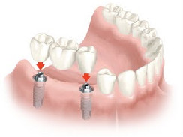
Implant supported fixed bridge

- All missing teeth :
- Removable denture
- Overdenture to be seated on ball attachment
- Fixed bridge on implant : here it either be 2 implants or 4 implants > the level of life differs too much.
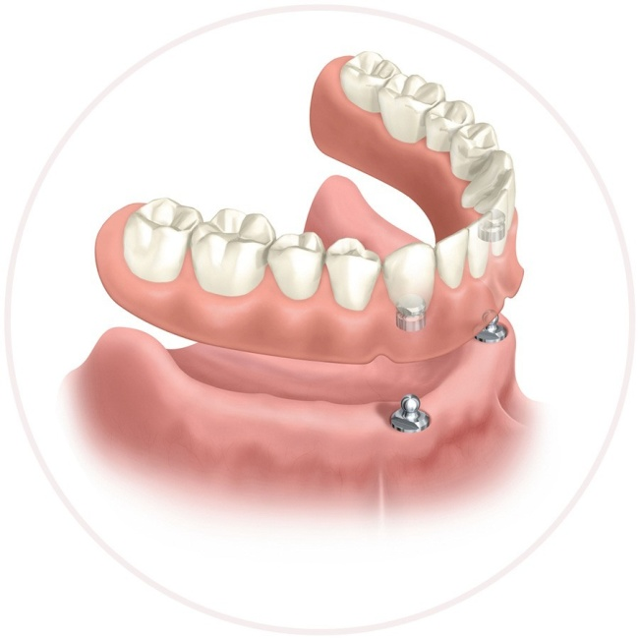
Overdenture seated on ball attachment

- Patient selection criteria :
- Medical history
- Dental history
- Prosthetic alternatives and options
- Financial conditions
- Esthetic considerations : the most important region to place an implant is the anterior area.
- Patients motivation for complex and sophisticated dental treatment : patient with an implant must improve his oral hygiene (brushing , flossing , mouth washing and periodical check ups).

#medical history: ex. patients with bleeding disorders are contraindicated for surgeries.
Ex. Patients who take warfarin and have prosthetic heart valve >> it’s extremely difficult for them to place implant . (if we knew while doing extraction that the patient is on warfarin we should stop the procedure)
# patients contraindicated for dental implants > patients on radiotherapy or chemotherapy.

- Conditions/ systemic disorders/ medications that could affect wound healing and the osseointegrative process :
- Uncontrolled diabetes
- Clotting disorders
- Anticoagulants and corticosteroids
- Radiation therapy and chemotherapy to the area
- Smoking : is a relative contraindication > because most of the patients that come to the clinic are smokers and they must sign a consent that smoking has major bad effect on their implant so they might lose it.
- Pacemaker
- Pregnancy
- Bisphosphonate : by causing jaw necrosis
- Drug abuse : they have personality disorders > they need special therapy
- Patients with unstable condition : because they don’t know what they want.
#Bronch (bone necrosis) :
Patient with metastasis due to whatever type of cancer in the body >> they take bisphosphonates to decrease the degree of bone resorption>> its contraindicated for extractions and implants.
# special way of management for patients who takes bisphosphonate:
1. Consult their physician
2. Hold the bisphosphonate : Depends on time of therapy and type of bisphosphonate (tablet or IV).
3. prophylactic antibiotic
4. then we go for extraction.
#this protocol only for extraction but for implants it still contraindicated otherwise bone necrosis will happen.
#dental history:
The patient who come to the clinic is either motivated or nonmotivated (we can motivate them)
#smoking
Heavy smoker patients >> implants failure after one month.

- Intra oral examination :
- Access : area of surgery must be feasible (limited mouth opening patients and patients with bruxism ,it’s very difficult to place implant for them.
- Prosthetic space : a lot of GPs don’t consider this thing ( first they place implant >> then when they want to put a crown they figure out that there’s no space for it because the upper are overerupting.
- Crown height
- Sizes and number of spaces
- Bone volume , contour and orientation : we have to assess the bone by examination , probing and radiology.
- Prognosis of the adjacent teeth : never place an implant when the adjacent is mobile , needs endo treatment or infected .
- Status of the existing prosthesis
- Biomechanical consideration ( bruxisim) : because these patient will increase the functional load on the implant > bone resorption > loss of implant
- Oral hygiene and periodontal status : before placing the implant the patient must be well motivated

- The general guidelines for botox therapeutic treatment :
Patients with bruxism (causing severe load on implants) if they want to place more than 2 implants must get botox injection to add value for the success of the implants.
Botox : it’s a toxin that works on the neuronal ends to stop the muscle contraction > so the muscle will be relaxed , so in case of bruxism we inject botox in the masseter to decrease the load on the implants > to improve the osseointegration.

- What should the dentist look for in planning ?
When evaluating any proposed site in all 3Ds
we should focus on hard and soft tissue contours .
always we must do wax up > we make the restorations on the models (we take the impression > make diagnostic cast > put it on the articulator > then we do wax up).
- Unless the position of the final prosthesis is visualized prior to surgery , placement of dental implants to achieve the end results cannot be achieved. (sometimes one implant we do placement for it although it isn’t accepted , so 2-3 implants or more you have to place it on models to check the posture of the final prosthesis , because the patient only care about the end result).

- evaluation of the soft tissue should include :
- Contours for shape
- Quantity
- Texture and color

- Anatomical limitation :
In the upper jaw >>> the sinus
Lower jaw >>> the ID canal
In the upper jaw when we want to place an implant either we elevate the sinus (either direct or indirect ) or we do bone grafting this depends on the 3Ds measurements .

- Case assessment :
Make Models > determine space of implantology > surgical stint
#surgical stint (surgical guarde) looks like a nightguarde : plastic sheet on the occlusal surface of the teeth with specific sites for the implants through which the orientation and the level to be perfect.
- The periodontal tissue should be in optimal health before implant placement.
- You must be able to distinguish the thick periodontal biotype : thick flattened osseous plates and offers higher resistance to recession than a thin tissue biotype.
- Thin biotype gives us thin erythematous peridontium covering a thin nonexisting alveolar bone , so recession will be higher.

- You have to consider :
- The size , shape and color of interdental papillae
- The accurate form of the free marginal gingival
- The relative root shape and size
- The width of attached gingiva and the prominence of roots on the facial aspects : this is very important because sometimes we do immediate implant placement > first we do extraction > then we place implant direct after extraction > if the root were very prominent in examination this means that the cortical plate is thin so we have to be careful about dehiscence or fenestration because we are going to drill the bone so we shouldn’t put support on it while working . your orientation while drilling must be at the same orientation of the occlusion (not too buccal / lingual , must be highly selected).
Must leave 2 mm from the buccal plate , if less it will make pressure on the bone >> causing resorption and the implant will start to appear (especially for anterior zone this would be very bad).
- When evaluating osseous contours , the dentist should use palpation and mapping with anesthesia (using endodontic explorers and stoppers probed to the periosteium measuring the gingival thickness every few millimeters ) coupled with radiographic examination using a radiographic guide with reference marker gutta-percha.
- Palpation : palpate for undercuts , because if there’s undercuts in some place and you thought that there’s complete bone and you placed your implant it will come out of the bone.
- Mapping : means that we have special gauges that pierce the alveolus buccal and lingual to measure the width of the alveolus but vertically by radiographs.
- By using the radiograph and the gutta percha marker we can calculate the magnification of the panoramic radiograph to get the actual measurements (ex. If we got the actual measurements we won’t harm the ID canal in case of lower jaw).

- Radiographic examination :
- Periapical
- Panoramic : is a must.
- Dental CTscan
- CBCT (cone beam st scan) : is better than the CTscan.

- The axis of the drill must be the same as the axis of the adjacent tooth
- Next lectures we will take the kit and the guides for the drill : we start with the starter drill > pilot drill > differential sizes drill , between them there’s a guide …. Guided by adjacent teeth , by bone volume

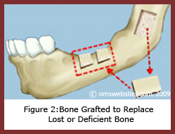
Onlay bone graft

#If the patient is an elderly with a medical history >> we can go for overdenture .
#it’s easy to place implants anteriorlly because it’s cortical bone and there’s no ID canal to limit them so we can put 2 anterior implants and place an overdenture (for cases of bone resorption).
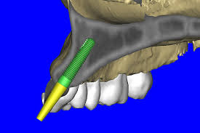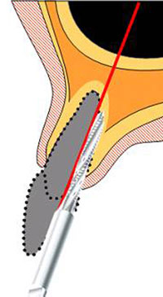
2mm

Anterior maxilla

#implants must be away from buccal plate by 2 mm otherwise the implant will exert pressure on the plate >> resorption >> then implant will be visible .
- To maximize the chance for success there must be adequate bone.
- In new softwares technology when we take a CBCT (virtual planning for the implant) scan it allow us to put the implant on the system and print your stint in a 3D pictures with the orientations and measurements to help us in the procedure.
- Space analysis is very important : there must be 2 mm bone from lingual and facial aspect (old edition it was 1 mm but it increased).
- Critical measurements , when u sometimes have to be near to some places like the ID canal but there must be space of 2 mm , but for example the mental nerve (has a backward reflection) there must be space minimum 5 mm.
- Implants tend to fail when there’s no sufficient quality and quantity of bone.

- Whenever we want to place an implant we must have surgical guide that help us :
- Increase accuracy of the implant placement
- Predictable outcome for occlusion
- Decrease cost by reducing the need for expensive custom abutments
- Prevent the fenestration because the orientation is right.

- The curve of the implant must coincide the curve of spee
- At the end we want to have a successful osseointegration : which depends on ?
- Biocompatibility
- Design
- Bone factors
- Loading conditions
- Prosthetic considerations

- Implant length : 6-16 mm
#The 6 mm implant is considered short so we don’t commonly use it , we use it only in cases when we don’t have another choices.
# when the length increases the osseointegration also increase.
#people who support the short implant use >>> say that the long implant increase the stresses on the bone
#when we want to place 16 mm implant in anterior maxilla to replace a canine >> they say when you start drilling you make stresses on the bone.

- Implant diameter is more important that the length because of the distribution of loads to the bone , implant diameter upto 6 mm is available which considered stronger but they aren’t so widely used because sufficient bone width isn’t commonly encountered .
#Anterior zone : 2-3.5 mm(maximum)
#Posterior zone : wider diameter
- Implant shape : hollow cylinder , solid cylinder , tapered (depends on the company) ……….. etc.
- Surface charicharistics : depends if its machined and coating with hydroxyapatite , grit plasting , plasma spray , acid etching , bioactive implants.
#the general rule : increasing the roughness >>> will increase surface contact with the bone (but there’re people against this rule).
- Bone factors : to evaluate the quality and the quantity

- lekholm and zarb bone classification :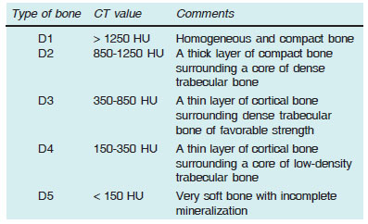

#Worst one type 4
#the doctor didn’t mention type 5

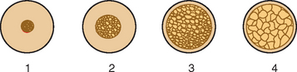

#posterior maxilla is cancellous bone that’s why implants may get into the sinus.
- These types of bone found in:

#type1 : anterior maxilla (mostly cortical)
#type2 : anterior mandible
Posterior mandible
Anterior maxilla
#type3 : anterior maxilla
Posterior maxilla
Posterior mandible
#type4:posterior maxilla (mostly cancellous)

- During drilling the temperture musn’t increase above 47 degree >> because it will cause necrosis.

BEST REGARDS
DALIA JIBREEL

