Noor AlQaisi Dr.jamal cons #8 3rd dec 2015
Last time we talked about MTA , what are the uses of MTA ?
* its used in endo to manage perforations , theres no long-term studies about this but theres long-term studies about apicectomy and retrograde fillings .
The rule of MTA for perforation repair is not something we do in our daily basis .
Its not true when someone makes perforation and uses MTA as perforation repair ,because its very difficult and theres no material with (80-90%) efficiency in perforation repair .
Its very difficult to seal the area of perforation . ( here he is talking about the coronal perforation *FLOOR* not apical ) especially when theres a communication between the furcation area and the oral cavity , it’s the most difficult to repair .
But MTA is used as pulp capping instead of CAOH , but theres no study that claims that MTA is better than CAOH in pulp capping .
The dr showed a x-ray with endodontic failure , post, crown .. here we don’t remove the post or the crown to gain access to the canals , but we go surgically and one year later the lesion disappeared
We drill the bone to get to the apical area , and here the healing is called scar tissue
We don’t rely on xray only to determine if theres healing or not , we rely also on clinical symptoms
The dr showed xray of an upper molar ( mesiobuccal root ) with endodontic failure , the pt hes feeling pain and theres a lesion , we don’t know if were gnna find the second canal or not because the pt has a crown
The endo failed due to
- Short obturation and peri-apical lesion
- Coronal micro-leakage (according to recent studies , it is responsible for endo failure more than apical micro-leakage)
- Decay under the crown
By doing the surgery and putting the amalgam as a retrograde filling material ,the lesion disappeared although we have short obturation and under extension , but by the amalgam we did a good apical seal .
The dr showed another xray with a J shaped lesion , and that’s indicated mostly for a vertical root fracture , a lesion that’s embrassing the root ( from the apical area to the coronal area )
If the lesion was only at the apical area , a retrograde surgery would have been successful .
But in this case , extraction was the final treatment .
Another case with endo failure and a crown , and they put amalgam and they kept on adding amalgam and it fits in and the reason is because there was a vertical root fracture , sometimes we do the surgery and the treatment but the case doesn’t work because the success rate of surgical treatment not like the success of conventional endodontics
Conventional success rate is about 97%
Surgical treatment success doesn’t go more than 70%
Another case with a failure on the MB root so we raised a flap for the upper molar and dicovered a lesion on the premolars that we didn’t see on the radiographs so by surgery we explored sth we didn’t see radiographically so we did a retrograde treatment fot the MB root of the molar and the buccal root of second premolar and the palatal root of the first premolar
Another case with a mb root failure without a lesion but with clinical symptoms , here we have stripping but we cant see if there’s a perforation radiographically or we cant decide the location of the perforation either Mesial or distal buccal or lingual , we cant redo the case because we don’t know if the perforation is buccal or palatal and we don’t want to take the same curve of the mb root , so the bet treatment here is root amputation leaving the distal and palatal roots
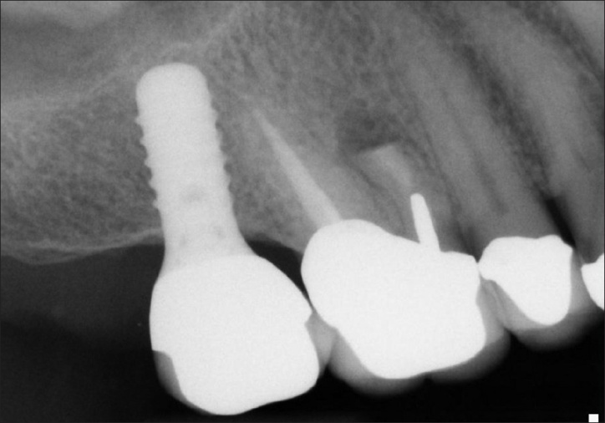

Another case with a perforation on the mesial area and part of the filling is coming out of the root
and a lesion so here the treatment was hemi sectioning for the root keeping the distal root
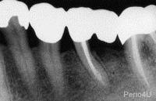

A case with a lesion and a short filling and amalgam coronally that is filling the orifice as well and a crown and an impacted 3rd molar distal to it and there are symptoms , first we’ll extract the third molar then we will do intentional reimplantation , we cut the apex 3 mm then we do retrograde filling then we replant the tooth
-the second lower molar we cant do hemisectioning or apicectomy because there is a lot of bone to drill and the access for the apex is very difficult so the intentional reimplantation is the solution and the success rate is very high (lower molars more than upper molars)
Another case with a periapical lesion but we cant redo it because there is a ledge and we couldn’t maintain the curvature and we straightened the canal causing a legde , so we took it out , retrograde filling the put it back in again
Sometimes when there’s a good filling in the apical area we don’t need to put a retrograde filling , so we just cut the root apex but if the gutta percha is weak we have to put a retrograde filling
Most of the times we do the retrograde filling as long as we are there we’ll do a retrograde filling
A case with an implant and a tooth that needs endo treatment , so they did the endo treatment and 2 years later the x ray shows survival of the endo treated tooth and the implant
There was a study about endo treatments and implants for more than 8 years and they published 1400 article about both subjects the result was there is no consensus for the factors that agree on endo treatment on imolants , it depends on the case , doesn’t depend on one individual case , it depends on the whole rehabilitation condition of the patient
The other result is we have to stay away from the aesthetic zone (anterior area) you better keep the tooth and do endo trt rather than extracting is and do an implant instead
Natural teeth are the ultimate imolants !
When we do 8 months follow up for root canals and implants , all what we have to do for the follow up of the endo treated tooth is check the restoration (good crown , good margins , no leakage ) no lesions . but for the implant there was about 18 interventions (surgical or mechanical)
A case with a good root canal and a lesion and a 3 units bridge , here there was an open margins which caused coronal microleakage and endo failure .
In surgical endodontics we have many aiding tools:
1.magnification and illumination
2.binoculars
3.head lamp
4.fibroptic light
5.microscope
-mini micro scalpel , regular scalpel are also used for the surgical endodontics
-conventional handpiece, micro head handpiece, ultrasonic handpiece
-standars mirror , surgical mirror
-irrigation syringe
-condensors
Question: when do we do root amputation and when do we do hemi sectioning?
When we have failure in the apical area = root amputation
when we have failure in the mid root = hemi sectioning
(the doctor refused to give me the radiograph because they are his cases so that’s all I could do )
Done by : Noor AlQaisi

