Non- Parametric statistics

- Unlike parametric statistics can be used with no assumptions and in cases where variables are not evenly distributed
- Used to answer research questions ranging from whether a relationship exists between 2 variables to groups differences on an outcome measure
- For example, when we study the relation between lung cancer and smoking, the outcome variables are nominal; we can not find the mean for the uneven distributed results, so we aim directly for the non-parametric statistics

- Non-parametric statistics assume distribution free; no even distribution between data
- Assumptions of Non-Parametric statistics :
1-Frequency data
2-Adequate sample, at least sample size of (5) subjects
3-Measure independent of each other (no subject can be in more than one cell in the design, and no subject can be used more than once).
4-Basic theoretical structure of categorical variables remains (rationale of categorization).

- Difference between parametric and non-parametric statistics:

- Parametric:
- Assume normally distributed population( no severe skewness)
- Powerful or robust
- Flexible
- Study effects of many independents on dependents ( The effects of teaching methods on students scores)
- Study the interaction between variables ( infinite number of comparisons can be made like in ANOVA; post-hoc test) ( e.g The effect of three drugs on lowering Hyper tension, which drug is superior? )
- Shows: magnitude of significance, relationship, and direction. ( e.g. t-test for 2 groups of students score in exam) ( e.g. experimental vs control drug which one is superior)
- Non-Parametric:
- Distribution free
- Small samples
- Data skewed
- Unable to handle multivariate questions ( can not handle more than one dependent variables )

- The most common non-parametric tests
Chi-Square
Mann-Whitney U-test
Kruskal Wallis test

Chi-square
- may be goodness of fit or cross tabulation
- Handle nominal data
- Lung cancer ( dependent; YES OR NO) vs Smoking (Independent; YES OR NO), 2 dep vs 2 ind
- 3 groups take different types of toothpastes( independent, K-groups) vs caries formation( dependent; nominal) 3x2 groups

Mann-whitnney test
- Smoking vs Quality of life ( Ordinal; Satisfied vs moderately dissatisfied, strongly dissatisfied ,,, )
Kruskal Wallis test
- 3 groups take different types of toothpastes( independent) vs
satisfaction( dependent; Ordinal)
Summery:
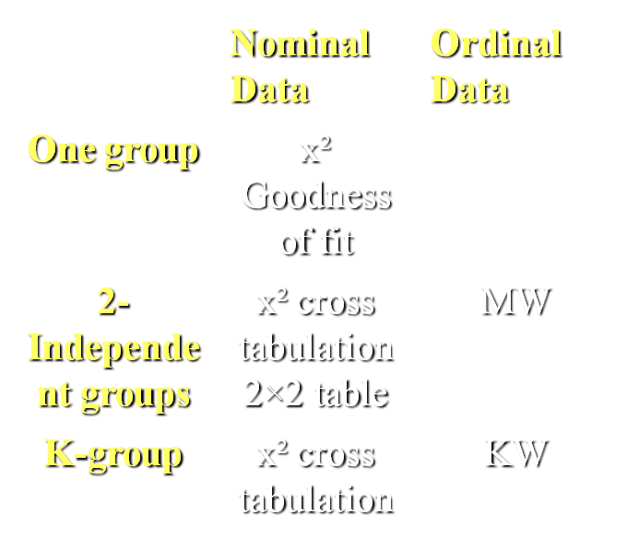
Back to examples in the slides and book
Notes on slides examples:
- Always look for p value from qui-square value in the table in quisquare test
- example 2 : the incidence is dependent variable;nominal
And the age is independent variable; ordinal

- example 3 we go for KW test because there is group of patients

Done by :
Hussain Alhawaj
Rawan Abu-Ghaza
Soooooooon..

