Fabrication of Crowns Under Existing RPDs
Treatment Sequence:
1-Survey and design of Diagnostic casts
2-If we have Surveyed crowns we surveying it ..Design it to the ideal contour and design parameters for the RPD fabrication to determine for the technician where to put rest seat, where we need the undercut
3-Then we fabricate it “ Fabrication of surveyed crown and verification of design parameters”
4-Deliver it
5-Then we start fabrication of the rpd framework

Today we gonna talk about the opposite direction ;
Ideally Surveyed crowns should be fabricated first!

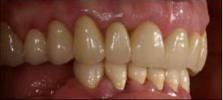 ---then--- 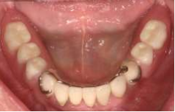

However !!! If an abutment tooth requires a crown underneath an otherwise acceptable and serviceable RPD, the abutment surveyed crown will be fabricated to fit inside the clasp assembly of the existing RPD.
Fabrication techniques; • Indirect: without the patient • Direct: Principally intraoral (intraorally fabrication of a crown pattern • Combination ;Direct-indirect or indirect-direct: intermediate intraoral steps

Indirect and direct techniques remind us with post cast ;
If direct :dura/lay inside pt’s mouth “chair side”
If indirect we dry the canal and use serrated post ,impression and the post made in the laboratory by the technician
Each one has its advantages and disadvantages;
-direct one “at dental chair” for e.g ; - more time –more stressful for the pt and the dentist –exposure the pt for the material
So by using the combination technique we try to avoid disadvantages for both
# Indirect technique;
• Impression of the prepared tooth with simultaneous pick up impression of the RPD
• RPD is incorporated in the master cast
• The crown is waxed on the die and within the clasp assembly of the RPD framework
• Disadvantage: Patient will be without the RPD while surveyed crown is being fabricated
4 things I need in metal try in (for the crown ) ;
1-marginal fit
2- clearance
3-rest seat are properly seated in the metal
4-theres enough space for porcelain
Check intraorally everything is okay;
if it’s fine send it to the lab for porcelain to be placed
check that the clasp assembly is as it was before glazing for the porcelain
once it’s glazed don’t touch it anymore ..Deliver it to the pt’s mouth .

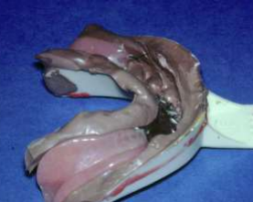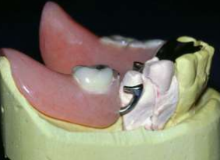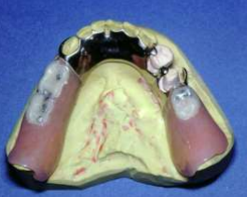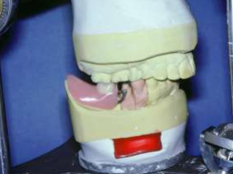

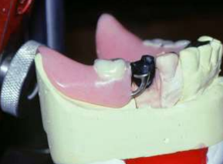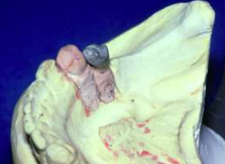
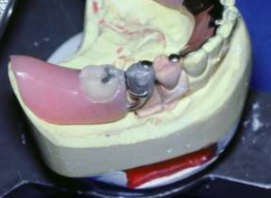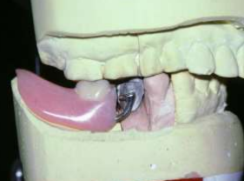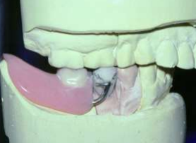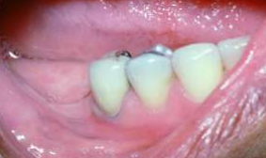

And finally
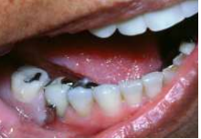

# Direct technique;
In the direct technique we do exactly as cast post direct technique ..we do pattern from dura/lay
*Acrylic resin and inlay wax are used intraorally to adapt and form a crown pattern directly to the tooth preparation
• The pattern is cast and the restoration is cemented after ensuring an intimate fit to the RPD frame work
• Patient is allowed to keep the RPD while the crown is being casted and finished
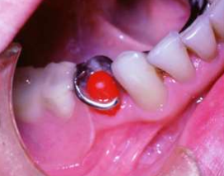
Here ,,the tooth is prepared ..we start with resin coping to catch all the details of margins
The crown is completed either by addition layer by layer dure/lay till achieving proper contact with the clasp and rest seat ..or by using wax
** in this photo the clasp assembly used is RPA not RPI **
-A stands for ACHER
Acher clasp differ from regular c clasp in the way that we do relief underneath clasp
“in c clasp we do relief only at retentive tip where the undercut area present while in this type of clasp we do relief all the way except the retentive tip to act as I bar …”
We use it when the I bar is contraindicated like if we have sever undercut .
The main disadvantage for the direct technique is ;
That we place a monomer on the tooth structure which’s risk for the tooth especially if the tooth is vital
It’s also take a long time .

# Combination techniques
- Direct- indirect method;
We start direct by making resin coping then we complete it in indirect way
We made aresin coping at the same time we take impression for the tooth itself (not pick up impression )

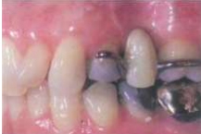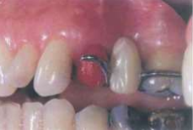

Here the abutment already have clasp and rest seat and we have to make a crwon for it
We start with preparation then we do resin coping and it’s properly fitted underneath the clasp but we will not do all the final details which will take too much time ..so the anatomy and contour will be finished on the dye on the lab

We take aregular crown/bridge impression (without the rpd pick up ) .. just to have Adie as a way to transfer the resin coping that I did intraorally …
On the dye I’ll finish the details that I want ( marginal fit ,anatomy , occlusal carving ).

To sum up ;
• After tooth preparation impression is made without RPD in place
• Resin coping is made intraorally and fit within the clasp assembly
• Resin coping is transferred to master cast and final contours and margins are finished on master die in the lab
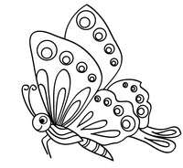
Best of luck /Maha khaled al-hussban

