** CRC **

Case 1
This is a periapical radiograph .. premolar projection ,, in the right side of the mandible what is the abnormality ?
There is asymmetric widening of the PDL (it is important one to focus on ) you can tell that bone level is intact ,, the apical bone is intact .. this tooth doesn’t have ortho treatment or post or anything else .. so the only reason for this to happen is because something occurs here and cause it to happen in this area.. I mean The lateral incisor show no chipping nor attrition or any abnormality within it .. and usually when fracture occur it is J shape radioluceny (it is not more lumpy circular) this is a good mental image to remember ..someone asked about s.thing and the dr answered : it may be due to low dose and low exposure ..
Diagnosis may be : lymphoma , osteosarcoma ,, SCC ,, the most common in this place are : osteosarcoma ,, lymphosarcoma and SCC .. Which one is particular we don’t know ..
There is a radioluceny present look like thin bone the Dr said it is a tooth extracted in this place (which is normal )
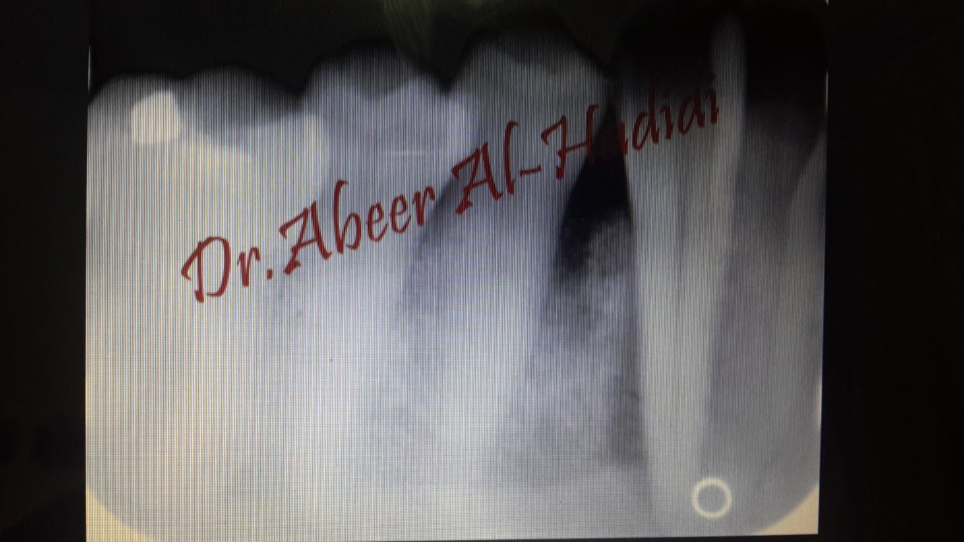
Case 2
It is a panoramic radiograph .. radiolucency presented on the left side of the mandible between the molar and the next tooth,, ill-defined (so it can never be corticated) ,, so it is malignancy of some sort
-it may be Langerhans cell histocytosis despite it has scooped out shape (one of the DD that you can write in the exam)
-it is malignant disease ,, SCC is easy one to write(it is the most common)
-ill-defined : the extension is run from 7 to 5 ,, margin means where is the intact bone and where is the ill bone (we can’t determine exactly) ,, it is a puzzle and you must collect the pieces ..
-one student say it is well-defined ! the Dr explains : ok lets assume that is well-defined ,, if it is well-defined Does it surround the tooth or displace it ?? here it doesn’t displace the tooth so it is malignant
So collect your ideas before categorization
-(ill-defined + non-corticated ) >> don’t write this in the exam you will loss 1 mark >.<
-there is residual airway spaces presented bilaterally so it is not malignancy -also the tongue presented here and look like the fracture line ! and the soft palate is also presented 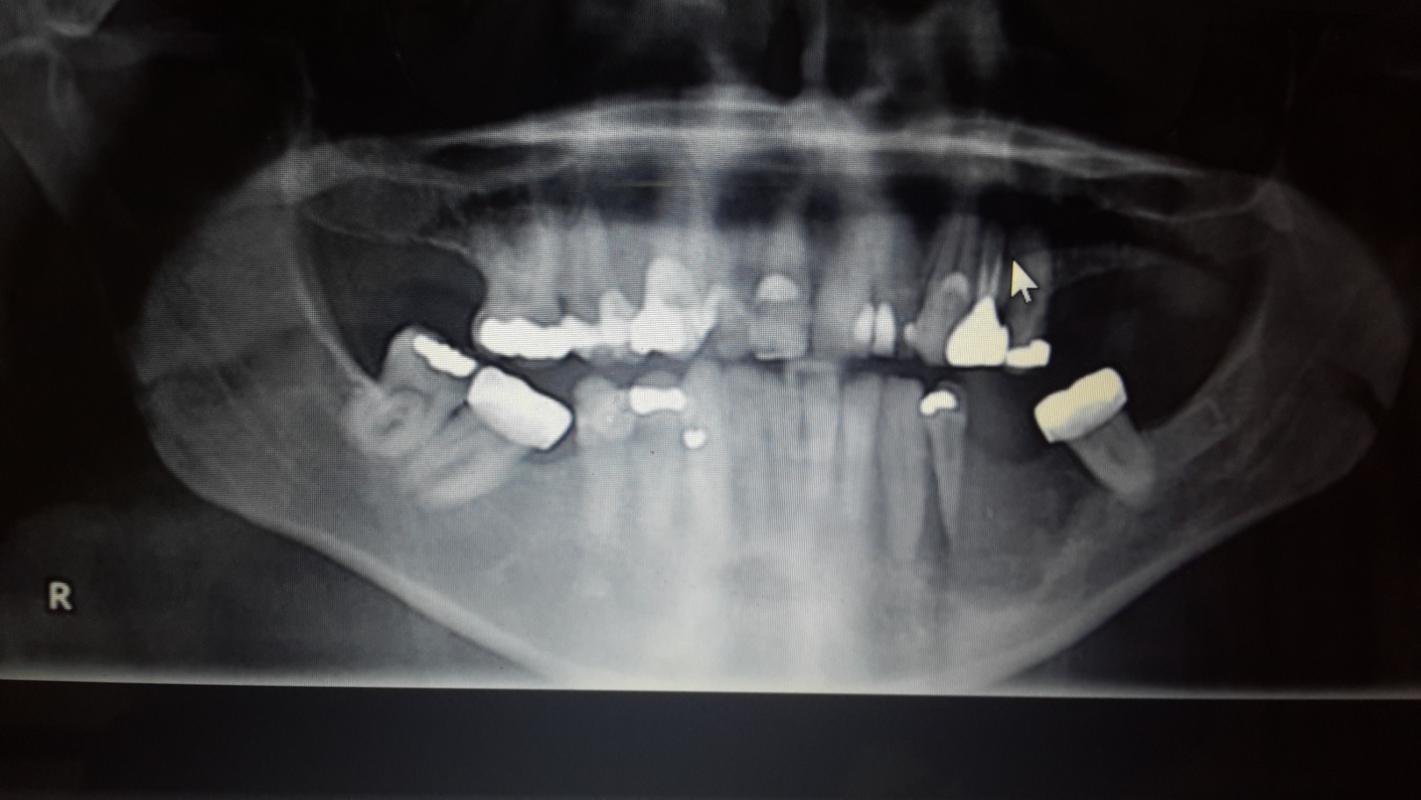
Case 3
It is a panoramic radiograph .. one said : lower border of the mandible from the molar to the molar on the other side there is some sort of radiopacity and radiolucency .. the dr then said if we assume that the lower is normal .. is the maxilla normal ??
-if we follow the cortices of the maxilla with the sinuses :it is difficult to follow ,, ill-defined ,, radiopaque .. and there is widening in the PDL space in upper left molar (focus more kman)
-ill-defined we don’t see the floor of the sinus so you must think aggressively .. what you thing when you say radiopaque ??
-radiopaque .. this may be : osteosarcoma ,, chondosarcoma
-metastasis of lymphoma is :radiolucent .. -metastasis of opaque is mainly from either breast or prostate
-there is s.thing also : ill-defined but not malignant is fibrousdysplasia ,, so this may be FD but the pt must be young not old (it comes in much earlier age compared to osteosarcoma) young doesn’t mean the teens ,, it means 20 s
-the mandible has no abnormality here ( what you see here is called antegonial notch) it is where the masseter muscle inserted ,, it is found mainly in pts having bruxism and males who fitting more muscular
-the angle of the mandible is more pronounced and the cortices look thicker (so what appears here are the cortices but look thicker)from the notch to the cotex there is an angle so appers thicker than normal- an important anatomical landmark presented here is : mental foramen 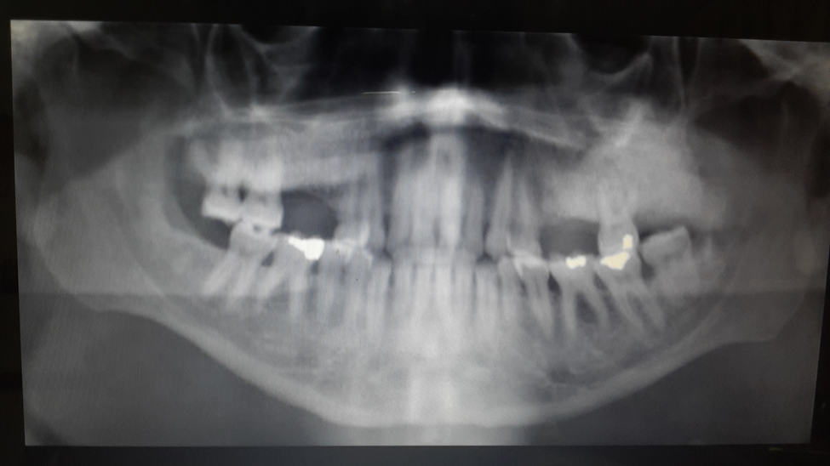

-case 4
-invasion to the canal and if we leave it , it will cause involvement for the lower border of the mandible .. the main two features appear : 1) ill-defined 2) floating tooth
-some one asked if we can said It is SCC ?? The Dr answered it is malignant ,, what type of malignancy you think ?
-SCC shall covered by the gingiva
-it may be central SCC or osteosarcoma (bone) ,, 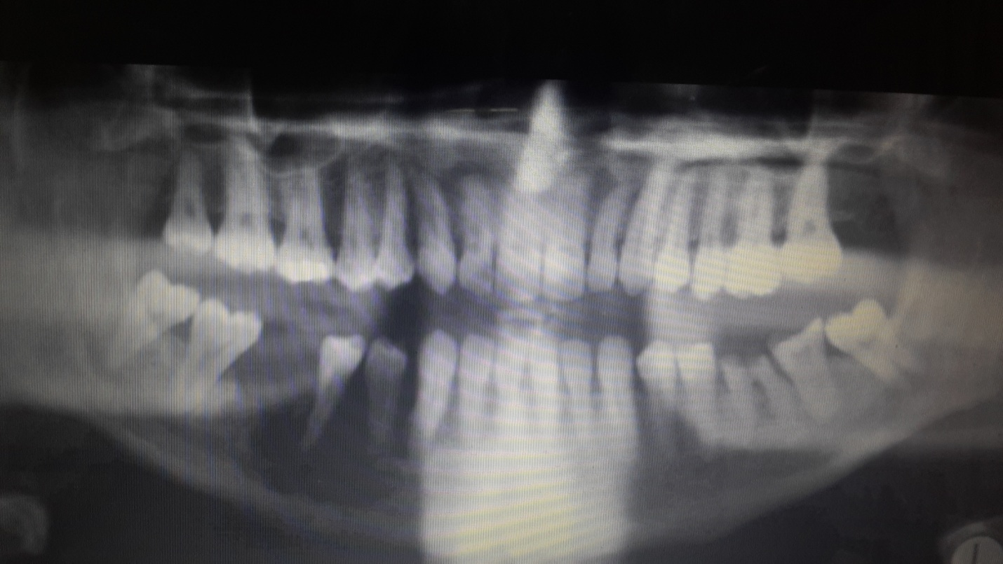

Case 5
Left side maxillary sinus is continuous then become interrupted
-if not interrupted : it is psedocyst (mucous retention phenomena) which is normal and not clinically important
-if it is interrupted it is important now
- here we don’t know when the extraction happened
- what we know : it is lymphoma of the sinus and it will go down to the alveolar process (the floor is not present)
-important anatomical structure : submandibular depression (for SM gland) appears bilaterally
-OH for the pt appears to be poor ,, class 5 appears clearly :O !

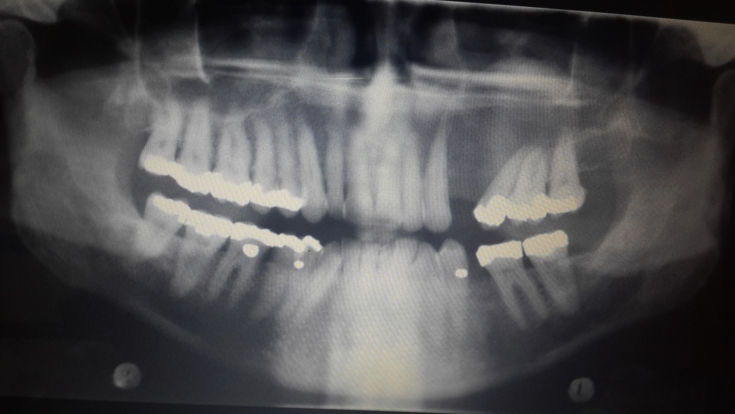

Case 6
Typical permiative il-defined .. no one sure where did it start and stopped !
-the right bone not look like the left one
-it is SCC ,, it may be : osteomylities we differentiated between them by clinical signs and symptoms
-maxilla : no problem ,, edentulous alveolar process and there is atrophy and periodontal problems
-there is confused area in the upper right : if we take a periapical radiograph ,, if we see another ill-defined lesion or multiple malignancy .. multiple myeloma will be ruled out
-we think about metastasis we don’t change the first opinion (it still malignant) but if I see it in more than one place the probability for metastasis will increase
- when we said radiopaque there is probability to have osteosarcoma (NOT always ) same thing applied here ..

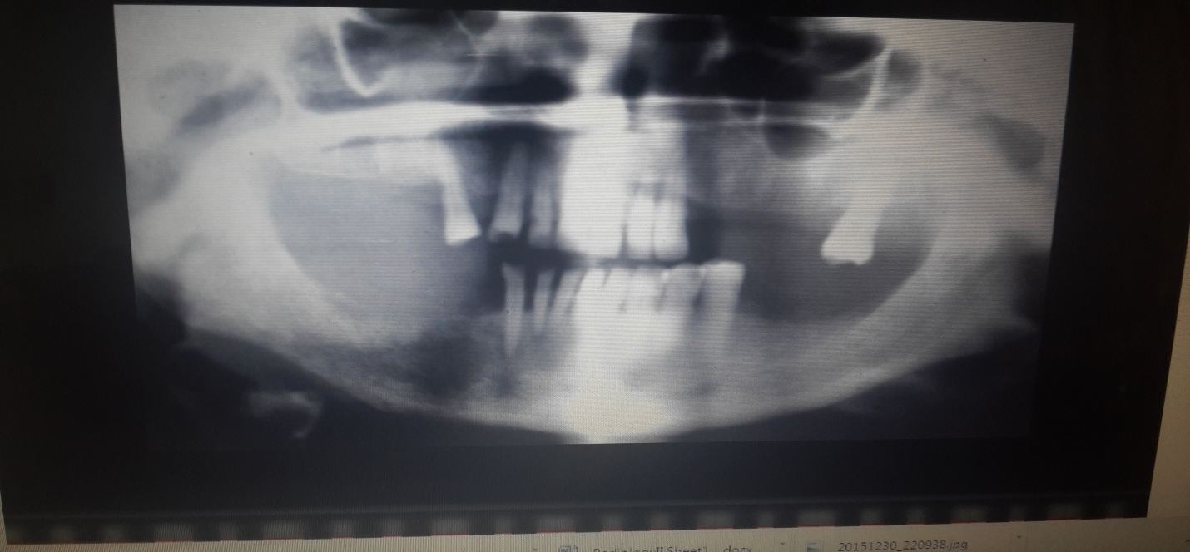

Case 7

Radiolucency on the left side of the mandible .. multilocular ,, well-defined .. nice septe,, radiolucent
-septa( mixed density lesion) : it is the lesion that produces it’s own calcification like the septe of ameloblastoma
- it is very benign : mainly keratocyst
- biopsy was taken ,, this lesion was :central muco epidermoid carcinoma which is the least aggressive of the malignant salivary gland tumors (cental variant of it)
-if you see it clinically : it is a benign lesion and it has all the benign characteristics
-(very indolent malignant lesion )
- it extends from the angle to the coronoid it takes all the condylar process
-why it is as bigger as that and there is no expansion ???
Keratocyst solves part of the question here there is some sort of expansion (but still small)
-ameloblastoma has more expansion if the pt is younger we can say :it is ameloblastic fibroma(but it is not multilocular)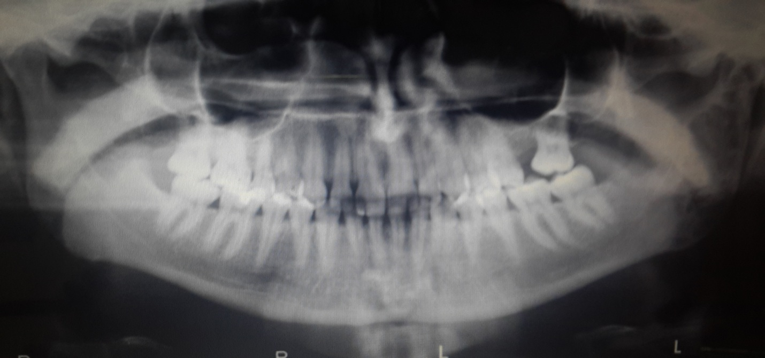

Case 8
More ill-defined lesion .. there is expansion
-look at the two sinuses the right one : well-defined cortices ,,
-left : no medial or lateral or posterior walls and that obvious invasion
-it is lymphoma case

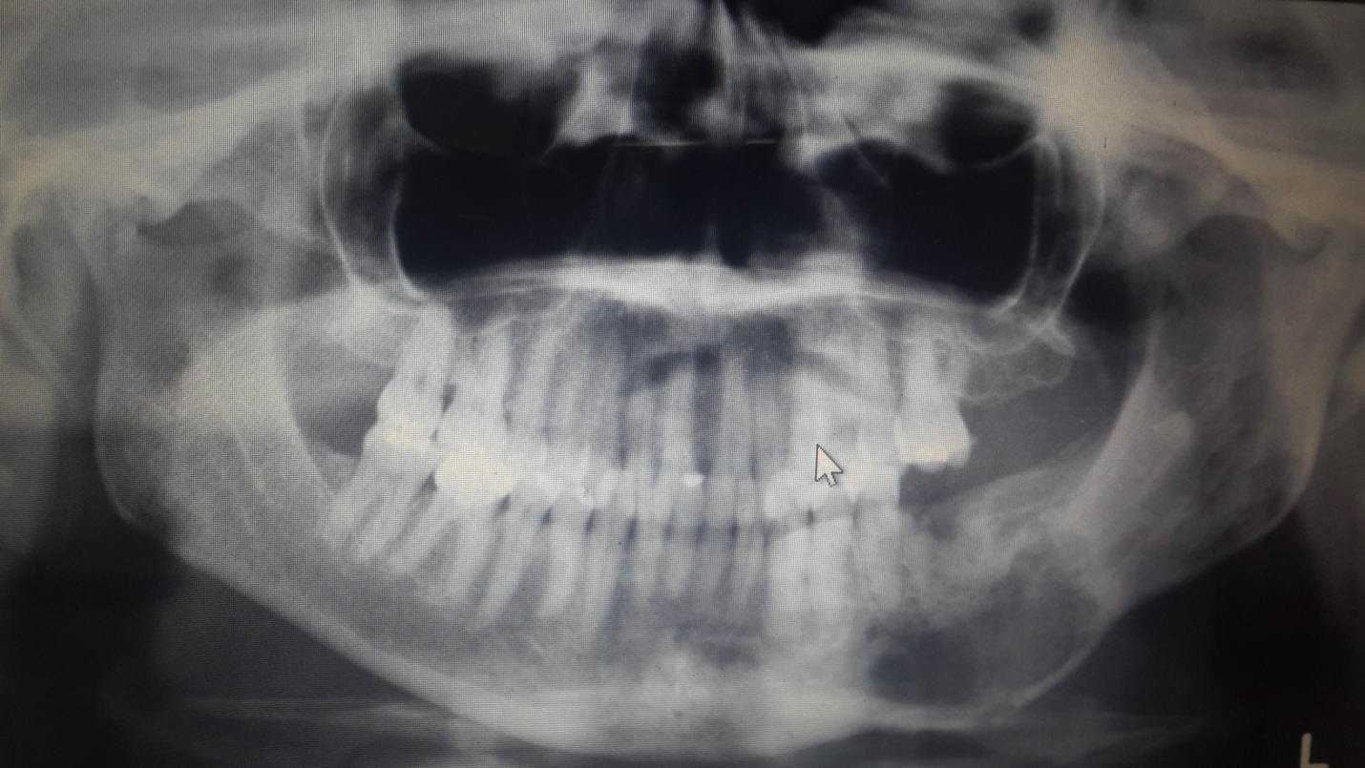

Case 9
Very interesting one : reconstructive panoramic radiograph
-Ill-defined lesion ,, floated teeth and all the radiographic signs that tell you : it is SCC
-IF you thing s.thing wrong you must re-examine the area ,, if you have panorama for example take periapical
-you have already CBCT and you have to examine the whole area
-one malignant lesion has multiple DD
-no expansion presented here
-DD : LCH (it is more scooped put it the last one in your list)
- SCC ,, osteosarcoma : more commonly then LCH
-lymphoma must commonly in the maxilla (sinus , and widening of PDL)
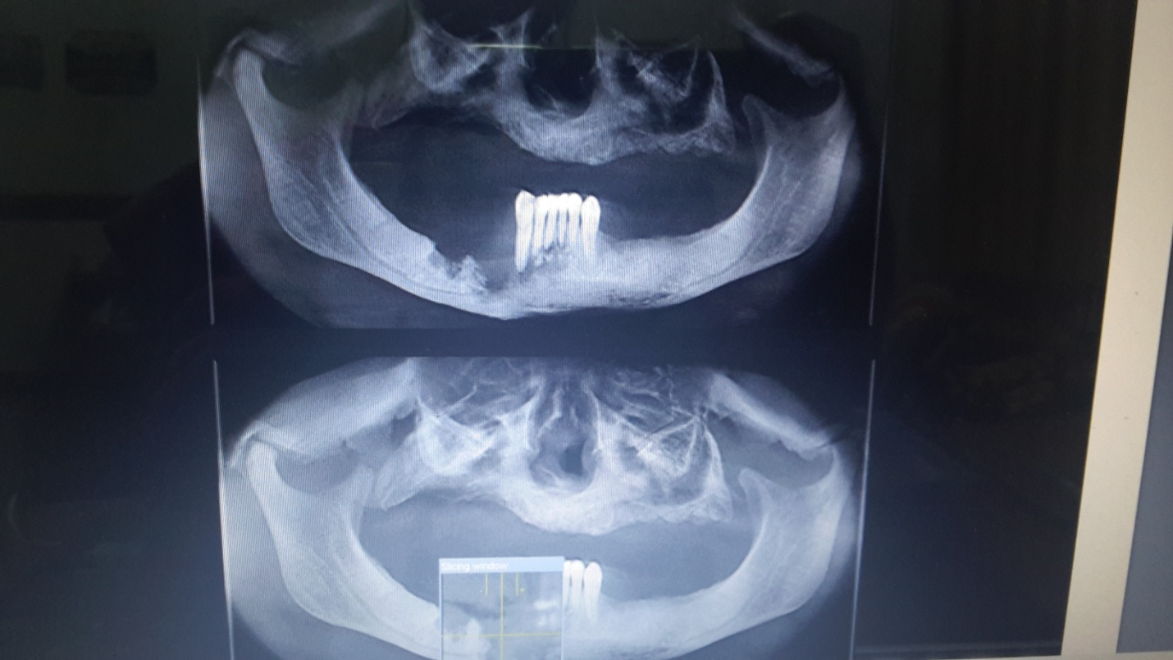
A5r shi 7kt 3n el exam : ma hathi el radiograph ,, what’s anatomy describe the lesion??what is the internal structure( opaque or lucent) . what is the category(inflamtory cystic metabolic) ? give me DD .. 7 marks 3l mid (generally) ,, 9 questions every one 10 minutes ..remember anatomy lecture !

لن تبلغ المجد حتّى تلعق الصّبــــرا **

