16  Dent-2011.weebly.com | Lecture No.
15/02/2016 | Date:
Dr Foad | Doctor:
Dalia Waia | Done by:
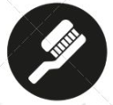
Conservative v

University of Jordan
Faculty of Dentistry
5th year (2015-2016)
Price & Date of printing:

.........................................................................................................................................................................................................................................................
Hand Out
Slide
Sheet

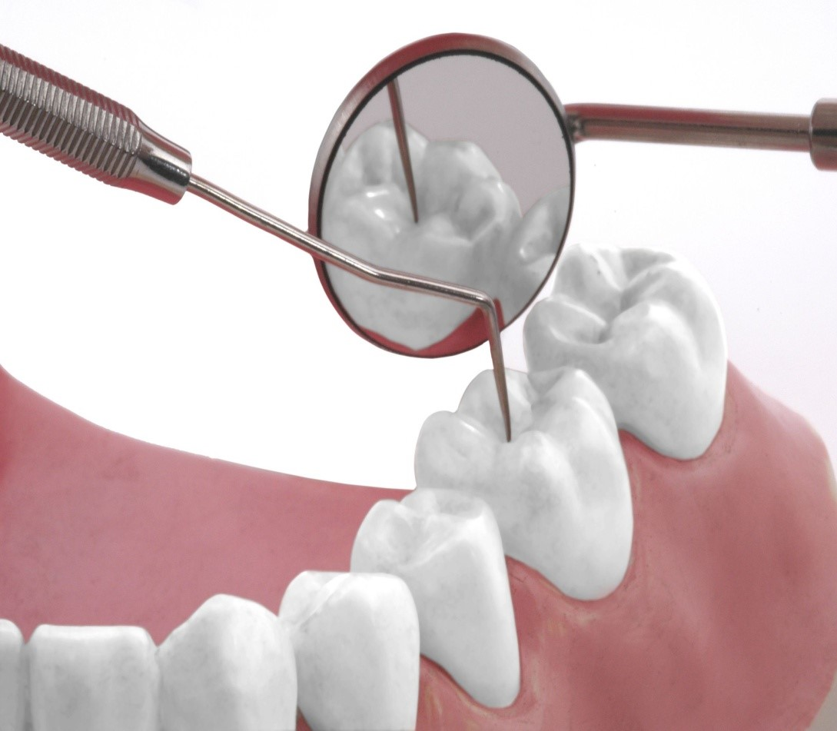
Designed by: Hind Alabbadi

Resin Bonded Bridge
It is defined as a fixed dental prosthesis replacing one or more missing teeth, which involves bonding a ceramic or metal wings to the inner aspect in enamel of an adjacent tooth/teeth (palatal/ lingual and proximal surfaces of the abutment teeth) using a special adhesive cement. The replacement tooth is held in place by means of wing (cantilever resin-bonded bridge) or two wings.
It's a very conservative option for the replacement of missing teeth and providing an intermediate-term restoration. It has good prognosis and offers several advantages over the conventional fixed-fixed bridge. Recent systematic reviews have estimated the five-year survival rate of bridge work as 88% for resin bonded prosthesis, just over 90% for the conventional bridge depending on design and about 95% success reported for implant-retained crowns. Therefore the resin-bonded bridge has comparable success rate to the other two if done in a proper way. It can survive for a long time and function as a proper restoration.
Now the primary goal of resin bonded bridge is the replacement of missing teeth with maximum conservation of the abutment tooth structure, although it was used before for splinting mobile, periodontally involved teeth.
These prostheses depend on bonding between the etched enamel and the metal casting, and requires precise and defined metal engagement of the abutments. It doesn’t mean that the retention depends on the resin cement. A proper design with adequate retention and resistance forms is needed. The metal should engage the abutments mechanically with good retention and although it seems for many workers as a simple procedure, it's a technique-sensitive procedure.
The main components of resin bonded bridge are 1or 2 wings considered as retainers, 2 connectors and one or more pontic teeth (PFM).
*The historical development of resin-bonded bridges and their different types:
Direct restoration represents the first generation. The indirect restoration is of three subtypes:
Second generation->Resin bonded bridge with cast frame work and perforated wings.
Third generation->Resin bonded bridge with cast frame work and non-perforated wings.
Fourth generation-> All ceramic resin bonded bridge.
So in summary, indirect restorations may have cast framework (metal then ceramic), maybe made of all ceramic, or hybrid. Resin bonded bridge with cast frame work may have perforated wings or non-perforated wings.

1-The First Generation
The first generation is the direct restoration where a natural extracted tooth, a tooth made of composite, or denture teeth are used as a pontic with the help of composite to replace a missing tooth. They are bonded to interproximal and lingual surfaces of abutments. It is a one visit technique, however these restorations demonstrated poor success rate due to many problems: like limited strength leading to debonding and discoloration. In addition, the composite resin connector is brittle and requires supporting wires or stainless steel mesh.
An example is a mobile, periodontally compromised lateral indicated for extraction. We can extract it and clean it, cut the root and clean the pulp chamber and fill it with composite. It can then be used as a pontic; we acid etch the proximal surfaces of the extracted tooth as well as the adjacent abutment teeth then we bond the pontic with the help of composite. This restoration can serve as a temporary measure.
These restorations were limited to short anterior span and had limited lifetime with the degradation of composite resin bonded to the wire or mesh (that we used to increase the strength of the connector area) and subsequent fracture. Such restorations should only be presented to the patient as short term replacement.

2-The Second Generation
The second generation is the Rochette Bridge (Resin bonded bridge with cast frame work and perforated wings). The concept of bonding a metal retainer to enamel using adhesive resin was first introduced in 1973. This application was used to splint periodontally involved mandibular anterior teeth using a cast gold bar bonded to the lingual surfaces of the adjacent teeth. The cast metal splint described as perforations that provide mechanical interlock between the cement and the metal, these perforations will properly hold the cement and the restoration. So at the try in and porcelain build up for the pontic area stage we etch the enamel and use resin cements mainly and also with the help of the perforations we will create a proper mechanical bond.
The perforated type was reported as a two-visit technique, as we have to take the impression in the first visit and the restoration will be ready for try in for the second visit. Later, many workers recognized that the metal framework improved retention as compared to bonded pontics (first generation) and so began using resin bonded bridge with cast framework and perforated wings bonded to the abutment teeth and metal ceramic pontics to replace missing anterior teeth.

*Retention increases as the surface area for bonding increases and as the amount of 'good quality' enamel increases.*
This restoration was retained by the help of acid etch to the enamel surface, perforations of metal, and chemical cure composite. Their design recommendation was to extend the framework to cover a maximum area of the lingual surface, to increase the retention.
It was suggested that no preparation is needed for these restorations, as these restorations were retained purely by adhesion (only related to the second generation).These restorations were limited to mandibular teeth or situations where there is an open occlusal relationship i.e. no heavy occlusion.
The second generation of RBB has the following limitations:
- Weakening of the metal by the perforations.
- Wear of resin at the perforations.
- Limited adhesion to the metal retainer provided by the perforations.
- Plaque retentive.

3-The Third Generation
Resin bonded bridge with cast frame work and non-perforated wings.
It has three main subtypes according to the bond achieved: Maryland Virginia or Adhesion Bridge.
The fitting surface can be treated by different ways in order to create proper retention for the restoration. Simply, if we do any treatment and we achieved micromechanical retention within the fitting surface is the Maryland subtype.
Macromechanical retention is the Virginia subtype.
Chemical bond between the fitting surface of the metal and the resin cement we call it the adhesion bridge.
1-The Maryland Bridge
We can do chemical or electrochemical etching to the fitting surface to create micromechanical retention, we do the etching using etching solutions such as 18% hydrofluoric acid or 10% sulfuric acid and both create a micromechanical bond within the fitting surface of the metal.
The quality of etching depends on numerous factors like the type of casting alloy, the type of acid etchant, the acid concentration, the etching time, and electrical current density.

The bond strength was good but problems include the difficulty in calculating the time for electrochemical etching, the hazards of chemical etching, and difficulty in producing a uniform etch pattern.
These problems led to the use of other methods to achieve micromechanical retention like sandblasting in which 50 micron alumina particles are used to produce a roughened oxide layer over the surface. Sandblasted based metal has been shown to have higher bond strength than etching or using salt particles (will be mentioned later on).
*If we can't achieve micromechanical retention by chemical or electrochemical etching we can achieve it by sandblasting.*
Again, due to the problems of acid handling that we face during acid etching like the possibility of contamination after etching in the try in step so we would need to repeat the etching, sometimes we use sandblasting. The sandblasting machine is the same that we use for PFMs clean it from the investment the only difference is the particle size under certain pressure.
The main advantage of Maryland Bridge is that the resin to etched metal bond can be significantly stronger than the resin to etched enamel (more than 20 MPa), the retainer can be thinner and still resist flexing, and the oral surface of it is highly polished and resists plaque accumulation. The main limitation of Maryland bridge is that such treatment requires the wings to be a little bit thicker and therefore less interocclusal space is available so more preparation is needed. The acid etching process is limited to the Ni-Cr and Co-Cr alloys (we cannot use the precious alloys), which means that these are the only cast metals that we can use to construct Maryland bridge.
2- The Virginia Bridge
-Where macromechanical retention is used-.
Treatment of the fitting surface to achieve
Due to the concerns regarding etching base metal alloys and the need to use alternative alloys several techniques were developed to provide visible macroscopic mechanical undercuts such as lost salt crystal technique and achieve this on the fitting surface or lost mesh pattern technique.
Lost salt crystal technique: a mixture of soluble and insoluble crystals ones 0.15-0.25 microns are incorporated in the fitting surface of the wax pattern then after washing the wax pattern with water, the soluble crystals are rinsed away the insoluble ones stay in position as part of a pattern creating positive and negative retention configuration (retentive pits).

So after we take the final impression, the lab constructs the die cast and on the die cast the wax pattern is made. While the lab constructs the wax pattern of the wings they spray salt onto the palatal surface and fitting surfaces. The salt contains some soluble and some insoluble particles, then they finish the wax pattern and wash it->the soluble particles will dissolve and the insoluble will stay within the fitting surface. So after we cast it we will achieve a certain pattern within the fitting surface.
Lost mesh pattern technique is an alternative technique to achieve macromechanical retention where the use of cast mesh wax pattern on the internal fitting surface of the retainer wings during wax pattern of the restoration. So after the first layer during wax pattern we use layer of mesh wax (same wax used for Co-Cr).
The main advantage of the Virginia Bridge is that it doesn’t require etching, and one doesn’t really need to worry about contamination of metal, the main disadvantage is the probability of resultant overcontoured retainer.
3- Adhesion Bridge
The third type is the adhesion bridge. We use the precious (noble) alloys like the gold alloy. Then we either use electrochemical coating by Tin of the fitting surface, another available method is sialocoating which involves the fusion of a thin layer of silica approximately 0.5 microns with the fitting surface of the metal. This silica coating reacts chemically with silane coupling agent applied prior to the application of the resin cement. The same machine as the one used for sandblasting but this machine does etching and at the same time coats the fitting surface with a layer of silica then when we use the silane coupling agent there will be a chemical reaction and a bond between the silica and resin cement (cement of choice for this type of bridge).

However; metal ceramic resin bonded bridge still have an unfavorable effect on the translucency and colour of the abutment teeth regardless of the metal used(In all previous 3 subtypes-Maryland, Virginia, & Adhesion). Clinically, after we do the cementation and especially when the incisal edges are very thin graying will result from the metal of the resin bonded bridge. A shadow of the connector area may appear in the interproximal areas between the teeth.
All ceramic resin bonded bridge where the pontic and the wings are made of porcelain, so it's an all-ceramic restoration.
The end result of the resin bonded bridge is determined by the retainer work, the porcelain work, and how the soft tissues were managed. Metal connectors may shine in the interproximal areas or the incial edges may appear gray as previously mentioned.

All ceramic resin bonded bridge were introduced in the early 1990s as a more esthetic alternative to the traditional resin bonded bridges. It is fabricated from glass infiltrated alumina which we call in-ceram.
However, the three-unit bridge may have many problems such as differential bond strength due to different sizes and mobility of the abutments, such problems may lead to debonding and compromising the results. (For example, if we have a missing lateral and the central and canine serve as abutments. There is a difference in the area of bonding on canine-larger- than central and they also have different mobility-the central does not move at the same time and amount as the canine).
This has led to the option of using a cantilever adhesive bridge (resin bonded one). Using a single retainer will eliminate the problems of partial decementation due to the flexion of fixed adhesive bridge and the difference of movements of retainers and abutment teeth during function. For example, the canine is the abutment of choice as for the conventional cantilever bridge when replacing the lateral although the central is another possible choice, but the canine has a longer root to dissipate the increased forces during supporting an additional tooth as well as the overall length of the tooth, which in turn maximizes the groove length(we may make proximal grooves to increase the retention and the resistance form of the restoration and these grooves are longer on the canine than on the central); retention is further increased by greater surface area for bonding and the convexity of the palatal surface of the canine which may increase the rigidity independent of retainer thickness.
Conversely the lateral incisor lacks all of these attributes because of its flattened smaller size and thus is a weak abutment choice.
Don't think of cantilever for posterior teeth, it's only for anterior teeth and mainly for replacement of lateral incisor.
If we have malalignments and you can't do conventional preparation and achieve parallelism such a case may be solved by the use of cantilever resin-bonded bridges using the adjacent teeth separately as abutments.
Clinically, these single retainer resin bonded bridge shows even higher survival rate than classic two retainer resin bonded bridge made from alumina ceramic. With advancement of zirconia ceramic into dentistry and even stronger framework material with considerably higher fracture strength became available for fabrication of all ceramic resin bonded bridge.

In anterior region an all ceramic resin bonded bridge with a single retainer glass infiltrated alumina ceramic presents the state of art in resin bonded prosthodontics. A possible alternative might be to use the lithium disilicate ceramic as long as sufficient connector size can be achieved. It is very esthetic but needs a larger connector because this material is not as strong as zirconia.
The success of these conservative prostheses depends on the bonding between the etched enamel and the metal or ceramic casting which requires precise and accurate metal engagement of the abutment.
During metal try in, a proper design should be made where the metal should be adequately engaged with a proper contour as well as margins. A good retention and resistance forms are crucial.
Resistance form is resistance to any lateral movement and resistance to any forces that tries to dislodge it along its long axis is the retention form. Poor design of the retainer and metal that was only bonded to the lingual enamel and combined with the difficulty of properly etching the metal result in failure of the restoration, so in fabrication of resin bonded bridge attention to details in the following three phases is necessary for predictable results:
1) Preparation
2) Design of restoration
3) Cementing of restoration
Tooth preparation aims to create a definite outline form and path of insertion of the restoration. Therefore optimizing resistance and retention form like for conventional cast restorations while minimizing metal display or show through. Tooth reduction is conservative mainly in enamel because once it is in dentine it is conventional. This is one of the numerous advantages of the resin bonded bridge. So whether anterior or posterior teeth are prepared common principles of tooth preparation design should be followed: Single path of insertion must exist (minimal path of displacement). This is a fact for any cast restoration (conventional crown or bridge or resin bonded bridge). Proximal undercuts must be removed(to provide enough metal on lingual and interproximal surfaces) , occlusal rests seats and proximal groove slots to provide the resistance form, and distinct metal margins gingivally so when we do proper cementation we can know where the finish line is and where the restoration ends.
Dalia Waia

