18  Dent-2011.weebly.com | Lecture No.
29/2/2016 | Date:
DR JAMAL | Doctor:
AMANI NIDAME | Done by:
Conservative v

University of Jordan
Faculty of Dentistry
5th year (2015-2016)
Price & Date of printing:

.........................................................................................................................................................................................................................................................
Hand Out
Slide
Sheet

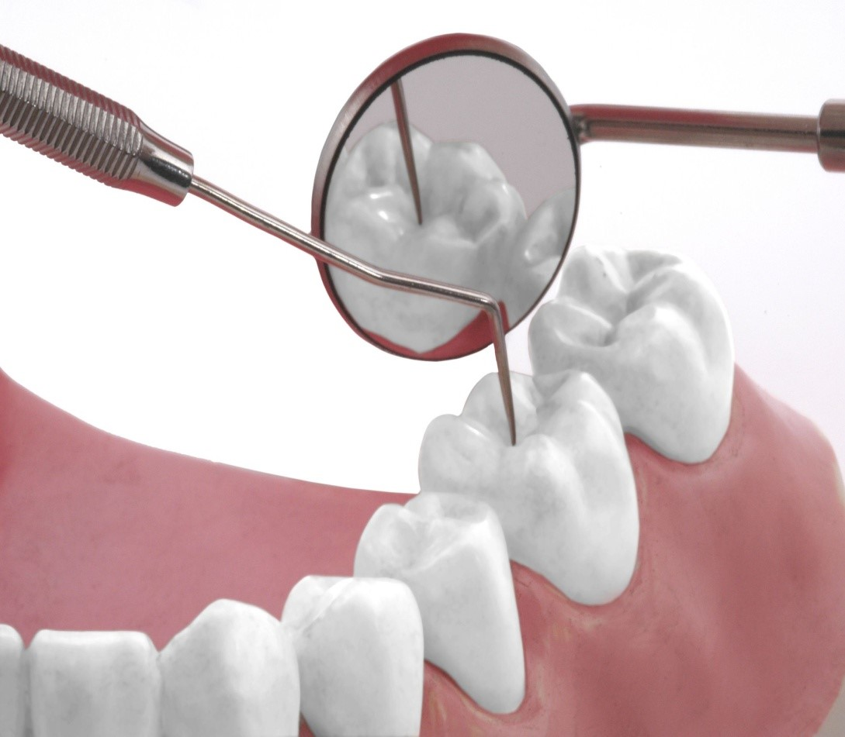
Designed by: Hind Alabbadi

- Heat carrier :
1)touch and heat
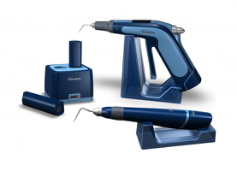
2) touch and tough

Another system is "system B" by Stephen Buchanan
SAME as touch and heat carrier .

We have two type of gutta perch connection and tapered one .
Vertical condensation need tapered gutta perch (not standard size one ) !

- To do filling by vertical condensation technique , you must achieve the requirements of cleaning and shaping ; continues tapering , apical area narrow , apical foramen as small as practical on it's origin place ....

- plugger fit
As we said we have 3 pluggers instead nine , One for coronal one third , one for middle one third and the last one for apical one third .
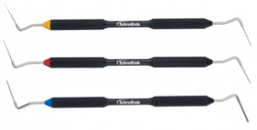

- The cone fit must have tug back ( not loose ) in the last 3mm apically .

- put sealer on the cone and put it on the canal , now we start the vertical condensation :
1- Take the heat carrier , heat it until be chary red , put it int the orifice , cut the gutta perch and take it out (we notice that gutta perch color appear red , the heat reach 4 mm below the orifice , so the gutta perch now is moldable )

2- take the plugger and push the moldable gutta perch downward , condense it .
3- gutta perch become cold , again we use the heat carrier ,and again take some part of the gutta perch out , use plugger to condense the moldable gutta perch downward .
So if we have lateral canal it well fill during the condensation process

4- We repeat this procedure until we reach the apical third

After we finish the " back packing " !

* if we need post , put it , then put crown
* if we don't need post , take any size gutta perch , cut it into four parts , we don't need the first part , so we have three part's , take the first part put sealer and put it int the coronal third
Take the heat carrier , heat the gutta percha without removing any thing , condense it with plugger
Take the 2nd and 3rd part of gutta perch and repeat the same steps as the first part .
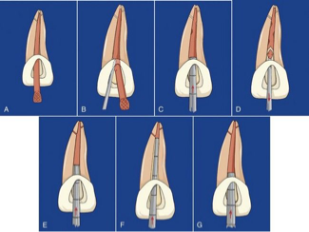

Some dentist instead of these procedure use what's called "obtura tube " : it's a gun contain gutta perch , inject it in the canal and condense it by plugger to prevent shrinkage and so on .

The advantages of vertical condensation , it can fill the lateral canal and give us very good filling .

How can we clean the lateral canal ?!
By using sodium hypochlorite , files can't clean it .

Note : in lateral condensation technique spreader must enter the canal 1-2 mm shorter than working length .

Dr show a radiograph for sever curvature root , so in this case lateral condensation won't work .

Another radiographies for failure cases due to unfilled lateral canal we can predict it by the radiolucent lesion laterally , so we repeat the canal filling by vertical condensation technique and complete healing achieved .

If we have furcation lesion due to endo problem we can treat it , but if it's due to perio problem we extract the tooth .

In our clinic when we use pro-taper , because we can't use vertical condensation technique , we must use use cone fit standard size one .02 and fill using lateral condensation (use accessory cones with the cone fit as usual ) .

