2  Dent-2011.weebly.com | Lecture No.
8/10/2015 | Date:
dr-fouad | Doctor:
muzayyan altaweel | Done by:
Conservative v

University of Jordan
Faculty of Dentistry
5th year (2015-2016)
Price & Date of printing:

.........................................................................................................................................................................................................................................................
Hand Out
Slide
Sheet

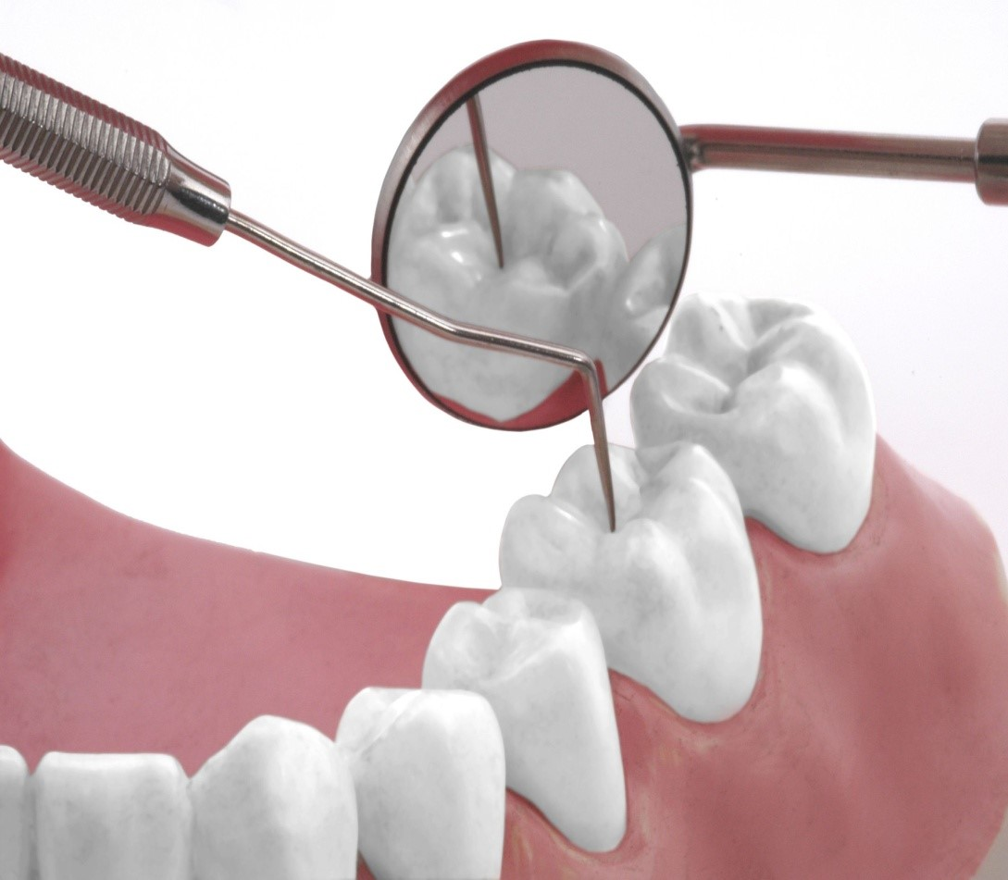
Designed by: Hind Alabbadi

In the previous lecture we mention about proper treatment plan: identification of patient's needs, available materials and techniques , treatment of tooth loss.
Treatment of tooth loss :
**Replacing of single missing tooth
First treatment of a single missing tooth is fixed-fixed prosthesis which is the 3 units bridge:one pontic ,one retainer mesially, one retainer distally .
Replacement of upper maxillary canine, we should take 2 abutments mesially which are lateral and central incisors ,and a premolar distally.
Also we talk about cantilever bridge sometimes we can do distal of restoration or replacement of upper lateral incisor and even for upper lateral incisor there is advantages and disadvantages and it still popular using cantilever bridge for replacing upper lateral incisor.
Assessment of abutment teeth **
Considerable time and expense are spend ,and loss of patient confidence can be avoided by further investigations in each abutment before proceeding with tooth preparation. radiograph are made in pulbal help in assess and by evaluating the response determine an electrical stimulation.
Remember if you want to replace missing upper 5 and spend more time and time in evaluating upper 4 and 6
Radiograph have limitation, also electrical and thermal pulb test have limitation so you have to do all these to reach for a conclusion and whether this tooth is good one or not.
Existing restoration , cavity liners and residual caries are removed. …...is made for possible pulbal exposure, teeth involve pulbal health is darker should be endodontically treated before the initiation of prostodontic.
Any old restoration done by some body else should be replaced.
When we take x-ray, x-ray is two dimension, there is possibility to have caries under it and we don’t see by x-ray,,, so you have to replace any old restoration done by somebody else, to be sure that this abutment is a good abutment for preparation.
remove old restoration if there is any risk that this tooth has the possibility for exposure. like in the picture the cavity is deep the axial wall very close to the pulb ,

on the radiograph always the picture is underestimated, if we see like this radioopacity in the radiograph and there is possibility of pulb involve and if we need to do restoration for this tooth we need follow up .
We put cavity liner (calcium hydroxide)and amalgam restoration and composite and then if the patient have any problem we can do endo but if we use this tooth as abutment we can't do endo .))so if there is risk of possible problem regarding the pulb so we should do elective endo and then a proper restoration.
Endodontically treated tooth : if the tooth is endo treated and have a proper restoration then we should consult an endodontics regarding the endo, regarding coronal restoration If there is post and core and you find it difficult to replace, you should ask your supervisor about. sometimes the core is not well retained so during preparation the filling will fall and will be too complicated.
sometimes l do proper preparation and well retained filling but l don’t have ferrule effect so the possibility for failure of the bridge will be high .
So remember if a tooth is properly treated endodontically it can serve well as an abutment with post and core foundation for retention and strength. Failures is particularly with tooth of short root or little remaining coronal tooth structure .for example upper central with cast post and core with ferrule so this one will serve a very good abutment but if the margine of the core was very close to gingival, no at least 2 mm, it is good to do crown lengthening and use as an abutment.
Any restored abutment, caries free tooth it can be prepared conservatively for a strong rententive restoration with optimal esthetics , the marginal can be placed without modification to accommodate restoration of caries in the oral cavity
Look at the preparation lingually and buccally and check your parallism in each abutment and then occlusally
First l look occlusally can l see the preparation finish line all around if yes it is a good preparation with no undercut
Again you have to keep walls parallel as much as you can. we don’t have to make it cone shape so no under cut will be^^ NO ^^
Check your preparation, check the finish line all around…
Mesially tilted 2nd molar when early loss of mandibular 1st molar is still relatively common , when we lose 1st molar there will be drift in 2nd molar and 3rd molar. remember radiograph will not give correct situation for the tooth , sometime we see tooth on x ray but clinically is acceptable.

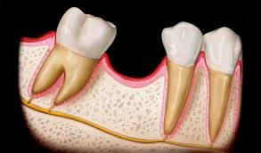

How to solve this problem, this become difficult to make satisfactory fixed partial denture because the conditional relationship no longer allow of insertion parallel without interference with the adjacent tooth.
A proper preparation for 5 and 7 , the walls of 2 abutment are parallel to each no undercut .but during insertion or metal try in there will be interference with the position of 8
how to solve this problem???????
1-extraction of the 8
2- when we preparation for abutment the tooth should not be full coverage we have another types: 3 quarter, 7/8, full coverage ,inlay like one of the way to solve this problem is to do partial preparation for 7 and leave the distal wall intact
3- ortho treatment and correct the position of the 8.
If the walls not parallel to each other, the restoration will be not retentive. somebody ask why not to do preparation for one wall only? the doctor said that metal try in will be easy, but when we do porcelain build up and return the anatomy of the tooth there will be interference so the solution is what we said before.
You should do proper examination and treatment plan >>one of the question you need to ask the patient ,regarding this space,does the patient has any complain ?? if there is small space and the patient has no complain nor functionally or esthetically so why to fill this space,, because of the patient no complain, at the end he will said: you damage my teeth
When the tooth is a little bit rotated ,try to follow surface by surface in preparation buccal stay buccal , lingual stay lingual ,mesial stay mesial, distal stay distal, then after we do the preparation , do modification to insure parallism and remove any undercut.
Replacement of several missing teeth:*

fixed prostodontic become more difficult when several missing teeth must be replaced. problems will be encountered when restoring a single long uninterrupted edentulous area ,or multiple edentulous area with an intermediate abutment pier abutment special way anterior and posterior teeth need to be replaced with a single fixed prosthesis.
This diagram we saw in the previous lecture:
6 missing and 4 missing we can start this treatment by cantilever bridge we take 2 abutment as cantilever bridge it will reduce tipping forces. if l want to construct conventional one we do preparation for the canine ,5,7
5 is the pier abutment, the case will be alittle bit difficult because l want to make parallism for 3 teeth underestimation of the problem involved in extensive prostodontic, can lead to failure .

ensure a successful result is to plan the prosthesis by waxing the proposed or planned restoration on articulated diagnostic cast. this is essential for the complex fixed prostodontic treatment, particurarly where an irregular occlusal is to be corrected the vertical dimension of occlusion is to be altered and an planned supported prosthesis is recommended or combination of fixed and removable prosthesis are to be used.
the patient has lower posterior missing ,upper right and left premolar are missing, patient by the time will loss the vertical dimension to restore this case you have to make study model ,wax pattern and do replacement by wax for missing teeth. try to study the case carefully. first correction to the vertical dimension then think how to replace the missing teeth may be by implant or fixed bridge, regarding lower posterior we can do replacement by either implant or rpd .
even for one missing tooth we need to wax it. proper articulation of study model this one will be very useful to do inlet for provisional restoration when we do preparation.
Regarding complicated cases we must do study model and wax pattern , good study for the case
Study model is the best way to evaluate the abutment teeth.
When l have several missing teeth and l think to use fixed fixed bridge l will have problem overloading of abutment teeth
The ability of the abutment to except drifting or becoming mobile must be estimated and has a direct influence on prostodontic in treatment plan .This particularly severe during parafunctional grinding heavy occlusion and wearing the teeth and clenching and then to eliminate them it become obvious during restoration of such a damaged condition.

Look to these 2 slides
One premolar and one or two molars are missing when we think to make fixed fixed bridge you have to excpect we will have overload on the abutement . any long restoration even to replace one missing tooth (three unit bridge) the bridge will flex. if the bridge is longer the flextion will be more. try to avoid any long bridge to prevent overload on abutment. if l have more than one missing teeth there is possibility to have overload on abutment.
how to reduce overload
Direction of the force 1
The magnitude of any applied force is typically doubtful. a well fabricated fixed partial prosthesis can be distribute, these forces in the most favorable way than in long axis of the abutment teeth.
In diagram one tooth is missing when we do preparation for restoration we will take these 2 abutment but how we can use these 2 abutment to distribute forces, how to be more conservative?? don’t make full coverage we can do 3 quarter so we have replacement missing tooth and proper distrubtion of forces for 2 abutment.
2 Root surface area
Ante suggest in 1926 unwised to provide a fixed partial denture when the root surface area of the abutment less than the root surface area of the teeth been replaced .
Surface area of the root of the abutment should be equal or more than the surface area of the root of the missing teeth
So we will reduce the overload on the abutment
3 Root shape and angulation
When the tooth support is border line, the shape of the roots and their angulations should considered. a molar with divergent root will provided better support than molar with conical root alittle or no interradicular .
In the picture there is abutment with convex root and the second picture have 2 root divergent and bone in between. The second one will sever abutment better than the first
*Regarding the periodontal disease after horizontal bone loss from periodontal disease, periodontal ligament supported root surface area can be reduced because of conical shape of most roots when one third of root length has been exposed half of the supporting area has lost.

In addition the forces applied to the supporting bone are magnified, because of greated leverage associated with length clinical crown plus potentially abutment need to be carfully assessment where sufficient bone loss has occurred.
Regarding span length, all fixed partial denture flexed slightly when subjected to load, the longer the span THE GREATER THE FLEXITY the relationship between deflection and length of the span is not simply liner what varies with cube of length of the span.
When one tooth missing( one pontic) force applied during mastication will flex the bridge, say x amount when pontics are more than one the amount of flex will be cubic . in this diagram the force applied on the pontic so the bridge flex to an amount 8 times the bridge flex when there is 2 pontics.
27 times the bridge will flex when there is 3 pontics.(3x3x3).
CASE :5 unit bridge, 2 abutment which are 4,7 and you have a good preparation but every 2 to 3 days patient comes complain of fallen bridge and need recementation,there is possibility to have fracture in porcelain and connector area, because this bridge is long and it get flex ,so accessible flexing under occlusal load may cause failure of long span fixed partial denture it can lead to fracture of porcelain veneer and fracture in connector area of the retainer or unfavorable tissue response this render the prosthesis useless.
**Replacing multiple anterior teeth
Special consideration in this situation include problems and appearance underneath to resist factorable directed tipping forces .
The 4 mandibular incisors can usually be replaced by simple fixed partial denture with a retainer on each canine, Final restoration is 6 unit bridge replace 4 lower anterior teeth. if alone incisor remain in between the space it should be removed because its retention will unnecessary complicate the the design and fabrication of fixed partial denture and jeopardize the long term prognosis .mandibular incisors because of their small size teeth generally make them poor abutment, it is particularly important to have overcontoured restoration on these teeth because flex control will be nearly impossible.
The clinician may have a choice between compromise esthetic form a thin porcelain veneer or pulbal exposure during tooth preparation. regarding replacement of upper anterior teeth upper central and lateral incisor are missing it is good to have 2 teeth on each side as abutment :canine and premolar on each side why?? because of the curvature of the arch, and the force of upper anterior teeth canine is not enough because there will be drifting in preparation
So the loss of several maxillary incisor presence a particular problem in term of restoring appearance and providing support, because of the curvature of the arch force of upper maxillary incisor will tend to tip the abutment teeth, therefore replacement of max incisor need 2 abutment of long span anterior teeth.
some time we have soft tissue bone loss as well as missing teeth, If anterior bone loss has been sever as can happened when teeth are lost because of trauma or periodontal disease may have ridge defect. In those patient rpd should be considered when the pt has high smile line since a fixed partial denture generally replacing only a missing tooth structure not a supporting tissue .
About the sequence of tx,, when pt need unidentified appropriate, corrected measures have been determine a logical sequence of steps must be decided on inconclusion the treatment of symptoms, stabilizing deteriorating conditions, then the definitive treatment and then a programme of follow up.
** tx of symptoms : always in any tx plan in perio ,ortho, cones, start by treatment of symptom then stabilizing ,definitive then follow up for any treatment.
So the relife of this discomfort or treatment of acute condition is apriority items in planned treatment, this discomfort can be due to one or more of the following items:
Fracture tooth\teeth
Acute pulpits /acute abscess of chronic pulpits/ dental abscess
Coronitis ,gingivitis, myofacial pain dysfunction so you have to start by the tx of symptoms, urgent tx of non acute problem
Stabilizing deteriorating condition regarding dental caries and periodontal disease and then *the following is essential for stabilizing the condition replacements of defective restoration removal of carious lesion recontour crown and oral hygiene instructions and then start the definitive tx
study model - wax pattern sequence of tx occlusal adjustment
when we do occlusal adjustment :
If I have ant and post teeth missing I must start with anterior then posterior and then the complex restoration and then follow up .
- At the first lecture we said if I have acceptance for fixed prosthesis start doing clinical examination then history then radiograph, perio, vaitality test , study model , pt excepectation and we said the advantages of articulated diagnostic cast and we said it is necessary even for one missing tooth to have wax pattern on the study model.

One benefit for wax pattern is to make inlets when do the temporary restoration.
remember steps of tx
1-tx of symptoms
2-stabilizing
3-difinitive tx
4-follow up
to write in more simple way always we start by pt chief complain
Rx , vitality test ,perio, articulated study model ,pt expectation
The first steps is solve the chief complain some time the patient who come to make bridge not necessary have any acute pain.
So if there is no acute pain the first step here to
- Solve chief complain.
- Perio treatment :proper scaling and polishing
and give pt instruction for good oH
3-exctraction ( SURGICAL TREATMENT)
4-endo tx
5-proper restoration for carious teeth as well as the endo treated teeth
Now I start doing the restoration on clean environment . and pt hasn’t any complain and has good oH control the all factor that I need
The result when I do endo before final restoration I can determine if the tooth is restorable and can be used as abutment.
Then finally I start fixed prostodontic.
remember if the pt has missing teeth upper +lower ant +post , right and left how can I start?
It is necessarily to start from anterior then post why?
Because I should correct the anterior guidance and anterior restoration is good and the patient has correct lateral movement in relation for the mandible and then go back to the posterior teeth.
So start restoration in anterior teeth upper and lower at same side to have proper occlusion .
It is unacceptable to do ,right+left at the same time
It is important when I do fixed-fixed prosthesis to check the occlusion , check maximum intercuspation lateral movement to know if the patient is canine guidance of group function, because the tx will be different specially if the canine involved. we should do the same occlusion the pt have ,,we should save it .
Complicated case is when the missing teeth are more so there is loss of vertical dimension so pt will not have proper occlusion so original one is lost so we have to make new,, but if the original occlusion (ant and post stops)is there we should save it
So I have to make the tx step by step with saving the original occlusion.

Good luck seniors

