20 part 1  Dent-2011.weebly.com | Lecture No.
21/3/2016 | Date:
dr-suzan | Doctor:
Bayan qteashat | Done by:
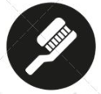
Conservative v

University of Jordan
Faculty of Dentistry
5th year (2015-2016)
Price & Date of printing:

.........................................................................................................................................................................................................................................................
Hand Out
Slide
Sheet

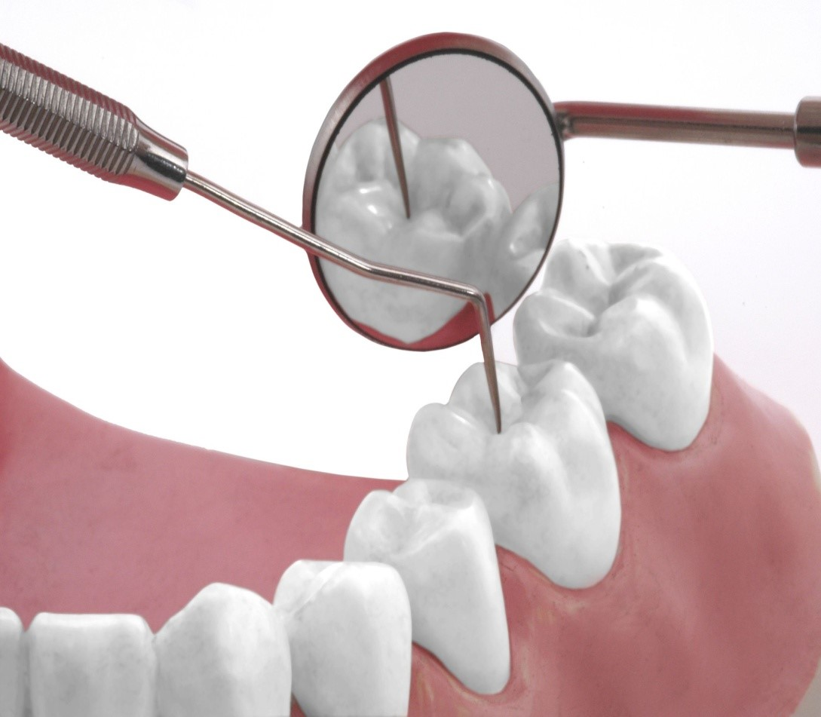
Designed by: Hind Alabbadi

Cosmetic inlays and onlays

Previously , we learned how to prepare a metal onlay on lower 6 in crown and bridge lab . but in this lecture we gonna focus on cosmetic onlays and inlays which could be either indirect composite or ceramic material . the ceramic material used for onlays is the same ceramic that is used for veneers ( you need to bond it to the tooth structure ) , we can use zircon but it bonds weekly to the tooth structure .

what types of ceramic material used for onlays fabrication ?
- Pressable ceramics , E.MAX
- glass ceramics ( silica ) empress I+II . empress I ( leucite reinforced ) , empress II ( lithium disilicate reinforced ), feldspathic ( highest percentage of glass , so it is the most esthetic , but with lower strengh )
silica that’s present in ceramics is the component that will be etched by hydrofluoric acid and then you will silane it and bond it later on .
two types of veneers : feldspathic and empress .

Treatment options for inlays and onlays :
- class I + II . simple class II needs only inlay , I will use onlay in case of MOD ( cuspal coverage ) .
- fabricated in resin composite or ceramic materials ( conventional or CAD/ CAM )
- resistance and retention forms are primarily provided by the adhesion to enamel and dentine . this is the first difference with gold onlay , since in gold onlay no bonding . in gold onlay retention and resistance are dependent on preparation ( mechanical ) ; boxes , divergence ,,, etc.
Indications :
- adequate remaining tooth structure . it is a logical sequence ; 1- starting from a small cavity (direct restoration) 2- a complex cavity ( large MOD , loss of one of the cusps ) , 3- partial coverage ( onlay ) 4- full coverage ( crown ) .
- low caries risk
contraindications:
- patients with heavy occlusal loading ( parafunction , bruxism ) , in this case we gonna use gold onlay . but it is not 100 % contraindicated , sometimes I may use esthetic onlay and construct an occlusal splint after , same as veneers .
- extensive caries ; we go directly for full coverage crown .
- inlays are contraindicated in large MOD cavities , because inlays are very rigid causing wedging effect. direct composite restoration is safer here , or we can do a cuspal coverage(onlay) to protect the tooth .

advantages:
- durable compared to direct composite restorations
- lower marginal deterioration and leakage , because it is cemented and no shrinkage ( no stresses because it is ready to be cemented )
- high esthetics
- Cusp support (onlays )
- Good contact compared to posterior composite . keep in mind that we use resin cement so we need good isolation .

Disadvantages :
- Less conservative than direct restorations.in inlays we need divergent walls , in onlay we need to do more cutting .
- Occlusal adjustments can only be made after cementation like veneers , because if it is high , it will be fractured immediately because it is not bonded yet .
- Time consuming and more cost.
- Abrasion of opposing tooth if it is made of ceramic material .

Inlay preparation:
after you removed all caries , undercuts and undermining enamel :
- Penetrate central groove to a minimum depth of 1.5mm

- Extend the occlusal outline conservatively through the central groove to the marginal ridge , avoid occlusal contact with the cavosurface margine because it is the weakest link (u have to stay 0.5mm away from the contact of the opposing ) , then do the box , the difference here is that the box is slightly diverging occlusally (6 degrees).

- the width of the gingival floor should be at least 1mm , positioned supragingival , and at least 0.5mm clearance with the adjacent tooth ( same as when we do class II, to be able to put the matrix) ,and here I did separation because I want the impression material to go beyond the cavosurface margin .

- type of impression material used : elastomers ( 4 types )
- Outline form is usually determined by the extent of the lesion and caries removal.
- Undercuts can be blocked using resin modified glass ionomer cement or even composite ; to minimize the cutting of tooth structure , in case of scooped out ( concave ) area in the pulpal or axial wall , but not on the external wall .

- Ceramic inlay preparation differs from a metallic inlay preparation in: ( important)
1* No grooves. We do them in gold to increase retention (mainly ) and resistance because we gonna cement it with conventional cement.
2* No bevel or flare. We do beveling for gold because u can burnish it inside the patient mouth and this will give u the most accurate margin ever . don’t do bevel for ceramic , because it will fracture in thin sections ( has low tensile strength )
3* Greater amount of reduction .

- If boxes are extended beyond the transition line angle , preparation will lose retention and resistance , you should switch to onlay instead of inlay.

Onlay preparation:
- Penetrate groove to minimum depth of 1.5mm
- 99% of your onlays are MOD at the beginning , so there are 2 boxes . occlusal reduction on both centric and eccentric cusps , 1.5 on nonfunctional and up to 2 mm on the functional cusp
- Occlusal shoulder width is 1mm minimum , without any bevel , and its height depends on the opposing ( 0.5 to 1 mm away from the occlusal contact )
- Margins are 90 degree butt joint
- Everything should be smooth and uniform
- all internal angles are rounded.
- Divergence from 6-10 , above 20 u will lose your retention dramatically.

Provisional restorations:
- For inlay , you can use IRM ( TF)
- For onlay , Provisional can be fabricated from composite or acrylic resin, with stronger cement than temp bond , u can use for example polycarboxylate cement mixed with vaseline, but you should avoid eugenol-containing cements in order not to inhibit the setting of resin cement.

Cementation
- should be cemented using resin cement either conventional resin cement(acid etching , bonding, then put the resin cement on the tooth surface ) or self adhesive resin cement ( rely X , unicem ,u don’t have to prepare the tooth , the resin cement itself has esteric monomers that will etch and bond to the tooth structure at the same time .very easy especially for post cementation , because it is very difficult to do good acid etching and bonding inside the canals ) .
- note : for veneers we always use light cure , because the activator that’s present in dual or chemical cure causing discoloration and staining.
- resin luting cement is the recommended material , because :
- it bonds to enamel , dentine and to the restorative material .
- it limits microleakage and enhances the strength of the restoration and the tooth structure .
- dual cure resin cement is advised , because the thickness of the ceramic material is usually 2 mm so light cure alone will not penetrate. So to be on the safe side , use either dual cure or chemical cure .

