1  Dent-2011.weebly.com | Lecture No.
1/10/2015 | Date:
foud | Doctor:
Ali jawad | Done by:
Conservative v

University of Jordan
Faculty of Dentistry
5th year (2015-2016)
Price & Date of printing:

.........................................................................................................................................................................................................................................................
Hand Out
Slide
Sheet

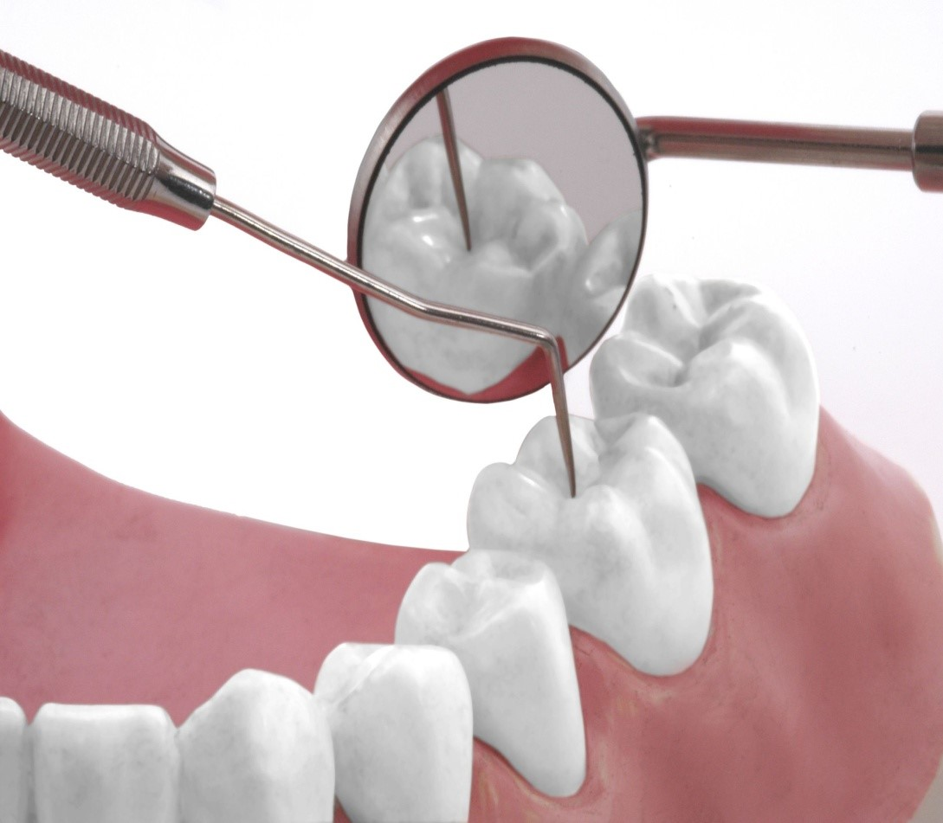
Designed by: Hind Alabbadi

Treatment planning
-Definition: it logical sequence of ttt design to restore pt's dentition to good health, function and appearance
-The plan should be presented in written form and should be discussed with patients in details
-The process of diagnosis and ttt planning helps us to maintain a comprehensive and complete guide to care for any given pt and their particular situation.
-Before diagnosis and ttt plan are made thorough data collection is necessary from :
1- medical, social and dental histories
2-physical examination
3-dental radiographs
4-articulated study models
5-perio charting
6-endo vitality tests
7-pt's expectation of the ttt
-So we should always remember these 7 points before making the ttt plan for any comprehensive pt case.
-The main advantages of articulated study casts are:
1- diagnosis problem arising during the ttt plan
2- allow an unobstructive view of the edentulous space
3- accurate assessment of the span length as well as the occlusogingival dimensions for the pontics
4- curvature of the arch can be determined so we can tell if the pontic or the pontics can act as liver arm on the abutment teeth
5- length of the abutment teeth can be accurately judge to determine which prp design can provide adequate retention and resistance forms
6- the true inclination of the abutments can be determined so any problem in the common path of insertion can be anticipated
- The patient's preference are paramount in establishing a suitable Treatment plan; it consists of identifying patient’s needs, electing his or her expectations and wishes for ttt , and then correcting these problems with available materials and techniques .
- An article in Reader’s Digest Journal, February 1997, summarized the current status of treatment planning in dentistry.
-The article described a patient who went to 50 different dental offices in different 28 states , and came back with treatment plans ranging from no need for any treatment to treatments that cost 30,000 dollars.
-for making a good treatment plan we should:
1- identify the patient's needs
2-determine available materials and techniques
3-treatmeant of teeth loss
4-selectition of the treatment of the abutments
5-sequenence of ttt

-now we will talk about:
I) Identification of patient's needs
- -Successful treatment planning is based on accurate and proper identification of patient’s needs. If an attempt is made to have the patient conform to the ideal treatment plan rather than have the treatment plan conform to the patient’s needs, success is unlikely… so we have to consider the patient's needs.

-Treatment is required to accomplish one or more of the following objectives:

- Correcting an existing disease
-Existing disease will be revealed during the clinical examination. The disease process can usually be arrested by identification and reduction of the initiating factors, identification and improvement of the resistive factors, or both. Such as oral hygiene instructions and fluoride application.
- so when we do examination the patient may need OHI, scaling and polishing, maintenance and then proper restorations.
b) restore the function:
-It is assessed during the examination. Treatment may be proposed to correct impaired function (ex: mastication or speech)
-if the patient lost his posterior teeth there will be loss in the vertical dimension so I must restore the vertical dimension to restore the function
c) Improving the appearance :
Patients often seek dental treatment because they are dissatisfied with their appearance.-
-The dentist should develop expertise in this area and should be prepared to appraise the appearance of the patient’s dentition and listen carefully to the patient’s views.
-The feasibility of the corrective procedures should be brought to the patient’s attention.
- so we have to tell the the patient what we will do to his teeth .
II) available materials and techniques :
-All existing restorative materials and techniques have limitations and cannot exactly match the properties of natural tooth structure. Before the clinician selects the appropriate procedure, he or she should understand these limitations. This will help prevent an experimental approach to treatment.

- Plastic Material
-Plastic materials ( amalgam or composite resin…) are the most commonly used dental restoratives. They allow simple and conservative restoration of damaged teeth. However, their mechanical properties are inferior to cast metal or metal ceramic restorations.
-we should be able to know that our choices if amalgam or composite for ex.(especially if the patient has bad oral hygiene we would go for amalgam in posterior teeth, composite used when the pt has esthetic concerns.
-the choice depends also on the next step we will do on the tooth, so if we want to do crown it's good to do an amalgam restoration because of it's superior physical properties.

b. cast metal
- Made entirely of metal , Cast metal crowns are fabricated outside the mouth and are cemented with a luting agent. To minimize exposure of the luting agent to oral fluids, a long-lasting restoration must have good marginal adaptation, however these restorations should have precise axial shape and occlusal surface.
c. intracoronal restorations
- An intracoronal cast metal restoration or inlay relies on the strength of the remaining tooth structure for support and retention, just as plastic restoration does (it needs a retention and resistance form).
d. extracoronal restorations
- An extracoronal cast metal restoration onlay or crown encircles all or part of the remaining tooth structure. As such, it can strengthen and protect a tooth weakened by caries or trauma.
- so when we want to do crown we must before evaluate the remaining tooth structre.
e. Metal-Ceramic Restorations (PFM restoration)
-Consists of a tooth-colored layer of porcelain bonded to a cast metal substructure. They are used when a complete crown is needed to restore appearance as well as function. The preparation design for a metal-ceramic crown is among the least conservative, although tooth structure can be conserved if only the most visible part of the restoration is veneered (Labial surface ,the mesiodistal margins and incisal in porcelain fused to metal, with the palatal sometimes done in metal only; using chamfer finish line).
- sometimes if there is teeth wear especially in the anterior teeth we can do only rough reduction on the palatal surface and put only metal on the palatal surface of the tooth to prevent exposure of the pulp that might happrn when doing reduction for porcelain .
- when we have shoulder finishing line we must have metal plus porcelain , and when the finish line is chamfer it's metal only.
-The labial margins of a metal-cermaic restoration are often visible and it may appear as a shadow .this can be fixed by doing an all ceramic restoration , or they can be hidden by subgingival placement of the finishing line, although they might then have the potential for increasing gingival inflammation.. Appearance can be improved by omitting the metal shoulder and making the labial margin in porcelain only that's not supported by metal by doing a shoulder finishing line too.
f. all ceramic restorations
-Crowns, inlays, and laminate veneers are made entirely of dental porcelain, it's the most esthetically pleasing of all fixed restorations.
g. fixed partial dentures (bridges)
- An FPD is often indicated where one or more teeth require removal or are missing.
-Such teeth are replaced by pontics that are designed to fulfill the functional and often the esthetic requirements of the missing teeth. Pontics are connected to retainers by connectors, which are the restorations on prepared abutment teeth.
- FPD requires precise alignment of tooth preparations; because unseating forces on individual retainers can be considerable , highly retentive restorations are essential. The restoration must be retentive at the metal try in stage, if not; that's mean there is a gap between the tooth and the restoration and it will eventually fail.
--The predictable long-term success of an FPD is ensured by controlling magnitude and direction of forces and by making sure the patient practices appropriate oral hygiene measures.
- we have four types of fixed bridges:
1)fixed fixed bridge :like the 3 units bridge; two retainers cemented on two abutments , one pontic and two connectors.
2- cantilever bridge:
we have 2 types either conventional cantilever or spring cantilever bridge, the first one is made of one retainer seated on abutment and only one pontic connected to it and it's mainly for replacing upper laterals.
- if there is a patient who have teeth spacing and missing upper lateral incisor, if we do fixed-fixed bridge it will not give an esthetic appearance due to the connector area that is different from the other teeth so we can use the spring type which have bar like connector that will eliminate this problem.
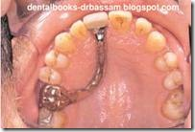

-spring cantilever bridge
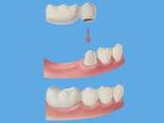
Conventional cantilever bridge
3-fixed movable bridge : where we have one side cemented.. the other side is movable attachment percision attachment (male and female)
4-resin bonded bridge : this type bridge has one pontic and two wings, it's placed by help of wings that cemented on the palatal surfaces of the adjacent teeth.
h. Implant Supported Prosthesis
Single or multiple missing teeth can be replaced with an implant-supported prosthesis.-

i.Removable or complete partial dentures
-They are designed to replace missing teeth and their supporting structures.

III-Treatment of teeth Loss
-Most teeth are lost as a result of dental caries or periodontal disease. More rarely they may be congenitally absent or lost as result of trauma or neoplastic disease.

-Decision to remove a tooth
-The decision to remove a tooth is part of the treatment planning process and is made after assessing the advantages and disadvantages associated with retention of the tooth.
-When trying to decide extraction of a tooth we have to get a periapical radiograph, and we have to try our best to save the tooth from extraction.
-If at the end we can get about 2 mm of sound tooth structure (ferrule effect) either from the crown itself or after crown lengthening to gain more tooth structure, then this tooth is indicated for restoration and we can build it up using the post and core system. Otherwise the tooth is for extraction.

-Consequences of removal without replacement.
-The stability of an individual tooth depends on a balance of the forces exerted on that tooth by the adjacent and opposing teeth and supporting tissues and by the soft tissues of the cheeks, lips, and tongue. When a single tooth is not replaced, this balance is disturbed.
-slight common situation that u see in clinics when lower six extracted without replacement, tilting of the adjacent teeth will happen, loss of proximal contact. and over eruption of the opposing tooth.
IV) Selection of abutment teeth
-Whenever possible, FPDs should be designed as simply as possible, with a single well-anchored retainer fixed rigidly at each end of the pontic. The use of multiple splinted abutment teeth, nonrigid connectors, or intermediate PIER (that comes in middle between two extracted teeth) makes the procedure much more difficult, and often the result compromises the long-term prognosis.
-Sometimes we’ll have cases with multiple extracted teeth and an intermediate abutment, this abutment is called pier abutment. The design will be a bit complicated, and it is hard to achieve parallelism for the abutments

-Replacement of a single missing tooth
-Unless bone support has been weakened by advanced periodontal disease, a single missing tooth can almost always be replaced by a three-unit FPD having one mesial and one distal abutment tooth.

-An exception is when the FPD is replacing a maxillary or mandibular canine. Under these circumstances, the small anterior abutment tooth needs to be splinted to the central incisor to prevent lateral displacement of the bridge under the forces… when we have missing canine , we can’t rely on a the lateral incisor as an abutment because it is a weak tooth , so we take the premolar , lateral , and central as abutments for fixed – fixed 4 units bridge .
-Replacment of single missing tooth with cantilever FPD:
-FPDs in which only one side of the pontic is attached to a retainer are referred to as cantilevered. An example would be a lateral incisor pontic attached only to an extracoronal metal-ceramic retainer on a canine.
-although some of the difficulties encountered in making 3 units bridge are lessened the use of the cantilever bridge is still popular in replacing the missing upper laterals, so the first choice is the 3 unit bridge and we can use the cantilever bridge depending on the case and to be more conservative.
-However, the long-term prognosis of the single abutment cantilever is poor. Forces are best tolerated by the periodontal supporting structures when directed in the long axes of the teeth. This is the case when a simple three-unit FPD is used.
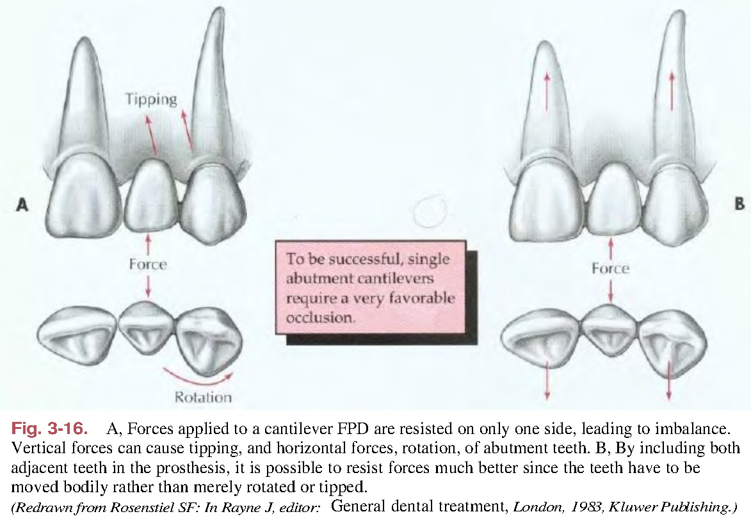

-when we do cantilever bridge(a), the forces on the canine and on the pontic don’t have good support so we will have tipping, drifting and rotation. We can prevent rotation by retentive groove on the preparation but to have more durable restoration we have to make 3 unit bridge like in (b).
- BUT When multiple missing teeth are replaced, cantilever FPDs have considerable application. The harmful tipping forces are resisted by multiple abutment teeth and the movement of the abutment is unlikely, like if we have missing four we can do cantilever bridge with the six and five as abutments instead of making 3 unit on the canine and the five and this we minimize the tipping forces by inserting these 2 strong abutments on the prosthesis.
Best wishes……

