17  Dent-2011.weebly.com | Lecture No.
22/2/2016 | Date:
fouad | Doctor:
Dalia jibreel and shahed rezqallah | Done by:
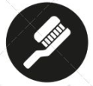
Conservative v

University of Jordan
Faculty of Dentistry
5th year (2015-2016)
Price & Date of printing:

.........................................................................................................................................................................................................................................................
Hand Out
Slide
Sheet

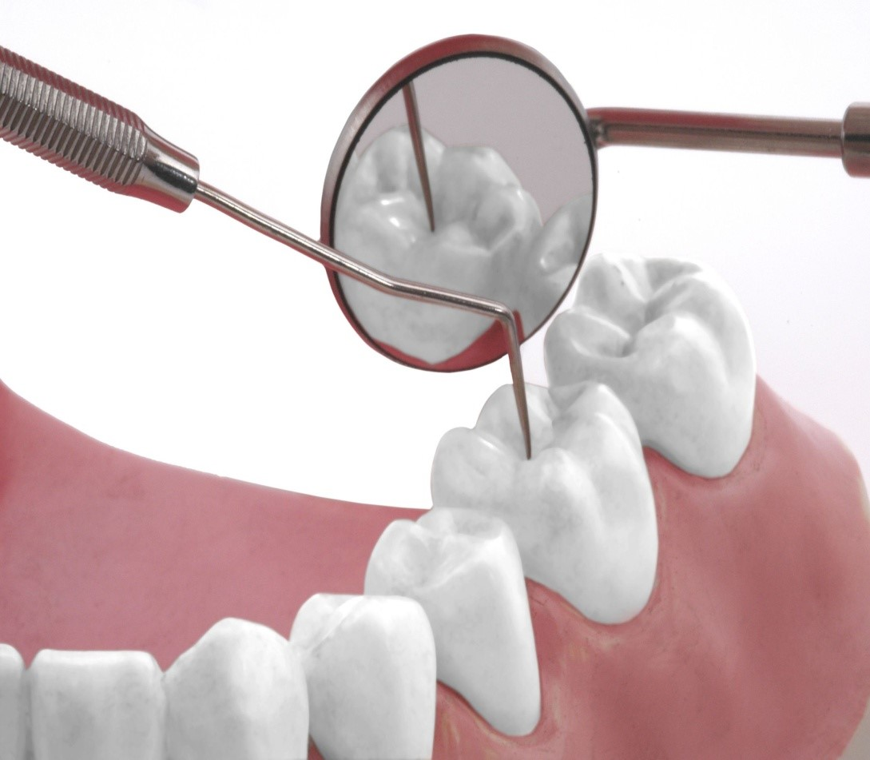
Designed by: Hind Alabbadi

We will continue talking about resin bonded bridges
- Fabrication of RBBs(resin bonded bridges):
Attention to detail in the following 3 phases is necessary for predictable success
- Preparation of abutment teeth.
In the first and second generation ( Rochette type ) no need for preparation … the main retention here we get it from the resin that’s why we called it the resin bonded bridges but the 3rd generation (Virginia or Maryland or adhesion) and all ceramic RBB need preparation.
Tooth preparation aims to create a definite outline form and path of insertion for the restoration, therefore optimizing resistance and retention forms while minimizing metal display or show.
Tooth reduction is conservative remaining within enamel for RBB preparation, it is one of the numerous advantages of these restorations.
- Design of the restoration.
- Bonding or cementation of the restoration.

- Whether anterior or posterior teeth to be restored, common principle dictates tooth preparation design with the following :

- single path of insertion must exist, with minimal path of displacement. As for Crowns and any conventional bridge we must have one path of insertion.
- If we have more than one path of insertion that means , when we reach the metal try in stage wherever we put the crown/bridge it we will be seated (if we rotate it and put the buccal to lingual and mesial instead of distal it will be seated that means its loose and fit in any rotation we place). >>>> this is for any cast restorations , it’s a must to have one path of insertion.
- One path of insertion >> resistance to displacement (any lateral movement won’t move the restoration out) and also gives retention (resistance to be displaced out with the long axis of the tooth).

2- Proximal undercuts must be removed in order to create parallel walls to provide “planes of metal” on the lingual and proximal surfaces of the restoration.
3- occlusal Rest seats either anteriors or posteriors and proximal grooves slots must provide Resistance form.
4- distinct metal margin gingivally either anterior or posterior . (usually the margin is placed 1 mm supragingivally <finishing line>).

- On anterior and posterior abutment teeth, there must be sufficient enamel area for successful bonding, and the metal retainer must encompass enough tooth structure and have sufficient resistance form, to prevent the individual abutment from being displaced in any direction out of the framework.

- For example, a tooth restored with an amalgam restoration, it’s a good idea to replace the restoration with composite and prepare the tooth for RBB to achieve better adhesion with the resin cement, but heavily restored tooth is not a good candidate to be a Resin Bonded Bridge abutment.

- Any flexing of the metal bridge retainers exerts stress on the cement lute that eventually leads to fatigue failure. Base metal alloys are highly rigid and therefore can be used in thin sections without risk of flexing, making them ideal for use in RB retainers, it has been reported that 0.7mm as a minimum dimension should be incorporated in the bridge metal construction.

      - As you remember, the longer the bridge the higher its tendency to flex and the more likely the cement will eventually fail.
      - Long abutments >More flexing > more stress on the cement > cement breakage and fatigue > failure > recementation.
      - Aunt’s law : as we remember when we want to increase the number of pontics we increase the number of abutments depending on this law.

Step by step procedure For anterior preparation:

- The occlusion is assessed to ensure at least 0.5-0.8 mm interocclusal clearness for the ceramic or metal retainers in the intercuspal position and throughout the lateral and protrusive movements. So if the patient had an interocclusal space of 0.5-0.8mm plus then he doesn’t need occlusal preparation, if there is intimate contact we can use articulating paper to mark the CO contacts to prepare them and create the required interocclusal space.

- The First step in the preparation is the removal of the centric occlusion areas from all the abutments (0.3-0.5 mm from an area of about 2-3 mm). in centric and lateral movements.
If we want to replace lateral incisor : We first check the occlusion in centric :
if the patient already have an openbite >then he already have interocclusal space > he doesn’t need the first step.
But if patient have normal class I and normal contact with the anterior teeth : first we mark the contact in centric then we do grinding in enamel(0.3-0.5 mm from an area of about 2-3 mm).
- The incisal finishline is 2 mm short of the incisal edge in order to avoid greater effect from the metal.

- The mini chamfer defines the gingival extent of the restoration “1mm supragingival”, and allow for the casting to blend in with the natural lingual contour.

- after we do reduction for the contact in centric (clearance) .3-.5 mm >> 2nd step try to remove the undercut within the proximal surface continuing through the lingual or palatal creating finishing line 1 mm chamfer / feather edge supragingival.
- Interproximally, the finish line ends at the center of the contact area, this proximal wrap around while minimizing visibility of metal from the facial aspect. The proximal surfaces of the 2 abutments should be parallel as much as possible to increase the retention form as well as reducing any negative space or black triangle .
- Define rests (spoon- shaped cingulum rest seat) and grooves will provide resistance form for the retainer, and will assist in a positive seating during cementation, the rest will act as a vertical stop should be placed in the most prominent part of the cingulum, and should be perpendicular to the path of insertion.
- For a groove to be effective, it should penetrate at least one half bur diameter into the enamel, retention is increased when grooves are placed more buccally (to get the wrap around design like the clasp) , but their placement is limited because of the potential for the metal casting to show through the thin labial enamel producing more graying. (it compensates for the lack of proximal wrap around).

- In the doctor own words as a summary:
first of all we have to create space for the retainers if at least 0.5 mm interocclusal space is not available, if there is contact “as shown by the articulating paper” with the opposing we reduce it but we keep the reduction within enamel .
the 2nd step is creating parallel proximal walls to reduce the proximal undercuts , (distal of central and mesial of canine if we’re preparing a RBB to replace a missing upper lateral), we have to remove any undercut, and we create a mini chamfer finish line palatally, then we continue cutting to end the preparation in the middle of the contact point, because we want our wrap around to cover around the tooth as much as we can.
3rd step is to create cingulum rest, we make it on the most prominent part of the cingulum, it will act as a vertical stopper where the restoration will end during cementation , after casting, the fitting surface of the wings will have projections in the area of rests and grooves, which guides the positive seating of the restoration during cementation and prevents further seating more gingivally, so they work as stoppers and increase the resistance form.

sometimes to enhance the retention proximal grooves can be placed

To enhance resistance, more than half of the circumference of the tooth should be prepared (i.e the concept of the greater than 180 degree wrap around which is particularly important for posterior teeth), so a retentive retainer will actually act like a c-clasp wrapping around the abutment tooth more than 180 degrees, retainers (wings) should involve one tooth mesial and distal if a single tooth to be replaced, if a combination of tooth replacement and splinting is intended, more teeth should be covered by the framework to increase the retention.

Preparation for Posterior tooth abutment

- the goals of preparation on posterior abutment teeth are mainly to:
1- provide parallel walls between the abutments
2- maintain the buccolingual curvature.
3- lower the height of contour to within 1mm of the crest of the gingiva, to eliminate the proximal undercuts.
Lingual reduction on mandibular posterior teeth, especially the molars, requires lowering the height of contour to provide maxiumum surface area of contact with the wings, and due to the normal lingual inclination require more enamel reduction.
Two occlusal rests, are required to support the lingual arm of the retainer at both ends, and eliminate the potential for flexing of that arm, they also provide additional surface area, occlusal rest with 3 degrees tapered walls provide a positive seat and stop for the restoration and limit horizontal displacement.
It is sometimes a good idea to prepare two occlusal rests to extend the lingual arm of the wing from mesial to distal and to support it from both ends, such a design will give the restoration a better resistance form through achieving the wrap around Concept.
Secondary Impression stage and Design
Make an accurate impression. Marginal fit is as critical for RBB restoration as for conventional bridge. Use silicone impression material or polyether.
Provide temporary occlusal stops ( younger patients or patient with reduced periodontal support) to close the rests and grooves prepared on the tooth until the cementation appointment, and this is using chemical/light cured composite without etching or bonding.
The lab should return the secondary cast to you after pouring so you can draw your design on it, as you should know by now and always remember; the three aspects you should consider for a successful restoration, the first is the preparation and we are done with that, the second which is the design of the restoration; and this means that you have to draw the outline of the restoration on the secondary cast by yourself.
Design of the anterior restoration:
The incisal finish line is conventionally 2mm short of the incisal edge to avoid any esthetic impairment of incisal edge translucency.
The restoration must extend labially to the center of the proximal contact point.
To optimize esthetic the proximal wrap in the anterior region may be achieved in part with porcelain pontic.
In maxillary arch the concept of maxillary coverage is limited by the translucency and thickness of the incisal edge of teeth, additional retention must be obtained by placing grooves on proximal surfaces more towards the buccal as much as esthetics will permit.

In mandibular anterior teeth, the surface area is much less than the maxillary arch and the wrap around Is more difficult to achieve adequate retention without using the proximal grooves.
Preperation of the mandibular anterior teeth is similar to the maxillary incisors, lingual enamel thickenss is 11-50% less than for maxillary teeth, therefore the preparation should be more conservative.
Design of the Posterior restoration:
The framework must extend bucally beyond the distobuccal and mesiobuccal line angles of the respective abutments.
Proximal resistance form can also be achieved by the use of grooves or boxes, , occlusal rests are important as vertical stops with consideration to esthetic or existing restorations kept in mind.
So remove the undercuts and create parallelism, you prep. Should be 1 mm supragingival, then prepare occlusal rests, take the final impression then on the cast you have to draw the design, try to cover as much as possible lingual and proximal by extending a little bit buccaly to achieve the wrap around concept, as we said the wings should cover more than 180 degree around the tooth, to get better retention the amalgam restoration can be replaced with composite one in order to achieve better bond during cementation.
Metal try in
The requirements for the metal framework :-
1- Single path of insertion should exist.
2- The alloy framework should be designed to engage more than 180 degrees of tooth structure when viewed from the occlusal.
3- Maximum lingual or palatal coverage is fundamental.
4- Rotational or oblique path of insertion allow Resin Bonded Bridge to snap into place and resist displacement.
5- Retention, mechanical lock (meaning that it is not easy to displace the framework even without cementation) and no occlusal interference.
Afterwards you take the shade of porcelain and return everything to the Lab. The next visit we do porcelain try in instead of saying we’re doing cementation. To check the occlusion and shape of the restoration.

Bonding procedure
Development in resin cements have helped to increase restoration longevity. Early composite resin material exhibited degradation and reduced bond strength with time.
In contrast, Panavia (one of the most common and widely used resin cement) demonstrated prolonged high bond strengths, this is due to formation of a chemical bond between the phosphate groups of the cement monomer and the oxide layer of the metal retainer (nitric acid successfully creates an oxide film on the surface of the metal retainer).
When cementing the RBB, the metal should have mechanical retention/mechanical lock, then the porcelain build up with a little bit extension labially we achieved better wrap around and better retention, now the cement itself can chemically bond to the metal, and on the other side it bonds to the tooth structure.
Sandblasting (air abrasion of the alloy surface with 50 micron alumina prior to bonding roughens the surface) to create micromechanical interlocking should be carried out before cementation to further enhance the bond.
An opaque composite resin can be incorporated into the resin cement as it can minimize the graying effect.
Remember: micromechanical retention Virginia, etching chemical or electrochemical Maryland and for both of them we use Base metal alloys (non precious alloys), for Adhesion one we used Noble alloys (Precious alloys), because we need to do precoating or silocationg treatment.
C&B Metabond (another type of resin cement) has been found to adhere strongly to smooth dental alloys and found a superior bond strength with base metal over noble alloys which increase the durability of the adhesion.
For all ceramic resin bonded bridge, Zirconia’s chemical inertness and glass-free composition means that acid etching and salination is ineffective on its surface (because it has no glass structure).
Subsequently, RBBs are bonded using autocuring composite resin such as panavia 21 TC (kuraray) or phosphate monomer containing primer such as monobond combined with a composite resin cement, which is applied directly to the abraded bonding surface to the fitting surface of the retainer wing using about 50 microns alumina particles at 1 bar pressure?
As for any adhesive cement system, the manufacturer’s instruction must be followed to achieve the best results.

Indications of Resin Bonded Bridge
1- replacement of missing anterior teeth in children and adolescence.
2- short span.
3- unrestored abutments.
4- single missing posterior tooth.
5- significant crown length of abutment.
6- excellent moisture control.
7- in case of maxillary obturators, Resin Bonded Bridge can be incorporated to replace any missing teeth at the same time.-

Contraindications of Resin Bonded Bridge
actually there is no true contraindication rather imitation.
1- patient with parafunctional habits.
2- heavy occlusion.
3- long edentulous span.
4- heavily restored or damaged abutments (no good surface area to bond to the cement)
5- compromised enamel as a result of hypoplasia or congenital problems such as amelogenisis imperfecta and dentinogenisis imperfecta.
6- Deep vertical overlap.
7- Nickel Allergy.

Advantages of Resin Bonded Bridge
1- minimal removal of tooth structure.
2- minimal potential for pulpal irritation.
3- anesthesia is not usually required.
4- supragingival preparation.
5- easy impression taking.
6- provisional is Not usually required.
7- reduced chair time.
8- reduced expense
9 rebonding is possible.

Disadvantages of Resin Bonded Bridge
1- reduced restoration longevity.
2- enamel modification is required.
3- space correction is difficult, patient with spacing between anterior teeth, when wings are placed on abutments they will be visible through the spaces.
4- Good alignment of teeth is required.
5- esthetic is compromise in posterior teeth (abutments).

For lower teeth and periodontally compromised teeth, we try to do proximal grooves on the abutments to increase the retention of the restoration. So RBBs can be used for replacement of a missing tooth and splinting periodontally compromised teeth.
Sometimes in cases of all ceramic RBBs instead of doing the wings lingually we place them labially, improving appearance as well as splinting of periondontally compromised teeth.
For Hybrid Resin Bonded Bridge
this design includes a resin retainer (wing) and a conventional retainer (tooth coverage), quit common we see amassing 6 and a drifted 7, this compromise the space available, with conventional bridge we will need more preparation of the abutments which is destructive.
now in case the 7 is heavily restored or endodontically treated and already needs crowning and the retainer will be in the form of a crown and on the 5 the retainer will be a wing, in case the 7 is Sound a 3/4 or 7/8 crown coverage is indicated and a wing on the 5.

Sorry for being late and for any mistakes

Best wishes graduates

