1  Dent-2011.weebly.com | Lecture No.
1/2/2016 | Date:
Suzan Hattar | Doctor:
Safa’a Aladwan | Done by:
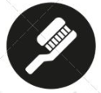
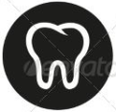
Conservative v

University of Jordan
Faculty of Dentistry
5th year (2015-2016)
.........................................................................................................................................................................................................................................................
Hand Out
Slide
Sheet

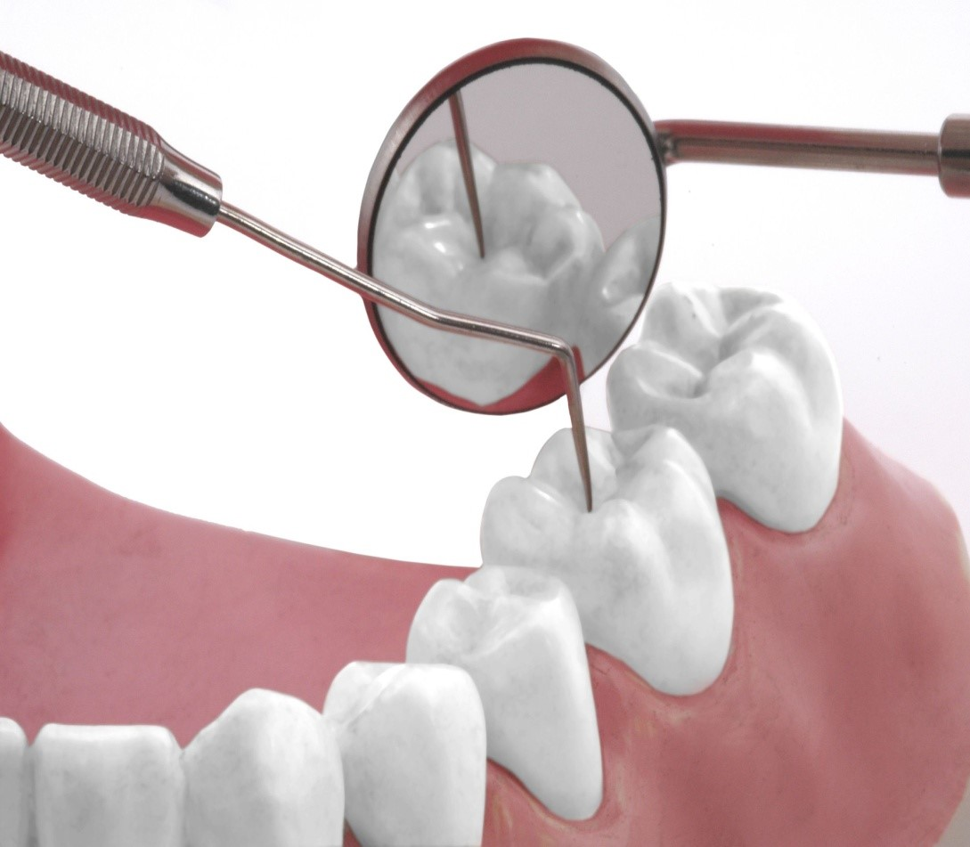
Price & Date of printing:

Designed by: Hind Alabbadi

At the beginning the Dr revised the previous lecture about TMDs

Tempromandibular Disorder Classification:

- Masticatory Muscle Disorder
- TMJ Disorders
- Chronic Mandibular Hypomobility (either ankylosis or muscle contraction that prevent the mandible from moving into its correct path)
- Growth Disorders

The most important classification is the first two and the later two we will not go into them in details
Masticatory Muscle Disorder
The etiology of TMD always starts with an event that could be of any kind from an emotional stress, trauma or a high filling this event can cause a TMD or not it depends on the patient’s tolerance if the event’s magnitude with normal function is above the patient tolerance it will cause TMD
Normal function+ event > tolerance ==== TMD
Masticatory Muscle Disorders are classified in sequence as :

- Protective muscle co-contraction
- Local Muscle soreness
- Myofacial pain or trigger points
- Muscle Myospasm
- CNS mediated myalgia
- Fibromyalgia

Protective muscle co-contraction
Which is a normal response from the muscles when the event occurs
If the protective co-contraction persists then we will have
Local Muscle soreness
If the muscle soreness persists then we will have
Muscle Myospasm
The myofacial pain or trigger points
In some muscle, some bands will be hyperactive once you press on them then a sort of referred pain will be felt

If we move down in sequence we will have the CNS involved
CNS mediated myalgia
Fibromyalgia (we will not go through them because they are difficult to diagnose and we are not qualified to treat as you know Fibromyalgia is a global systemic musculoskeletal disorder affects the whole body muscles including masticatory muscles and to be diagnosed as fibromyalgia, it needs to have 11 muscles involved from ¾ body quadrants )
TMJ disorders:

Derangements of Disc-Condyle assembly
- Disc Displacement (slight anterior movement of the disc)
- Disc Dislocation with reduction (the disc and condyle are not related to each other but the condyle can get under the disc in some point)
- Disc Dislocation without reduction (the disc and condyle are not related to each other but the condyle can’t get under the disc)

Structural incompatibility
- Deviation in form
- Adherences/Adhesions
- Subluxation and hypermobility (the condyle is moving beyond the eminence)
- Spontaneous dislocation (locking of mouth opening)

Inflammatory disorders
- Synovitis
- Retrodiscitis
- Osteoarthritis
- Arthritis
- Osteoarthrosis
- Rheumatoid arthritis

Now we will start our lecture
Treatment of TMD
Treatment should be based on an accurate diagnosis and understanding of the disorder .
Orofacial pain is very complex ,many structures in the head and neck can produce complaints that mimic TMD .
it’s very difficult to diagnose TMDs because muscles pain, TMJ pain, and head and neck pain they mimic each other .

Challenges
- The patient’s symptoms do not fit into one classification.
- The patient may be suffering from one or more than one disorder (myospasm and internal derangement).
- One disorder may contribute to another (so you need to know the primary disorder).
- Etiological factors that contribute to TMDs are difficult to control and eliminate.
- Some etiological factors are not yet identified.
- Pain from musculoskeletal system varies greatly.

Trauma is one of the most common etiological factors either it’s a macro-trauma (blow to the face) or micro-trauma (occlusion or parafunction).
The Dr showed trauma as the etiological factor in the chart but it’s not the only one you could add emotional stress or deep pain input.
As you see in the chart, all TMDs are related to each other which means that masticatory disorders could lead to disc derangements.

Treatment can be :
Definitive treatment (eliminate the TMD cause )
Supportive treatment (relief the TMD symptoms): analgesic , massage, ultrasound

Definitive treatment
To do definitive treatment you should know the etiological factor (Occlusal factor, emotional stress)
- Patient awareness
- Restrictive use (to decrease or restrict the use of the mandibular movement to it’s full limit and use small movement)
- Voluntary avoidance (to avoid tooth contact )
- Relaxation therapy

Treatment modalities

Pharmacological therapy : depends on the severity of the disorder
Analgesic
NSAIDs
Corticosteroid
Anxiolytics
Muscle relaxants
Antidepressants

Physical therapy modalities :
Thermotherapy: hot packs (better blood flow and it changes the sensory input to reduce the pain )
Coolant therapy (reduce swelling)
(High and low temperatures are very useful )
Ultrasound
Acupuncture
Laser

Manual techniques
Massage (by the dentist or you educate the patient how to do massage )
Joint immobilization or distraction (patient should open and relax used in cases of adhesions or myospasm and you need the patient to relax
Passive muscle stretching (in front of the mirror do a few exercises like opening and closing repeatedly)
Splint therapy
Surgery (the last option to choose from the treatment modalities)

Masticatory muscle pain is a common symptom of TMDs
Protective co-contraction
Eliminate the cause
Restrict mandiblular movement to painless limit
Soft diet
Short term NSAIDs (for a week)
Local muscle soreness
Eliminate the cause
Educate the patient
Restrict mandiblular movement to painless limit
Soft diet
Splint ( if the soreness persists for along time )
Minor analgesic
Muscle relaxant
Muscle myospasm
Effectively treated by reducing the pain of the patient
Massage
Cold or thermotherapy
Eliminate the deep pain source
Allow the muscles to rest
No need for Muscle relaxant
Trigger points myalgia
Eliminate the cause
Reduce the systemic involvement in the myofacial pain
Treat sleep disturbance (as sleep disturbances might cause trigger points)
Pressure and massage (if you find the trigger point)
Spray (local anesthesia ) and stretch ( the muscle)
Inject (local anesthesia ) and stretch ( the muscle)
Ultrasound
Chronic myositis
Restrict mandibular movement
Soft diet
Avoid exercises, dental appointments
Disengage the teeth
Anti-inflammatory
NSAIDs (at least regularly for 2 weeks)
Fibromyalgia
We will not go into details of it
If diagnosed then refer to medical society and they will use pharmacological treatment like NSAIDs, antidepressants and physical therapy and regular exercise.
TMJ disorders

Derangements of Disc-Condyle assembly

Disc displacement and disc dislocation with reduction
Characteristics:
Normal range of movement
Restriction is associated with pain
Deviation or deflection
Clicking
The aim in this disorder depend whether the patient is complaining of pain.
Studies have shown that most population have clicking and they don’t evolve into something serious and in most population it’s intermittent (it will come and go)
If the patient have pain or some restriction of movement treatment will be:
Reduce the pain and reposition of the condyle back on the disc and recapture it if possible .
Studies have shown that it’s difficult to recapture the disc and if it’s not recaptured most population will function normally without pain
So if the patient only have clicking without pain there’s no need to interfere
Definitive treatment:
- Reduce the pain
- Not to recapture the disc
In some cases where circumstances are favorable in all aspect and you are able to recapture the disc you can do it but we shouldn’t aim to recapture it in all cases because in most times it’s very difficult .
- Splint therapy
Splint : hard acrylic device that sets between the teeth in a certain relationship
We can use stabilization splint or anterior repositioning the splint
Stabilization splint
AKA: Centric splint, Michigan splint, and many other names
Constructed in Centric relation
Anterior repositioning splint
Puts the mandible in a more forward position to try to recapture the disc .
We use the splint at night and we gradually reduce their use, sometimes they are worn for 8 weeks and sometimes for months
Weaning: reduce gradually the use of the splint
If after we remove the splint , the symptoms is back then the duration of use is not enough or the patient didn’t wear the splint enough or might have a really serious occlusal instability in this case the occlusion is not allowing proper disc condyle relationship and it’s the only situation where orthodontic treatment or full mouth rehab is allowed for the treatment of TMDs
- Patient education
- Restrict the movement
- Soft diet
- Medications
- Moist heat or cold packs
- PSR (physical self regulation)
In some patients where sleep disorders, breathing disorders, or emotional stress are the cause of TMDs in these cases the treatment depend on the patient to educate him to relax, do exercises at home , and to sleep in a more relaxed forms.

Anterior repositioning splint:
To put the mandible in a more forward position but to what extent ?
It’s the minimal forward movement that eliminate the patient’s clicking (in which we try to recapture the disc so no clicking will be heard)
Time of use: at night and gradually reduce the use
Duration: depend on the severity of the case, age, general health of the patient, the extent of trauma
**Regarding the age of the patient, in older patients the adaptive changes are slower.

In Anterior repositioning splint after the withdrawal of its use the symptoms will disappear sometimes the condyle-disc relationship will get back to normal but in most times what happens is that before the use of the splint the condyle was positioned posteriorly and presses on the retrodiscal tissues which was causing the pain and once we use the splint these tissues will be relieved and fibrotic changes will occur and healing starts and there will be some sort of adaptation that even if the condyle get back into position before the treatment it will not cause pain because the tissues adaptation, so not all the times you can recapture the disc using the splint
--Studies have shown that joint sounds are common in population they are not related to serious disorder or pain or restriction of movement.
--Not all clicking will progress into clinical disorder .
--even after treatment reoccurrence is common.
--Most of the times the choice of splint will be the easiest, safest and most effective one which is the stabilization splint.
Anterior repositioning splint : not commonly used because the success rate is not high but it reduces pain in 75% of cases
--During Anterior repositioning splint, retrodiscal tissues undergo adaptive and reparative changes and they become more fibrotic and avascular (more like the discal tissues)

Disadvantages of Anterior repositioning splint
Long duration use can cause posterior open bite.

Disc dislocation without reduction
The disc is in an anterior medial position which is locking the condyle and restricting the movement of mandible not allowing Normal range of movement .

Disc dislocation without reduction
Anterior repositioning splint is contraindicated in disc dislocation without reduction where the condyle will never be under the disc so if you do forward positioning you are pressing the disc more forward which is very painful and harmful.
We use in this case stabilization splint.
But if we have acute clinical case that happened just 2 days ago for example we could recapture the disc by manipulation to relax the muscles,first inject local anesthesia in the lateral ptyregoid muscle and manipulate the muscle to relax and recapture the disc manually and once you achieved that then Anterior repositioning splint is worn for 2 days at night and then we will change it to stabilization splint, this the only case where we use Anterior repositioning splint in Disc dislocation without reduction

We try other conservative methods of treatment and if it didn’t work and the patient is still having pain and restriction of normal movement then surgery is the option left for treating the disorder.
Studies have shown that most patients respond well to the conservative method and splints.
Surgical treatment like : arthroscopy, arthocentesis, arthrotomy, discetomy

Supportive therapy :
Patient education
Anti-inflammatory
Soft diet
Small mouth opening and gentle exercises

Structural incompatibility

Deviation in form
Treatment : surgery

Adhesions and adherences
Treatment : stretching
Exercises
Stabilization splint
PSR

Subluxation (the condyle is moving beyond the eminence)
Treatment : eminectomy or reduce the slope of the eminence

Spontaneous dislocation
Treatment: inject local anesthesia to relax the muscle and manually manipulate the condyle into its normal position

Inflammatory disorders we will not go through them but you should know that it can be treated by :
NSAIDs
Ultrasound
Soft diet
Small bites

Occlusal appliance
Can be definitive or supportive treatment
Non-invasive method of treating TMDs they alter the occlusal forces , prevent wear of teeth, reduce bruxism, treat masticatory pain, change the relationship between maxilla an mandible or the condyle to glenoid fossa.

Theories of how occlusal appliances work
- Occlusal disengagement (separate the teeth)
- Maxillomandibular realignment (more physiologic and stable position)
- Increase vertical dimension (the more you increase the vertical dimension the less contracted the muscle can be)
- TMJ repositioning
- Cognitive awareness theory
To aware the patient about the disorder so if for example he has bruxism he will be reminded not clench on his teeth .

--One theory can be responsible for the treatment or more than on theory.

--The Dr will provide a chapter about splints types.

Type of splints
- Soft bite
- Localized occlusal interferences splint
- Stabilization splint
- Anterior repositioning splint
- Anterior bite plane

Soft bite guard
which is known as night guard some dentist think that it’s the ideal splint while it’s used in emergencies with severe pain and it shouldn’t be used for a long time because it’s soft the patient will continue to chew on it so it exacerbate rather than alleviate the problem it should be given for one week and then replaced with hard appliance, it’s used by athletes during sport for short time.

Localized occlusal interferences splint
It’s like balls the patient bite on it the idea is to increase the proprioception on 4 teeth to aware the patient about the parafunction and he will try to avoid it the Dr never used it and doesn’t like to use because it overloads certain teeth and it’s not used for long time worn for short time few months(2-3) only

Stabilization splint we talked about it is called
Centric , tanner, fox, Michigan, muscle relaxation splint
It’s used in parafunction
Aims to temporarily give the patient ideal occlusion because he will bite in centric and the forces are equilateral and he have proper anterior guidance without interferences and you are putting the condyle in a musculoskeletal stable position
Safe to apply
Duration of use : according to the severity
How it’s made: Take the centric relationship with a soft material and it’s constructed to have flat surface never indentated the splint in order not to cause interferences while moving and to have proper anterior guidance without posterior interferences.
After a successful period of splint therapy patient will return with free symptomatic stage it’s a common mistake that after the removal of splint that we should do a full mouth rehab and try to achieve ideal occlusion .

Anterior bite plate
Same as stabilization splint but only anterior part only it’s used for short time because it will cause posterior open bite and it can be easily swallowed .

--Permanent occlusal adjustments are rarely indicated.

--The Dr showed several photos of these appliances at the end of the lecture.

