1  Dent-2011.weebly.com | Lecture No.
1/10/2015 | Date:
Hawazen | Doctor:
Sakina Dashty | Done by:
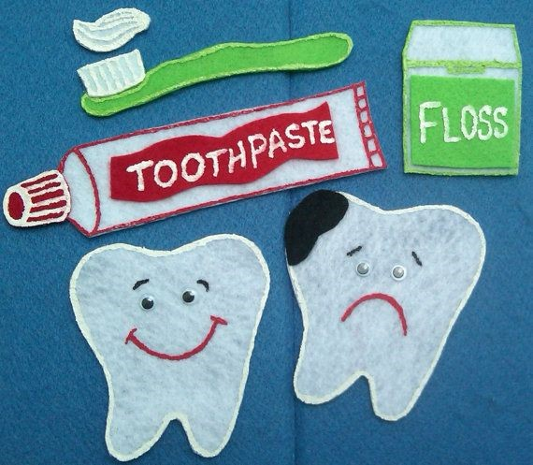
Preventive II

University of Jordan
Faculty of Dentistry
5th year(2015-2016)
Price &Date of printing:

.........................................................................................................................................................................................................................................................
Hand Out
Slide
Sheet
Designed by: HindAlabbadi
Prevention of Dental trauma

Epidemiology:
Common causes of dental truma:
-Accidents
- Falls around home and schools, so make sure that these places are safe
-Sport injuries
-Violence (mainly in teenagers about 16-17 years of age)

-For Young children falls are the most common cause of dental injury mainly about 1-3 years of age when they start to be mobile.
-The Peak age of this type of trauma occurs between the age of 1-3 years because by the age of 1 children start to walk but they lack the sense of balance and coordination and so they fall frequently.
-If you see injuries before the age of 1 when the child is still immobile you need to suspect child abuse or non accidental injuries.

Sports:
-Accounts for 10-40 % of traumas
-Boys are more likely to have dental trauma than girls because more boys participate in sports but now they're becoming more equal.
-The Peak age for this type of trauma is between 8-11 years of age.
-The most common teeth to be affected are the upper anteriors and mostly the centrals.
-If we consider the age between (8-11) years the central incisors would be fully erupted by this time, but the roots won't be fully closed, so should any trauma occur the formation of the roots would be affected, so you need to expect an open apex and this will eventually affect your type of treatment.
You then might need to use non-setting calcium hydroxide or MTA.

Classification of sports:
-High risk sports: there's direct contact between the players like:
Football, ice hockey, ice skating, marshals and skating.

-Medium risk: basketball and squash
There is a study that says: the sport that is associated with the highest risk of trauma is ice hocky. Why?
Because it's on ice and uses sticks.

Why do we need to prevent dental trauma?
Because treating dental trauma costs a lot.

Preventive measures:
-Primary
-Secondary
-Tertiary

Primary prevention:
The Prevention of the circumstances that lead to trauma.
Two aspects for primary prevention are:
1. Safe environment
2. Mouth guard

1. Environment:
-Most injuries occur during playing.
-Regarding the environment we're concerned about two things :
-The play ground surface
-Playground equipment
Play ground surface should be:
- Safe
-Should not be hard surface; so we need an impact absorbing surface to dissipate actual force
-Not abrasive
-Not slippery
-Not flammable.
-Made of elastomeric material
-Alternatives: sand, tree bark

2. Playground equipments:
-Not to be high (not more than 2.5 meters).
-Should be fixed very well to the ground
-Should be under supervision

*Early treatment of large overjet
-The risk of Central incisors damage significantly increases with increased overjet
*Early treatment of increased overjet is needed when:
-Overjet larger than 9 mm
-Incompetent lips
-Children who participate in sports
-Children those are more prone to accidents
-And early intervention when it cause psychological impact as bullying in schools because of the appearance of teeth

*Mouth guards:
An Appliance that is placed inside the mouth to protect the teeth and surrounding structures.
-Mechanism of protection :
With no mouthguard any trauma to the chin will be directly transmitted to the teeth and jaws and will eventually cause a crown fracture , condylar fracture or simply a concussion.
But with the mouthguard worn there will be a space of about 3 mm separating between the teeth in each jaw and this will dissipate the force and carry a lower risk of trauma.

An Ideal mouth guard should be :
-Protective
- fits properly
-comfortable
-resilient
-odorless
-Tasteless
- Inexpensive
-not to interfere with speech

Types of mouth guards :
1. Stock mouthguards:
-come in different sizes
-do not fit specifically (not retentive)
-restrict speech
-Made of rubbery material PVC

2.Mouth formed :
-Usually done by the person himself
- made of thermoplastic material
-One only needs to soften it in boiling water and forms it with his fingers.
Dis advantages:
-it might not be molded properly
-not thick enough to protect teeth (uneven thickness)
-Might burn the mouth

3. Custom made :
-Most satisfactory
-Made from dental cast By 2 techniques:
A.Vacuum :
-A Single layer of sheet around the teeth
- it takes the shape of teeth
-made of AVA copolymer
-The disadvantage of this technique that when it is stretched on the cast it will have uneven thickness in different areas with some areas with very thin material.
To overcome this problem we used multi-layering (the 2nd technique).

B.Pressure laminated :
-Done under high pressure (which is preferred)
-It should not hurt the patient (the extensions should be shorter than the mucobuccal fold and should be relieved around the frenal attachment)
-thickness:
3mm labially
3mm occlusally
Lesser thickness palataly

*Practical considerations :
-If a patient is wearing a removable appliance and is participating in any kind of sports; it should be removed
-If a patient has Braces: you should put a layer of wax around the wires before taking the impression for constructing a mouth guard

*Secondary prevention:
By providing Treatment so complications will not occur
Examples:
-A fractured incisor restores it to protect exposed dentinal tubules
- bleeding incisors we can restore it with GI if composite can’t be used because of bleeding
-pulp exposure partial pulpotomy ; using calcium hydroxide , MTA
-Laxated primary tooth removes it; don’t return it back to the socket because it will damage the permanent tooth.
If you have an injury to a primary tooth you need to check for any trauma to the underlying permanent successor.
There is no need for space maintainers for anterior teeth

*Tertiary prevention:
To provide th best quality of restorative treatment to minimize the impact of trauma.

Conclusion:
-General practitioners should be aware of trauma and how to deal with dental
Environmental changes
Regulations:
-As in the national alliance of football 1962:
Every player should wear intraoral device with tooth protection.

*Plz notes that you need to refer to the chapter "prevention of dental trauma" in you textbook.

أسأل الله العظيم رب العرش العظيم أن يشفي والدي شفاء لا يغادره سقما " "
Special thanks to omar shams Aldeen

